Assignment 2
  - Deadline: Saturday 05/11/2022 @ 23:59
[Total Mark for this Assignment is 8]

Integrated Enterprise Systems
IT402

Student Details:
Name:###  CRN:### |  | ID:###

Instructions:
- You must submit two separate copies (one Word file and one PDF file)using the Assignment Template on Blackboard via the allocated folder. These files must not be in compressed format.
- It is your responsibility to check and make sure that you have uploaded both the correct files.
- Zero mark will be given if you try to bypass the SafeAssign (e.g. misspell words, remove spaces between words, hide characters, use different character sets, convert text into imageor languages other than English or any kind of manipulation).
- Email submission will not be accepted.
- You are advised to make your work clear and well-presented. This includes filling your information on the cover page.
- You must use this template, failing which will result in zero mark.
- You MUST show all your work, and text must not be converted into an image, unless specified otherwise by the question.
- Late submission will result in ZERO mark.
- The work should be your own, copying from students or other resources will result in ZERO mark.
- Use Times New Roman font for all your answers.

Question One
2 Marks
Learning Outcome(s):
CLO 3
Discuss the issues and challenges associated with implementing ES and their impacts on corporate enterprises.

Comparison between three BPMS product examples"Cordys BPMS" [OpenText Process suit], "Oracle BPM Suite", and "IBM WebSphere BPM Suite" is provided in book.Your task is to pick any two BMP Suite examples from internet (other than the names BPMS discussed above) and provide comparison between them.

Question Two
2 Marks
Learning Outcome(s):
CLO 5
Develop robust business intelligence solutions that provide an integrated framework for improved business processes within a global context.

Maturity models define five levels of increasing maturity.Discuss the main differencesbetween Level 4 (Predictable Organizations) and Level 5 (Optimizing Organizations).

Question Three
2 Marks
Learning Outcome(s):
CLO 4
Employ advanced technology in ES to develop, install, and maintain business intelligence systems.

Discuss the purpose of employing business process modeling and notation in organizations, why it is essential, and when should you implement BPMN.

Question Four
2 Marks
Learning Outcome(s):
CLO 6
Design ES architectural models for various business processes.

Based on the following BPMN diagram:
- Listthe main elements in the diagram.
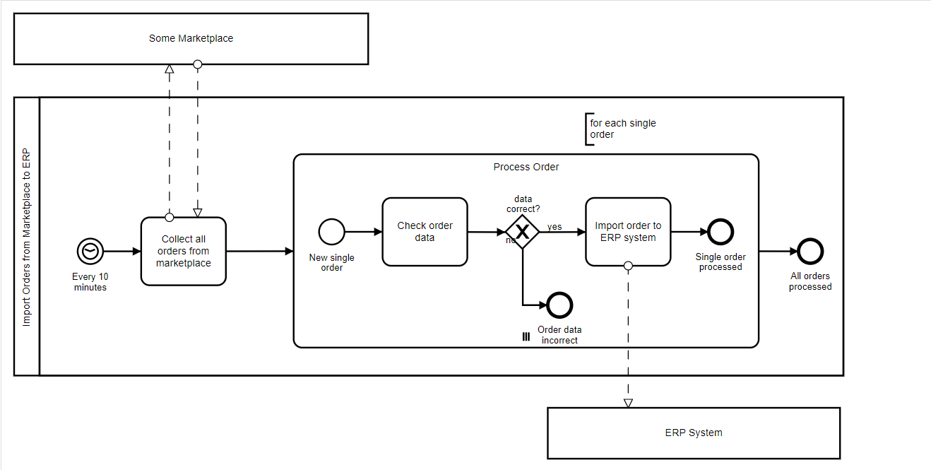
- Illustrate the model scenario and situation

