Strategic HRAudit Assignment Instructions
Overview
Choose any company with 100 or more employees and apply the following Model of Strategic HR Management as a means of investigating and assessing the strategic HR practices of the firm.

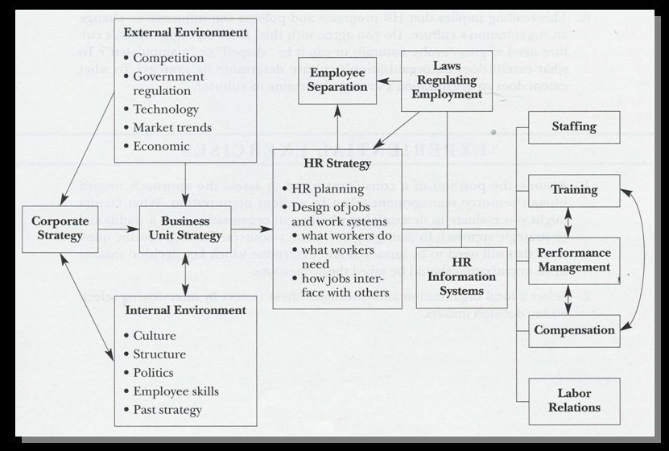

Source: Mello, J. A. (2019). Strategic human resource management (5th ed.).Mason, OH: South-Western.

Instructions
There are three steps to this Strategic HR Audit Assignment:
- Quiz: Strategic HR Audit: Company Choice
- Strategic HR Audit: Paper Assignment
- Strategic HR Audit: Presentation Assignment
Please see the instructions for each part below:
Quiz: Strategic HR Audit: Company Choice
The purpose of this quiz is to propose a topic for the Strategic HR Audit Assignment.
In one essay question on the quiz, submit the name of your company choice for the Strategic HR Audit. Your chosen company must have at least 100 employees.
Strategic HR Audit: Paper Assignment
Write a 2,000-word (minimum word count excluding your references section) paper.
Provide 3 distinct sections for both your paper.
- Section 1: profile of the subject company (e.g. corporate strategy, revenue base, financial performance, employee base, ownership structure, product/service mix, competitive position, primary locations for operations, etc.).
- Section 2: analysis and assessment of the strategic and theological soundness of the HR practices of the subject company (paying special attention to HR strategy, staffing, training and development, performance management, compensation, and labor relations).
- Section 3: posit 5–7 key recommendations for improving the strategic and theological soundness of the HR practices of the subject company.
Required Sources
Include the following sources in your reference page, and use in-text citations as follows:
- At least 4 citations from Valentine (2020).
- At least 4 citations from Hardy (1990) and/or Keller (2012).
- At least 5 citations from related scholarly journals (e.g. Human Resource Development Quarterly, Human Resource Development Review, Human Resource Management Journal, Journal of Applied Psychology, Journal of Strategic Human Resource Management, Journal of Biblical Integration in Business, Christian Scholars Review).
- At least 3 citations from related trade/practitioner publications (e.g. Harvard Business Review, HR Magazine, T&D Magazine, Business Week, Wall Street Journal).
Note: Your assignment will be checked for originality via the Turnitin plagiarism tool.
Strategic HR Audit: Presentation Assignment
Develop a related 15 slide presentation (you will not actually deliver your presentation live but prepare your slides as though you were going to).
Provide 3 distinct sections for your presentation.
- Section 1: profile of the subject company (e.g. corporate strategy, revenue base, financial performance, employee base, ownership structure, product/service mix, competitive position, primary locations for operations, etc.).
- Section 2: analysis and assessment of the strategic and theological soundness of the HR practices of the subject company (paying special attention to HR strategy, staffing, training and development, performance management, compensation, and labor relations).
- Section 3: posit 5–7 key recommendations for improving the strategic and theological soundness of the HR practices of the subject company.
Required Sources
Include the following sources in your reference slide, and use in-text citations as follows:
- At least 4 citations from Valentine (2020).
- At least 4 citations from Hardy (1990) and/or Keller (2012).
- At least 5 citations from related scholarly journals (e.g. Human Resource Development Quarterly, Human Resource Development Review, Human Resource Management Journal, Journal of Applied Psychology, Journal of Strategic Human Resource Management, Journal of Biblical Integration in Business, Christian Scholars Review).
- At least 3 citations from related trade/practitioner publications (e.g. Harvard Business Review, HR Magazine, T&D Magazine, Business Week, Wall Street Journal).

Note: Your assignment will be checked for originality via the Turnitin plagiarism tool.

