TOPIC: Tourism and its effect on global warming
This green rubric assignment includes:
- An integrated review of pertinent literature (at least 10 current, evidence-based/empirical and peer- reviewed research articles – do not confuse these with articles from newspapers which are NOT empirical nor peer-reviewed) - (literature review section).
- A synthesis of literature section highlighting key points and themes illustrated throughout the review of the literature section.

The assignment will be graded using the following rubric:
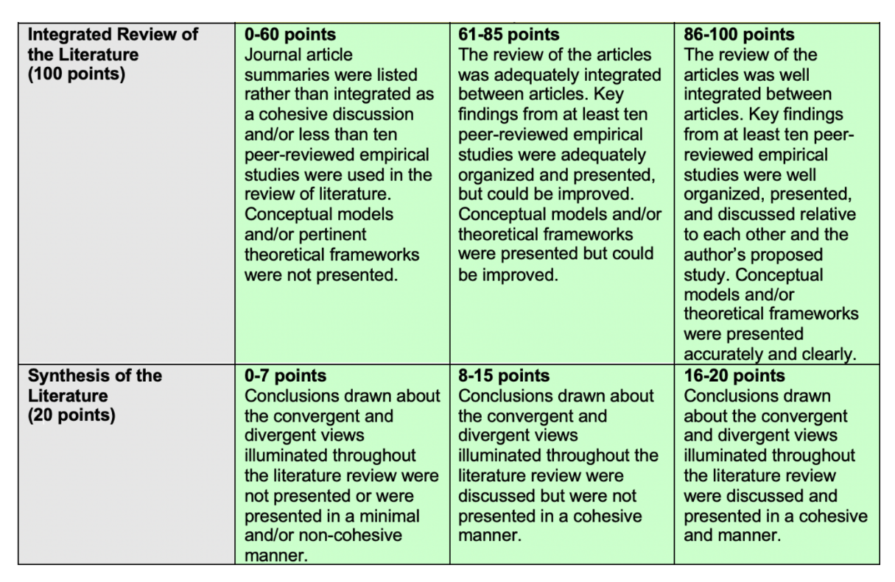
References Already Used:
Chisht, M. Z., Ullah, S., Ozturk, I., & Usman, A. (2020). Examining the asymmetric effects of globalization and tourism on pollution emissions in South Asia. Environmental Science and Pollution Research, 27(22), 27721-27737. https://doi.org/10.1007/s11356-020-09057-9
Haseeb, M., & Azam, M. (2020). Dynamic nexus among tourism, corruption, democracy, and environmental degradation: A panel data investigation. Environment, Development, and Sustainability, 23(4), 5557-5575. https://doi.org/10.1007/s10668-020-00832-9
Koçak, E., Ulucak, R., & Ulucak, Z. Ş. (2020). The impact of tourism developments on CO2 emissions: advanced panel data estimation. Tourism Management Perspectives, 33, 100611. https://doi.org/10.1016/j.tmp.2019.100611
Pablo-Romero, M. D., Pozo-Barajas, R., & Sánchez-Rivas, J. (2019). Tourism and temperature effects on the electricity consumption of the hospitality sector. Journal of Cleaner Production, 240, 118168. https://doi.org/10.1016/j.jclepro.2019.118168
Sharif, A., Saha, S., Campbell, N., Sinha, A., & Ibrahiem, D. M. (2019). Tourism, environment, and energy: An analysis for China. Current Issues in Tourism, 23(23), 2930-2949. https://doi.org/10.1080/13683500.2019.1703913

