Lesson 4 Commentary
In this lesson, you will learn about a new breed of AI-powered organizations that will transform the role of management, including the human capital management architect. The following topics will be discussed:
- the historical view including:
  - the first firms
  - the rise of mass production
  - 20th century operating models
- traditional operating limits
- a critical, difficult transition
- architecture for an AI-powered firm
- breaking traditional constraints
You will also learn about the rise of the talent intelligence platform or digitization of the talent acquisition process. “Bayer AG, a German multinational pharmaceutical and life sciences company and one of the largest pharmaceutical companies in the world, will be highlighted” (“Bayer,” 2021). Two years ago, the HR leadership team at Bayer created a new people strategy around five pillars:
- the employment propositions
- fit for purpose
- digitalization and connectivity with the external market
- leadership
- speed to market
A key takeaway from this lesson is that HRER leaders and practitioners will be challenged to rethink talent management from a digital transformation lens. For instance, talent acquisition can be viewed from a global perspective—that is, technology can connect and enable a globally dispersed workforce. If we remove geographic boundaries, the focus can shift to identifying, acquiring, and onboarding the best talent on planet Earth to help create and execute organizational strategy. Such an approach could serve as a multiplier effect and help our organizations become destinations for global talent. Furthermore, studies conducted during the global Covid-19 pandemic of 2020–2021 indicated that workforce productivity increased and a sizable portion of the workforce (i.e., knowledge workers) prefer working remotely or a hybrid arrangement.
Objectives
After successfully completing this lesson, you should be able to do the following things:
- Discuss what forward leaning firms are doing to rearchitect and become AI-powered firms.
- Describe an operating architecture for an AI-powered firm.

Reading and Activities
Text: Ch. 4 - Rearchitecting the Firm
Other Readings: The Rise of the Talent Intelligence Platform
Link Here: chrome-extension://efaidnbmnnnibpcajpcglclefindmkaj/viewer.html?pdfurl=https%3A%2F%2Fmedia.trustradius.com%2Fproduct-downloadables%2FV0%2FW0%2FWJDDJTF4GJ44.pdf&clen=5062512&chunk=true

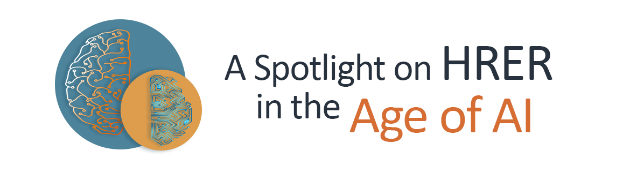
In this brief article titled Human Resource Management in the Age of Artificial Intelligence, the author provides a perspective on the potential of how AI will transform the HR function in organizations. This includes the following:
Link here: https://blog.primus.vn/human-resource-management-in-the-age-of-artificial-intelligence/
- streamlining the recruitment process
- automating repetitive tasks
- improving employee engagement
- transforming learning and development
The topic of how AI has the potential to streamline the recruitment process relates directly to a key takeaway for our lesson—that is, HRER leaders and practitioners will be challenged to rethink talent management from a digital transformation lens.

