The True Energy Price Exposure Of Everything You Eat
The Oil Drum
Mar 11, 2011, 12:27 PM
This is a guest post by Michael Bomford, a research scientist and extension specialist at Kentucky State University, an adjunct faculty member in the University of Kentucky Department of Horticulture, and a Fellow of Post Carbon Institute. This article was originally published on the Post Carbon Institute website.
"There is nothing as deceptive as an obvious fact." -Sherlock Holmes
A locavore is “a person who endeavors to eat only locally produced food.”[1] What better diet could there be for an energy constrained world? After all, feeding Americans accounts for about 15% of US energy use,[2] and the average food item travels more than 5,000 miles from farm to fork.[3] It seems obvious that eating locally will go a long way to reducing food system energy use.
Yet cracking the case of America’s energy-intensive food system demands that we look beyond the obvious. A local diet can reduce energy use somewhat, but there are even more effective ways to tackle the problem. Single-minded pursuit of local food, without consideration of the bigger picture, can actually make things worse from an energy perspective.[4]
For you

Media
Some ex-BuzzFeed staffers are fuming that they couldn't immediately dump their shares after the company's public debut

If you realize you’re spending too much money, the first thing to do is figure out where it’s going. Cutting back on pizza won’t make much difference if you’re spending most of your money on beer. Similarly, the first step in reducing food system energy use is to figure out where all the energy is going. That’s what a team of economists working for the United States Department of Agriculture (USDA) did last year, in a report called Energy Use in the US Food System.

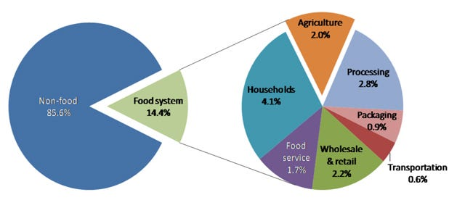
Where the energy goes: Energy used in the food system as a proportion of total energy used in the US in 2002 [5]. The Oil Drum
The report contains some surprises. Transportation is the smallest piece of the food system energy pie. Even farming isn’t a particularly big contributor. The big energy users turn out to be food processing, packaging, selling, and preparation. Our kitchens command the biggest slice of the pie, using twice as much energy as the farms that grew the food in the first place.
Dissecting that little transportation component of the system offers more surprises. The distance food travels between farm and fork has little impact on how much energy it takes to get there.
How food travels is far more important than how far it goes.[6] Big boats, like freighters and barges, can bring vast quantities of food thousands of miles using less energy per ton than a small truck or car uses to transport smaller amounts of food a few miles. Over land, freight trains are more energy efficient than big trucks, which are more efficient than small trucks. Worst of all are airplanes, which use a disproportionately large amount of fuel for takeoff and landing. In almost every case, flying food uses more fuel than other means of transport, regardless of the distance it travels. Fortunately, air freight still accounts for less than 1% of US food transport.[7]
Since the distance food travels has little impact on total food system energy use, obsessing over ‘food miles’ probably isn’t helpful when we're looking for ways to reduce energy consumption. When food is purchased from major grocery or fast food chain, the distance to the farm where it grew is probably just a small fraction of the distance it has traveled overall. For every mile between farm and plate, an average food item travels more than three additional miles[8]—but some travel much more and others much less. This means “place of origin” labels give consumers little clue as to how far food has actually come before purchase.
The USDA’s report offers some insight into what kinds of food are made with all the energy going into the system. More than half of that energy it is used for highly processed and packaged ‘junk food,’ like chips, doughnuts, soda pop, and beer. About a third is used for animal products, like meat, eggs, and dairy. A measly sixth goes to the grains, fruits, and vegetables that are the foundation of a balanced diet. In other words, the relative energy we invest in each food group reflects the opposite of how we should be eating. Eating well doesn’t necessarily require a lot of energy; eating badly does.

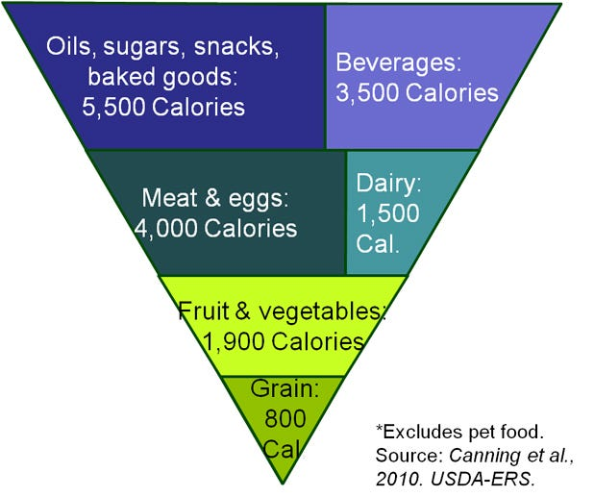
Inverted food pyramid: Daily per capita energy input to the US food system exceeds 17,000 Calories before food reaches the home. [9] This is more than eight times the average Caloric requirement for a healthy diet. [10] Most of this energy is used to provide highly-processed, high-Calorie foods. The Oil Drum
Buying from the local farmers’ market offers great opportunities to cut down on food system energy use, but it's not because the food there has traveled less than the food at the grocery store. [11] It's because the aisles of a typical grocery store are mostly filled with highly-processed and packaged food, while farmers markets offer mostly whole or minimally-processed foods. Grocery stores are artificially heated and lit, with plenty of electricity-hungry coolers, freezers, checkouts, and other conveniences. By contrast, farmers’ markets tend to be held in the open air, with few electric gadgets. The farmers’ market saves energy by carving it out of the processing, packaging, and retail segments of the food chain, which are much larger than the transportation segment. From this perspective, the backyard garden offers all of the advantages of a farmers’ market, and then some.
There are even some cases in which growing food locally requires more energy than importing it. For example, produce grown out-of-season in heated greenhouses usually takes far more energy than field-grown vegetables trucked or shipped from a region where they are in season. Growing produce under artificial light can demand even more energy than heating a greenhouse. Energy demands are the downfall of popular futuristic schemes of ‘vertical farms’ in urban skyscrapers.
Highly-processed and packaged foods simply require far more energy than whole foods, regardless of how far they travel. Choosing imported whole foods over local processed foods almost always reduces food system energy use.
The way that food is grown usually has a bigger impact on energy use than the distance it travels. The proportional impact of farming on food system energy use is substantial for whole foods, but trivial for highly processed foods. Since organic farmers reduce agricultural energy inputs by about a third by eschewing synthetic nitrogen fertilizer, choosing organic over local can make sense for whole foods. It makes little difference for highly processed foods, however. Organic soda pop is still soda pop: Far more energy goes into the aluminum can than was ever used to grow the corn for the corn syrup, organic or otherwise.
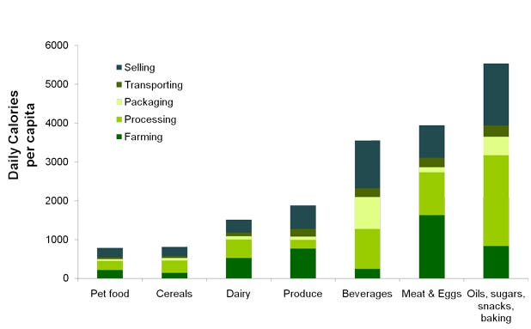
Daily per capita energy input to the US food system, by food group and production phase, excluding household energy use. [12] The Oil Drum
Choosing local food is one way to reduce food system energy use; but even more effective ways include:
1. Choosing whole foods over processed foods;
2. Getting a small, energy-efficient refrigerator and getting rid of extra refrigerators;
3. Replacing animal products with grain and vegetable-based proteins;
4. Drinking tap water instead of processed beverages;
5. Choosing food that was grown in a region well-suited to the crop, using methods that build soil and rely primarily on sunshine for energy and rainfall for water.
By combining tactics we can eat well using much less energy than we currently do. An understanding of the food system helps put our various food choices in context. Following a single, hard-and-fast rule—even a seemingly-obvious one like “always eat local food”—can lead us astray.
Michael Bomford is a research scientist and extension specialist at Kentucky State University, an adjunct faculty member in the University of Kentucky Department of Horticulture, and a Fellow of Post Carbon Institute. His work focuses on organic and sustainable agriculture systems suitable for adoption by small farms operating with limited resources. His projects examine practical ways to reduce food system energy use and meet farm energy needs using renewable resources produced on-farm. Michael has a Master of Pest Management from Simon Fraser University, and a PhD in Plant and Soil Sciences from West Virginia University, where he conducted research on one of the nation's first land grant university farms operated entirely according to national organic standards.
Endnotes
[1] New Oxford American Dictionary.
[2] Patrick Canning, Ainsley Charles, Sonya Huang, Karen R. Polenske, and Arnold Waters. Energy Use in the US Food System. U.S. Department of Agriculture Economic Research Service. (ERR-94) 39 pp, March 2010.
[3] Christopher Weber and H. Scott Matthews. 2008. Food Miles and the Relative Climate Impacts of Food Choices in the United States Environmental Science and Technology 42: 3508-3513.
[4] This article is concerned strictly with energy. Other reasons to favor local food include supporting local economies and building local food security.
[5] Graph by Michael Bomford, based on data in Canning et al, 2010, Figure 7, p. 20.
[6] Weber and Matthews, 2008, op. cit.
[7] Ibid.
[8] Ibid.
[9] Graph by Michael Bomford, based on data in Canning et al, 2010, Table 6, pp. 22-23. ‘Fruit & vegetable’ group presented here sums fruit, vegetable and processed produce categories from original. ‘Meat & eggs’ group sums beef, fish, poultry, pork, other meat, and egg categories. ‘Dairy’ group sums milk and dairy categories. ‘Beverage’ group sums alcohol and beverage categories. ‘Oils, sugars, snacks & baked goods’ group sums oil, sugar, baking, and snack and processed food categories. Pet food category and household energy use excluded. Units converted from BTU per year to Calories per day.
[10] Stacey Rosen, Shahla Shapouri, Kathryn Quanbeck, and Birgit Meade. Food Security Assessment, 2007. U.S. Department of Agriculture Economic Research Service. (GFA-19) 55 pp, July 2008
[11] Steve Martinez, Michael Hand, Michelle Da Pra, Susan Pollack, Katherine Ralston, Travis Smith, Stephen Vogel, Shellye Clark, Luanne Lohr, Sarah Low, and Constance Newman. Local Food Systems: Concepts, Impacts, and Issues, U.S. Department of Agriculture, Economic Research Service. (ERR-97), May 2010.
[12] Graph by Michael Bomford, based on data in Canning et al, 2010, Table 6, pp. 22-23. ‘Fruit & vegetable’ group presented here sums fruit, vegetable and processed produce categories from original. ‘Meat & eggs’ group sums beef, fish, poultry, pork, other meat, and egg categories. ‘Dairy’ group sums milk and dairy categories. ‘Beverage’ group sums alcohol and beverage categories. ‘Oils, sugars, snacks & baked goods’ group sums oil, sugar, baking, and snack and processed food categories. Units converted from BTU per year to Calories per day.
This post originally appeared at The Oil Drum.

