Risk Assessment Chart Analysis
Your Name
American InterContinental University
Submission Date

Scenario
You are the project manager working on a Market Mailing project. Below is the status update that two project team members (Jennifer and Ben) put together. Using this information, answer the following questions.

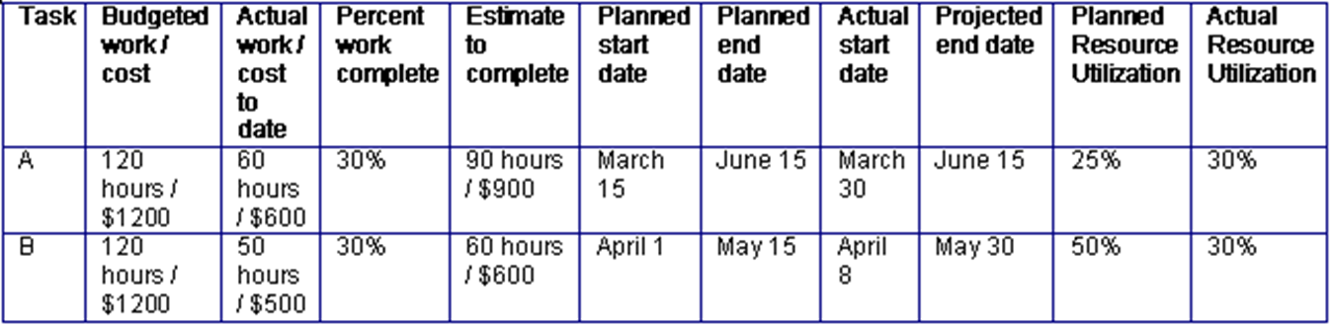

Introduction
Delete highlighted information.
The introduction is the best opportunity to convince your audience that you have something worthwhile to say (one solid paragraph). An introduction can accomplish this by fulfilling five important responsibilities, as follows:
- Get the audience's attention.
- Introduce the topic.
- Explain its relevance to the audience.
- State a thesis or purpose.
- Outline the main points.

Risk Assessment
- Define risk assessment in a project plan.

Risk Assessment Importance
- Explain the importance of a risk assessment in a project plan.

Rating Project Risk
Complete the risk assessment chart below by rating each risk factor as follows:
- High, medium, or low in terms of its potential impact
- High, medium, or low in terms of its probability of occurrence
Extract the combined effect of those two values, combined with your judgment, and score each risk factor as high, medium, or low overall. Justify your scores using the data provided above.
Project Risk Items | Potential Impact  (H / M / L) | Probability of Occurrence  (H / M / L) | Overall Risk  (H / M / L)
Completing Task A over the $1,200 budget
Completing Task A after the scheduled end date of June 5
Completing Task B under the $1,200 budget
Completing Task B after the scheduled end date of May 30

Conclusion
The conclusion is the last thing that the reader will remember about your essay.
- The conclusion should be a summary of the highlights of your statement of purpose.
- The conclusion should include the main points of the statement of purpose.
- The conclusion should be as well-constructed and grammatically correct as everything.

References
Example
Jayaraman, R. (2016). Project cost control: A new method to plan and control costs in large projects. Business Process Management Journal, 22(6), 1247–1268. https://doi.org/10.1108/BPMJ-10-2014-0102

