Assignment Content

Refer to the scenario located in the “Analyze, Think, Communicate” section 12-5 of Ch. 12, “Job-Order, Process, and Hybrid Costing Systems” of Fundamental Managerial Accounting Concepts. This scenario involves an altercation between Rene Alverez and Bill Sawyer and requires you to weigh in with calculations and comments on the matter.
Read the scenario in the textbook and complete the activity below.
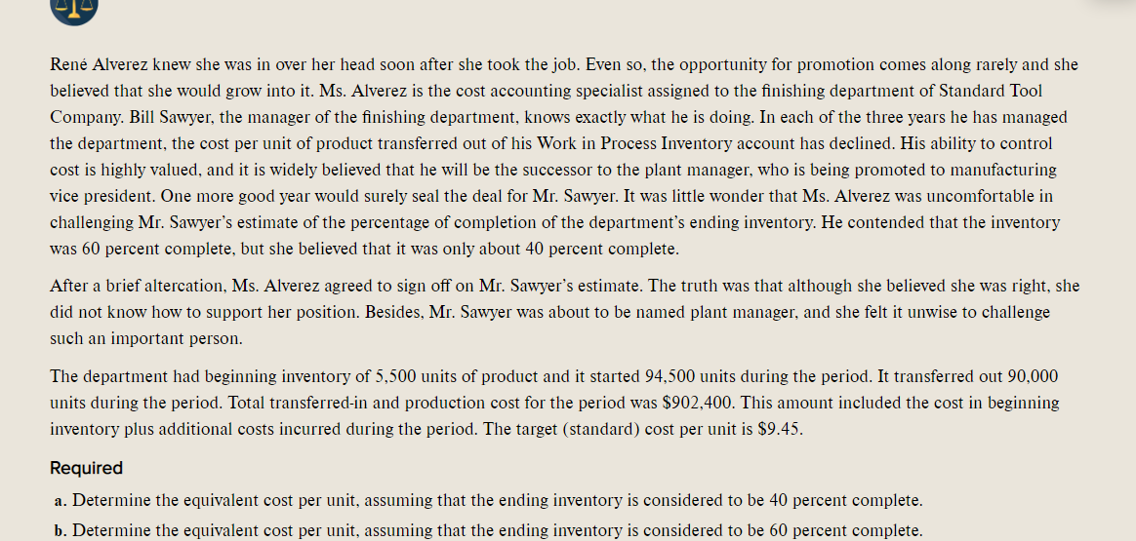
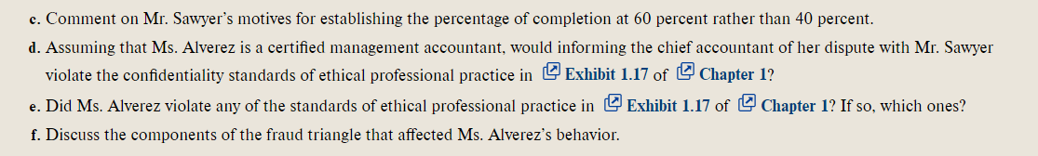
- Compute the equivalent cost per unit, assuming the ending inventory is considered to be 40 percent complete.
- Compute the equivalent cost per unit, assuming the ending inventory is considered to be 60 percent complete.
Write a 350-word summary of your calculations and findings. Comment on Mr. Sawyer’s motives for establishing the percentage of completion at 60 percent rather than 40 percent.

