MBA 6100 Fall 2020 Block 1
Case Study #1 – CVP Analysis

NTM Corporation was formed on January 1, 2016 and the company has been growing steadily since inception. The Chief Financial Officer, Myrna Snowflake, has hired you to perform some cost-volumeprofit analysis to determine what changes can be made to increase profitability. She has provided you with the following traditional income statement for 2019.

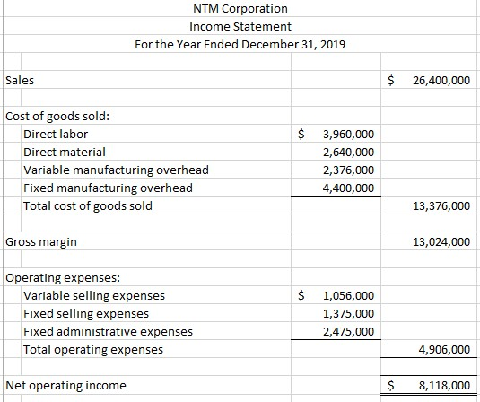

Total sales volume for 2019 was 550,000 units. The relevant range for NTM Corporation is 400,000 – 700,000 units.

Requirements:

- Prepare a contribution format income statement for 2019. Calculate the break-even sales dollars and the break-even sales units.
- The Production Manager believes that by using a lower quality material, the cost of direct material can be reduced by 10% per unit. While he doesn’t expect the change in material quality to be readily apparent, he believes that customers will overlook any change in quality if the product has a lower sales price. He believes that by lowering the sales price by $1.25 per
unit, there will be a 7% increase in sales volume. Prepare a contribution format income statement for this alternative. Calculate the break-even sales dollars and the break-even sales units.
- The Quality Control Manager does not agree with the Production Manager’s suggestion and has a different idea. He believes that an additional piece of equipment can be purchased. The new piece of equipment will allow the company to decrease Direct Labor to 12.5% of Sales. The new piece of equipment will increase fixed costs by $400,000 per year. The Quality Control Manager also believes an increased marketing effort will lead to additional sales volume. He has proposed spending an additional $9,000 per month on advertising which he believes will lead to an increase in sales volume of 2%. Coupled with an increase in sales price per unit of $0.75, the company should see increase profitability. Prepare a contribution format income statement for this alternative. Calculate the break-even sales dollars and the break-even sales units.
- The Sales Manager also believes that an additional piece of equipment is the answer to increased profitability. She agrees with the Quality Control Manager that a new piece of manufacturing equipment can lead to cost savings. She has located a similar piece of equipment to that suggested by the Quality Control Manager but at a cost of $350,000. The Sales Manager believes that a decrease in sales price of $5.25 per unit will increase sales volume by 7.25%. In addition, she believes the new piece of equipment will allow the company to eliminate some direct labor which will change the revised direct labor percentage to be 10% of sales. With the decrease in direct labor necessary to produce the merchandise, she is proposing laying off three manufacturing managers for a total savings of $400,000. She also believes a change in the Sales Department is necessary and has proposed eliminating all sales commissions and other variable selling costs so that variable selling costs will be totally eliminated but sales salaries will be increased by $80,000 per year. Prepare a contribution format income statement for this alternative. Calculate the break-even sales dollars and the break-even sales units.
- Prepare a memo to the Chief Financial Officer summarizing the results of your analysis and your recommendation for the best plan for the company. Include specific financial information from your analysis. Also include any non-financial information that was part of your decision making process.

Usual errors with case study:
• Incorrect formatting. Single and double underlines should be used correctly and dollar signs should be used at the top of a column of numbers, at the grand total level, and possibly at the subtotal level (based on your preference).
• Not including a column for percentage of sales.
• Not utilizing Excel to the fullest extent possible. All calculations should be entered as a formula in the desired cell in Excel. All subtotals and totals should be entered as a formula. I set up a third column in my original contribution margin schedule with per unit cost. I then used my original contribution schedule as the reference point for my proposed amounts.
• Combining amounts into general categories. Each expense should be listed on a separate row on the income statement. You may want to include a separate row for the new equipment purchase proposed by the Quality Control Manager and Sales Manager.
• Poorly prepared memo in terms of both content and presentation. The memo should be prepared in a professional format. Your memo should be easy to read (i.e. - not typed on one long line in Excel). Proofread your memo. See the following website for how to format a professional memo: https://owl.english.purdue.edu/owl/resource/590/04/

Other Info
• You cannot submit an identical or nearly identical case to that of another student, I will consider this as not being completed by an individual and your grade will be adjusted accordingly.
• The submission is to be one Excel file including the memo. You can type your memo in Word and copy it into your Excel spreadsheet or type the text submission directly into a text box in Excel. Each of the three alternate proposals should be considered independently of the other two proposals. All parts should be included on one Excel sheet.
• If any calculations are required, they must be shown. This is done by entering your calculation as a formula in Excel. I will be able to review the Excel formulas in your worksheet.
• Utilize Excel formulas and functions to the fullest extent possible.
• Do not round your dollar amounts but display all dollar amounts to the nearest dollar.
• Formatting counts. I have included examples of properly formatted financial schedules in the Week 3 Readings and Resources folder. There are also examples of contribution format income statements in the text, including in the Solution to Review Problem 2 at the end of Chapter 1. You must list all expenses on separate lines on your income statements. Do not combine expense amounts into general categories (for example, cost of goods sold or variable and fixed). Your income statement should include a column for total dollars and a column for percent of sales.
• The case study answers must be clearly marked and easy to follow.
• The memo portion of your case will receive the greatest value in the “Correct Answers” portion of the case study rubric. There is no one correct answer for the memo. You are being evaluated on your ability to communicate effectively in writing.

