MARKETING PLAN PROJECT
In this assignment, you'll take a closer look at the marketing environment in which your company operates. Six specific areas to examine are: competitors, the economy, political forces, legal and regulatory forces, technology, and sociocultural forces, all of which affect the marketing plan you're developing. You'll also consider the role of social responsibility and ethics in your marketing plan.
- Your first step in analyzing the marketing environment is to examine the competition. What brands and products compete with yours? How strong are these competitors, and what weaknesses do you see? Does your industry have only one competitor (a monopoly) because there are no close product substitutes or because of barriers to market entry? Does your industry have a few competitors with some barriers to entry (an oligopoly)? Or does your industry have many competitors and a lot of product differentiation (monopolistic competition)? How much of a role does competitive pricing play in your market(s)? Identify two specific competitors, and look at their strengths and weaknesses. What are the implications for your competitive strategy? Write two paragraphs about competition and the specific rivals you plan to monitor.

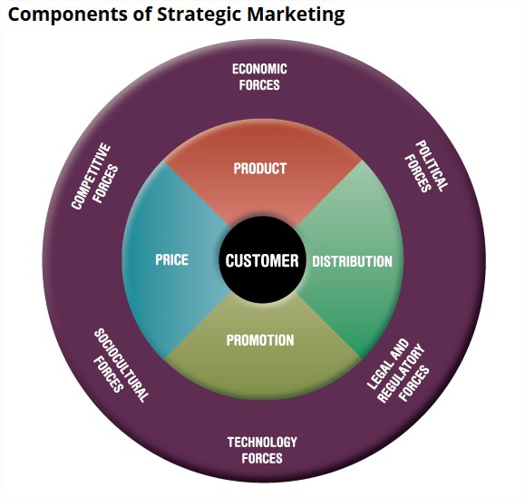

- Next, research the economic conditions in the market where you will sell and the market where you will buy supplies or services. Identify the point in the business cycle where these economies appear to be. Do economic conditions constitute an opportunity or a threat? Then determine how much buying power customers are likely to have once they have access to your product—and how willing they will be to make purchases. What changes in the local, national, or international economic situation could affect your marketing performance, and in what ways? Write one or two paragraphs about the current economic situation, not just in your specific business location(s) but also in the broader economic context.

- Political forces are another key aspect of the environment to analyze. Pay close attention to the current political situation in the geographic area(s) where your product will be created and marketed. Think about the ways in which politics might affect the design and production of your good or service, the way you promote the product, how the product is transported and distributed, and your pricing decisions. Identify at least two elements of the political situation that you must understand to successfully put your marketing plan into action. Write a paragraph about these political factors and the overall political situation in the areas where your plan will be implemented.

- Find out how local, state, or federal laws and regulations might affect your ability to achieve your marketing objectives. Search the Internet to find at least two federal laws that apply to your product (such as the Nutritional Labeling and Education Act, if you're marketing a food product). Look for a state or local law or regulation that applies to your product, such as needing a license to provide a certain type of service. Finally, conduct a search to see whether any new laws and regulations—or major legal and regulatory changes—are in the works. Write a paragraph about the legal and regulatory climate for your product, including the possible effect on your marketing plan.

- Within the technological environment, what are the key trends that could be positive or negative for your product? What new technologies are emerging that could influence your ability to implement your marketing plan? Are any new technologies expected to make competitive products obsolete or make it easier for customers to buy and use your product? Write a paragraph about how technology can help you to pursue opportunities or fend off threats, develop products, connect with stakeholders, compete more effectively, or otherwise affect your marketing plan.

- Sociocultural forces are one final set of forces you'll need to analyze within the marketing environment. How will demographic and diversity characteristics such as age, gender, ethnicity, income, and family composition affect your customers, their needs, and their buying patterns? What about the effect of cultural values on your marketing plan (such as the importance of nutrition and exercise or increased interest in earth-friendly products)? What changes occurring now (or projected for the near future) should you consider as you plan? Write a paragraph about the key sociocultural forces that affect your customers, your market(s), and your product.

- Now it's time to focus on social responsibility and ethics. What social responsibility issues are important for your product and your stakeholders (such as working with suppliers that don't hire children or using earth-friendly materials)? What are competitors doing about these issues? How can you address these issues in your marketing plan? What ethical issues have emerged in your industry or have been linked to products like yours (such as questionable pricing practices)? Are there any potential conflicts of interest you must avoid? Write one or two paragraphs about how you plan to deal with ethics and social responsibility.

- Optional, as your instructor directs: In a team or individually, explore what two of your product's competitors are doing to demonstrate social responsibility. For example, are they promoting “green” products or supporting efforts to reduce poverty? How do these competitors communicate about their social responsibility actions? Based on what you find out, which of these two competitors appears to have the most powerful stakeholder appeal on the basis of social responsibility? What lesson(s) can you learn from these competitors to strengthen your marketing plan? Draft a paragraph or plan a brief (three-minute) presentation explaining your ideas, with specific examples from the competitors you studied.

- BUILDING YOUR MARKETING PLAN: Transfer your answers to Questions #1 through 7 to the Marketing Plan document you previously created, inserting them within the “Environmental Analysis” section. If you've identified any particularly challenging or particularly favorable environmental factors, note the highlights in your “Executive Summary.” Continue to save your work so you can expand and revise your plan later, and upload your Marketing Plan below.

