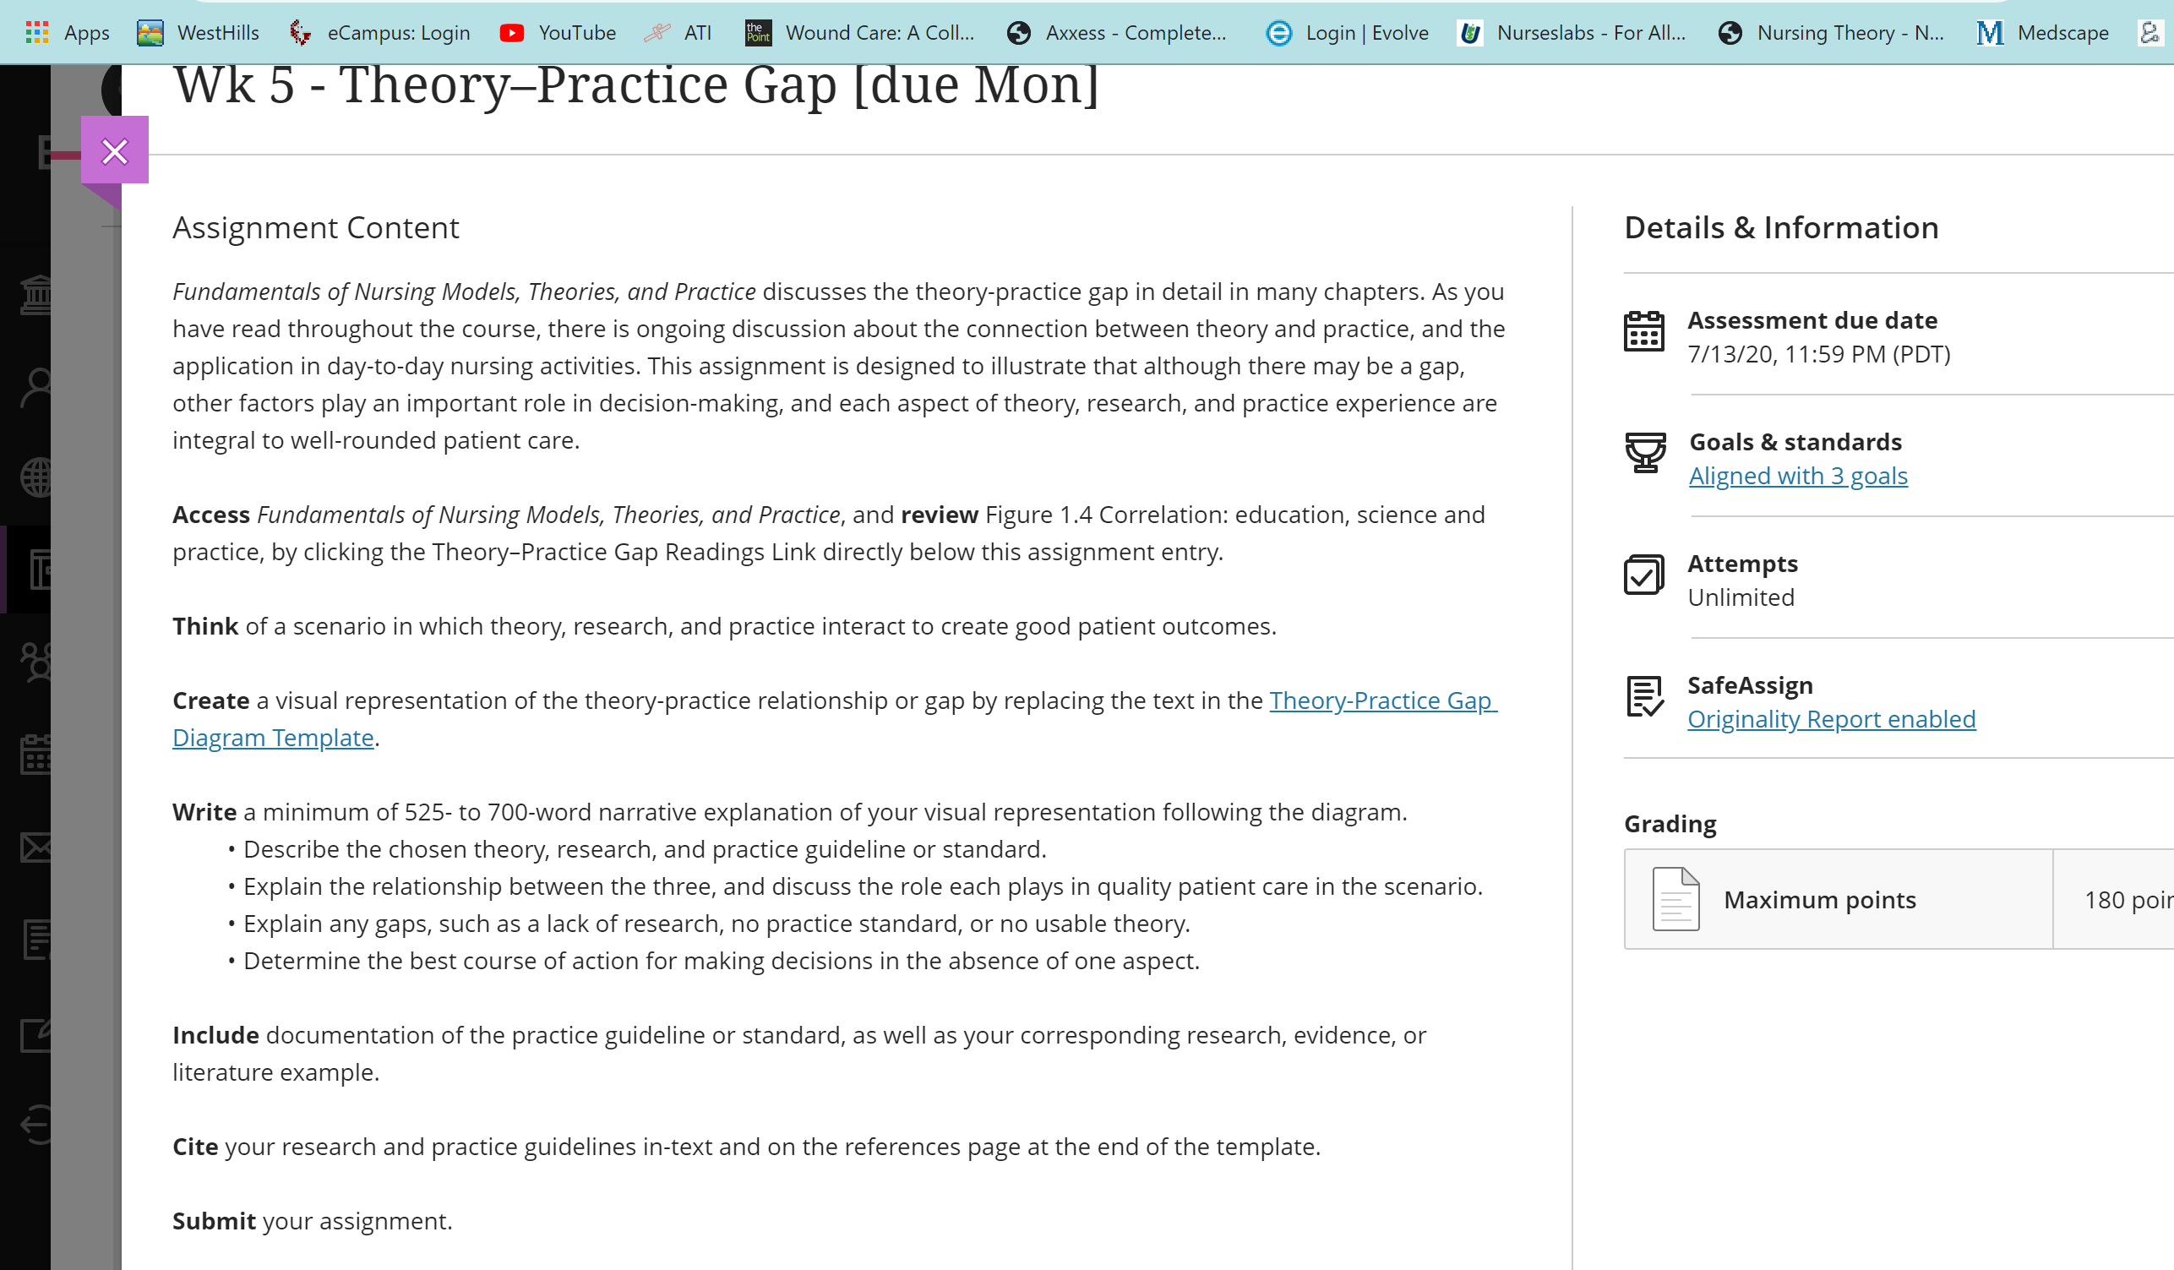

Hello Mr Boniface…
This is my last assignment, thank you for getting me thru class. I’m hoping that you complete this for me. It’s different from the previous, but hopefully my last one at least for a while.
Here below is the example of the visual representation template she wants. From the link above: Theory-Practice Gap Diagram Template. But before you view it. There are a few discussion points each student inputs in class. I am inserting 3 more relevant that might help piece out the project. Thank you again!
- I do believe that theory pratice gap is present in just about every setting of nursing practice and there are many reasons why that's happening. First of all, the generational gap; nurses who work for many years, were schooled differently. They apply the theory they learned but have a great ammount of experience, so they will use an analytical mix of theory and practice accumulated along the years. Another contributing factor might be the personal beliefs and views about life, the personal philosophy that gets transfered in our work consciously or subconsciously. For example, when one is in the situation to save a patient by administering blood, but the patient declines for religoius reasons; that would be a situation of great distress for a nurse who's beliefs are different. For example, the article bellow is informative of how one nurse couldn't handle seeing the patient dying and acted upon her personal beliefs by administering blood; it was classified as batery.(1) Furthermore, every one of us has a natural disposition a certain kind of temperament: some of us are very focused and analytical and apply theory and skills by the book while others will be detail oriented and look beyond the theory and practice and modify practice according to what they find works the best. While volunteering at NICU I encountered an example of such discrepancy. I was trying to bottle feed a newborn holding the baby in varied positions as I was instructed; my efforts were futile. Several nurses tried to feed the child as well, with not much luck. Afterwards, I asked one of the older nurses to help; she held the baby on her knees, positioning the child with the head slightly lower than the body. I was mortified thinkig the child will get sick and throw up even the tiny bit of the food she ate ... but she realxed and started eating just fine. Afterwards, the nurse said: "this is not something I learned from books, I just figured it out on my own". It is hard to define where practice and theory gap; it's more important to remember we need theory to support our actions but also need to use common sense and intuition when applying them. I think the following citation from the recommended reading is relevant: "Nurses need to embrace theory and learn what it can do for patient care. EBP and “high tech” does not absolve us from doing the right thing in being compassionate and caring with patients. Do not be pacified into one over the other; let us hold on to nursing theory while accepting EBP as a model from medicine". ----Discussion from student

- Theory is a tool to guide us in our actual practice, Since we operate in "real-time" situations, the application of theory will gap during our practice as we attend to each scenario uniquely and rationally. This happens all the time, all day long in the Emergency department when life threatening events are constantly walking through the door. It is when the knowledge of "know-that" eventually connects with the knowledge of "Know-how", that's when we beginning to really see the theory-practice gap alive and doing well, for the most part. Marrs and Lowry find that the journey from practice resulting in a theory-practice disconnect is due partly in the conceptual models for education and practice which is contributed to defining a unique nursing perspectives that are useful in practice settings (2006). "Since nursing is a practice discipline, it is logical that situation-producing theory be given the greatest consideration because it will guide actions that have an impact on reality." (Marrs and Lowry, 2006) That being said, Yes, theory-practice exists. "Utilizing a multitude of methods for knowledge development, including inductive approaches, could enhance the progress of nursing knowledge devopment as long as connections to theoretical knowledge are mad explicit." (Marrs and Lowry, 2006) --- Discussion from student

- Theory is a tool to guide us in our actual practice, Since we operate in "real-time" situations, the application of theory will gap during our practice as we attend to each scenario uniquely and rationally. This happens all the time, all day long in the Emergency department when life threatening events are constantly walking through the door. It is when the knowledge of "know-that" eventually connects with the knowledge of "Know-how", that's when we beginning to really see the theory-practice gap alive and doing well, for the most part. Marrs and Lowry find that the journey from practice resulting in a theory-practice disconnect is due partly in the conceptual models for education and practice which is contributed to defining a unique nursing perspectives that are useful in practice settings (2006). "Since nursing is a practice discipline, it is logical that situation-producing theory be given the greatest consideration because it will guide actions that have an impact on reality." (Marrs and Lowry, 2006) That being said, Yes, theory-practice exists. "Utilizing a multitude of methods for knowledge development, including inductive approaches, could enhance the progress of nursing knowledge devopment as long as connections to theoretical knowledge are mad explicit." (Marrs and Lowry, 2006)
Also a student ask for clarification of the assignment, I will include to see if it helps. Let me know if it is something you are able to do. Thank you.
“
“Related to this week's assignment, I am a little bit unsure of how to go about it. Do I need to use a clinical scenario and apply the nursing theory/gap to that situation or I need to look up various theories and how they connect/or not with practice.
Answer from instructor: Thank you for asking for clarification. For this week’s assignment you will think about a theory you like. Then show the research that supports the theory and how the research is accepted—the science behind the theory. Then demonstrate how you can use in practice.

For example. I like Orem's self-care deficit theory (theory). (Research) supports the theory--findings indicate better patient outcomes when patients are as independent in their care as possible. Therefore, the (science) is the “research support” for assisting patients to be independent—which in Orem’s case is assisting with their deficits. This impacts my (nursing practice)---for ex---if I care for a new diabetic patient I may teach them about how to perform a finger stick and then encourage him/her to perform. I don’t want to keep doing the stick—allowing the patient to be dependent on me as the nurse, etc.

University of Phoenix Material

Theory–Practice Gap

The book discusses the theory-practice gap in detail in many chapters. As you’ve read throughout the course, there is ongoing discussion about the connection between theory and practice and the application in day-to-day nursing activities. This assignment is designed to illustrate that although there may be a gap, other factors play an important role in decision making and each aspect of theory, research, and practice experience are integral to well-rounded patient care.

Return to the classroom to review Figure 1.4 from Fundamentals of Nursing Models, Theories, and Practice.

Think of a scenario in which theory, research, and practice interact to create a good patient outcomes.

Create a visual representation of your theory-practice relationship or gap using the diagram below by replacing the text in each box below to illustrate your scenario.

Note: Use names, citiations, or brief explanations only. The narrative summary should include desciptions and more detailed discussion about each concept in the scenario.

Theory
Research
Science
Nursing Practice

Here, write a 525- to 700-word narrative explanation of your visual representation in APA format. Your explanation should:

- Describe the chosen theory, research, and practice guideline or standard
- Explain the relationship between the three and discuss the role each aspect plays in quality patient care in the scenario
- Explain any gaps (a lack of research, no practice standard, or no useable theory)
- Determine the best course of action for making decisions in the absence of one aspect

Cite your research and practice guidelines in-text and in the references section of this document.

References

