Complete the Assignment Checklist. Check off items that you have in inventory.

* **For items that are not applicable to you and your living situation, please write N/A (not applicable) in the space, otherwise it will be counted as incomplete.**﻿
* Remember to **protect personal information** by using pseudonyms, or by providing only partial information
  + ​Ex: Sister: Britley *****, phone: 724-***-****, email: b********@yahoo.com

Review the rubric for more information on how the assignment will be graded.

Please note: You are **not** required to purchase any items on this list, however, take note of the items you are missing and consider how it could impact your safety and survival in a disaster.

**My Family’s Disaster Plan**

Learn about the natural disasters that could occur in your community and how you can respond to them. Provide at least two references and sources of information. Use APA Style for your reference.

**Possible hazards in my area:**

1. **Hurricanes**: Hurricane season begins on June 1st to November 30th (Miami Dade County, 2020) One should monitor radio or television for weather updates and instructions from public safety officials, stay indoors, preferably in a room without windows. Use flashlights and not candles or kerosene lamps, listen to advisories from local law enforcement agencies regarding roadways and bridges being locked down. (Miami Dade County, 2020) Residents that are impacted by a hurricane may register for FEMA assistance at the DisasterAssistance.gov.

2. **Tropical Storms:** Stay inside and away from any window, skylight, or any glass floors. Be sure to find safe area in the home. Do not go outside. (Hurricanes: Science and Society, n.d)

3. **Flooding**: If there is a threat of flooding at home, turn off any electricity at the main breaker. (Hurricanes: Science and Society, n.d) It is important to be careful when driving during a flooding situation, always keep in mind that 6in. of standing water is enough to stall some cars and just one foot of water can float a vehicle and two feet of moving waters is enough to sweep a car away. (Flood preparedness and response, 2019)

**Emergency Phone Numbers**

(Program these into all phones and post in a common area in the home.)

* Police department: (305) 418 7200, Dade County Police Department 1701 NW 87 Ave. Doral, FL 33172
* Fire department: (786) 331-5000, MDFR Firehouse 47 9361 SW 24th St. Miami, FL 33165
* Local emergency services: (305) 630-7900, Town & Country Emergency Room 11800 Sherry Ln., Miami, FL 33183
* Healthcare provider(s): (305) 669-0690, Miami Medical Consultants 4950 S Le Jeune Rd., Coral Gables, FL 33133
* Local American Red Cross: (305) 644- 1200, American Red Cross Greater Keys 335 SW 27th Ave. Miami, FL 33145
* Poison Help: 1-800-222-1212
* Other local emergency personnel numbers: 1800-621-FEMA (3362)

**Employers and School Officials Contacts**

I know the emergency response plans for employers and schools. __X___

**School:**

Address: West Coast University. 9250 NW 36TH St. Doral, FL

Phone: (786) 501- 7070

Contact name: Adiela Naranjo

|  |  |  |
| --- | --- | --- |
| **Child** | **Day Care/School** | **Phone #** |
| N/A | N/A | N/A |
| N/A | N/A | N/A |
| N/A | N/A | N/A |

**Employer:**

Address: 9250 NW 36 St. Doral, FL

Phone: (786) 501- 7051 Ext. 48***

Contact name: Adiela Naranjo

**Family Communication Plan**

Prepare a family communication plan so that each member of the family can contact one another quickly.

* Everyone has a cell phone or calling card __YES___
* Young children know how to call (numbers are saved) __N/A____

|  |  |  |  |
| --- | --- | --- | --- |
| **Name** | **Contact Name** | **Phone** | **Email** |
| Iv** Os**** | Ivan | (305) 346- **** | Iva*****@hotmail.com |
| Dey*** Re**** | Deya | (786) 262- **** | Dey*****@gmail.com |
| Car*** Rod**** | Carlos | (786) 344- *** | Car******@hotmail.com |

**Identify two meeting places for your family in the event that you are separated.**

**Near your home:** Baptist Hospital

Location: Miami, FL

Address: 8900 N Kendall Dr.

Phone: (786) 596- 1960

**Away from your home (in the event you cannot return home):**

Location: South Miami Hospital

Address: 6856 SW 53 Street

Phone: (305) 666- 5871

**Draw a floor plan of your home and attach it to your submission; mark two escape routes from each room.** ______

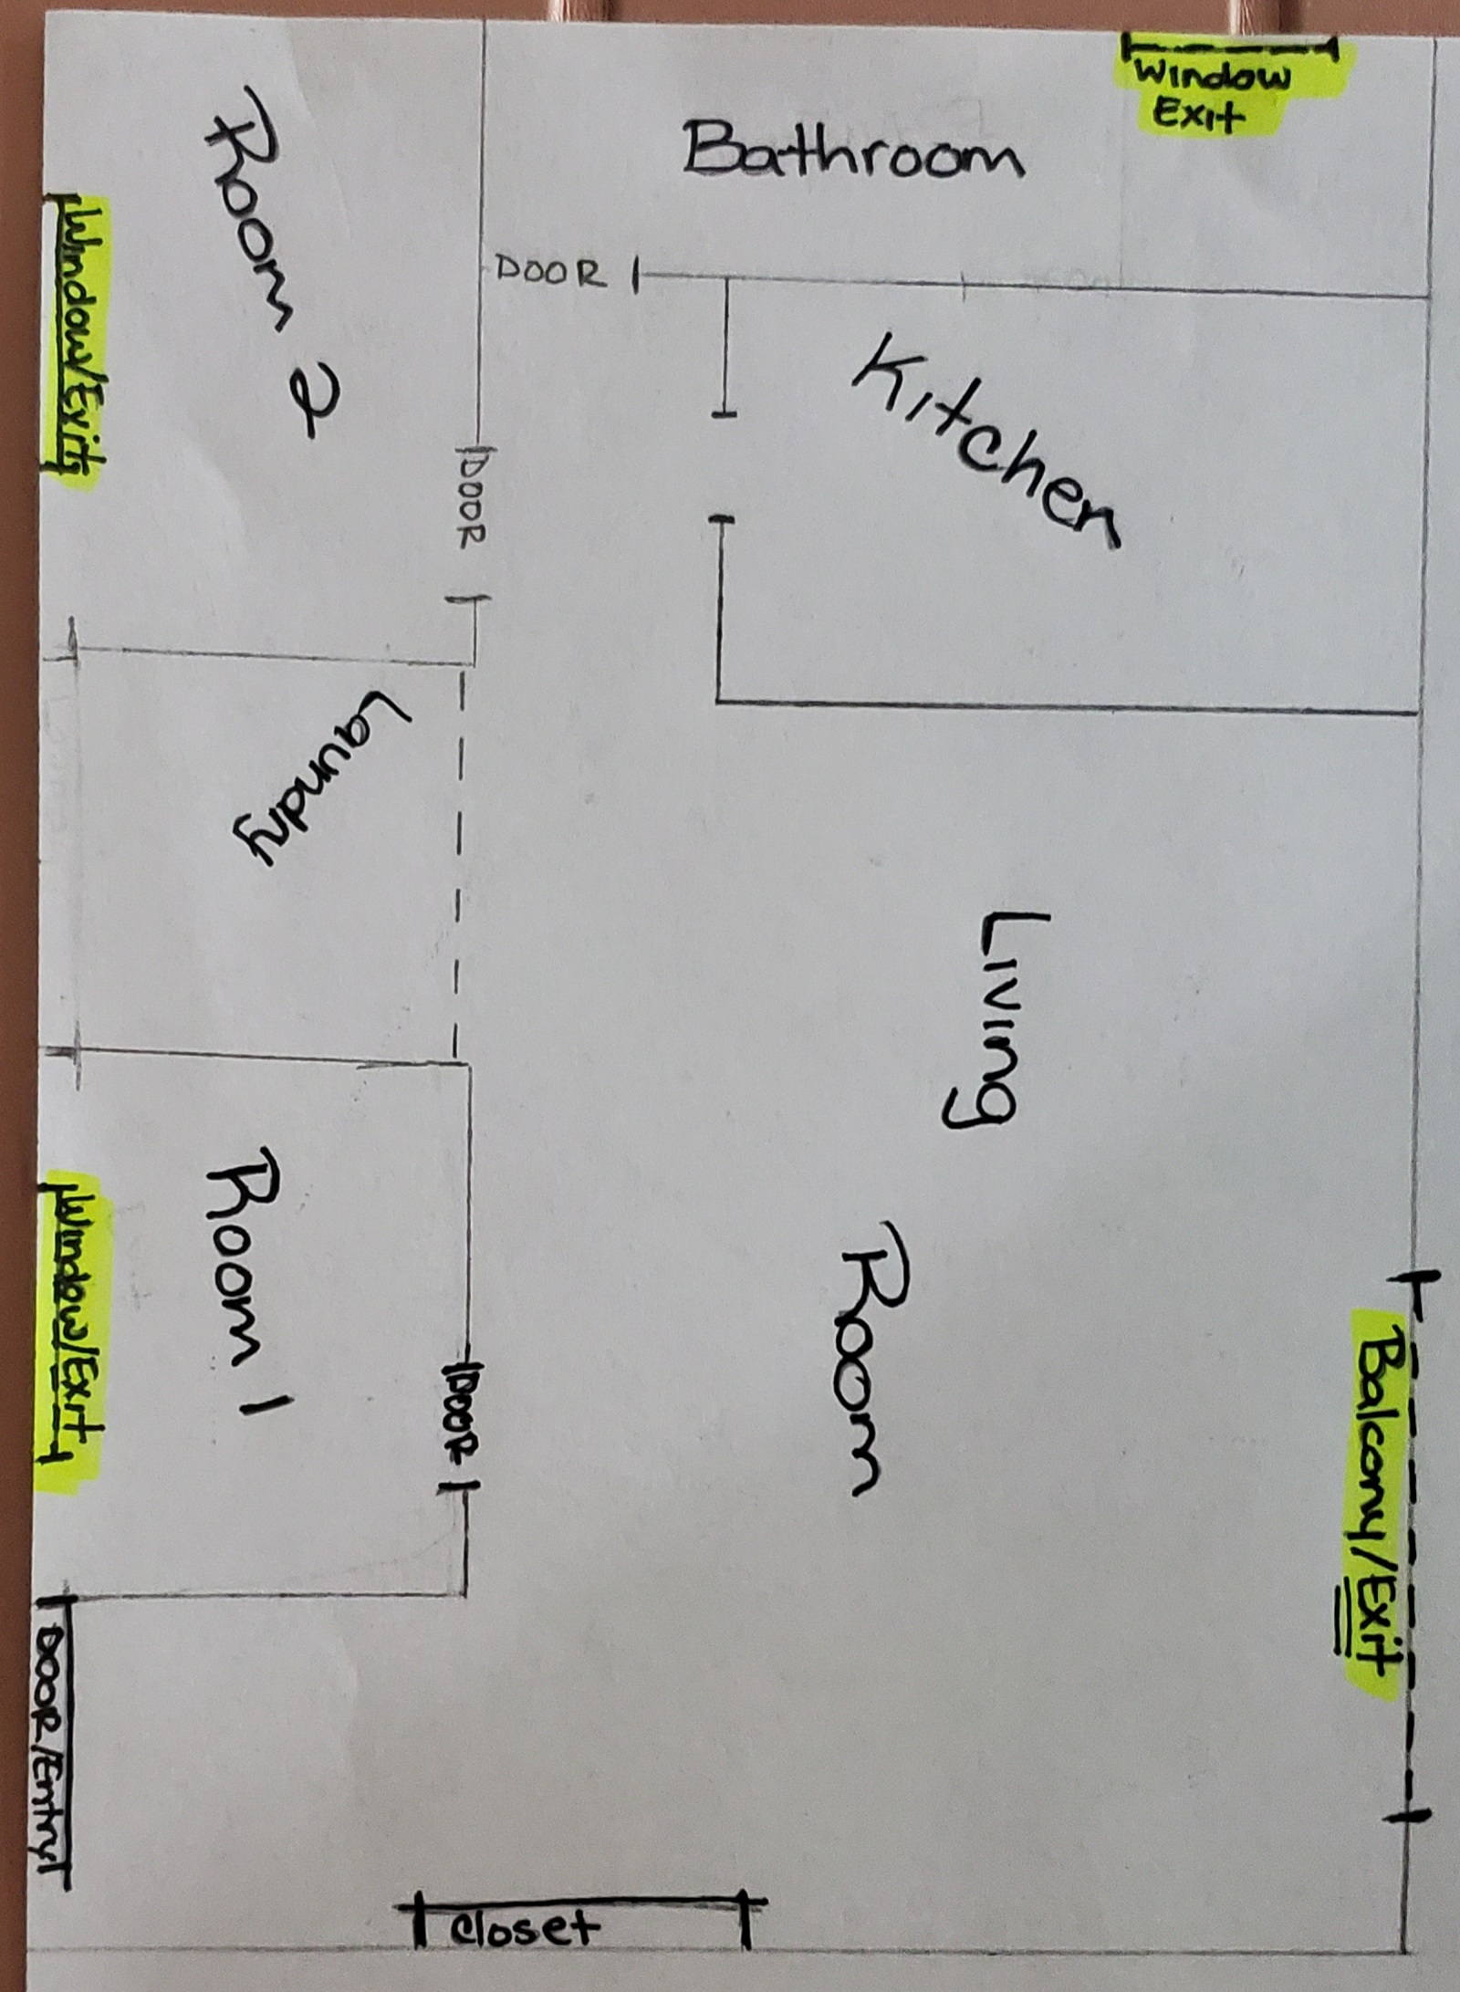

**Pick a friend or relative who lives out of the area for household members to call/email to say they are okay.**

Name: Nelc** Coi***

Phone: (786) 422-3953

Email: [Nelc****@gmail.com](mailto:Nelc****@gmail.com)

**Everyone in the house knows how and when to shut off utilities. ___X___**

|  |  |  |
| --- | --- | --- |
| **Utility Name** | **Number** | **Shut-Off Location/Main Controls** |
| Electric | 1 | Main Hallway |
| Water | 3 | Main Hallway |
| Gas | N/A | N/A |

**Evacuation Plan and Transportation**

Extra gallon of gas __N/A____

Local government resource ___N/A___

Contact person/agency: N/A

Address: N/A

Phone: N/A

**Certifications**

Stay current and up to date (e.g., CPR, ACLS, PALS, TNCC).

* Certification #1: CPR
* Date of Completion/renewal: 06/2020
* Certification #2: BLS
* Date of Completion/renewal: 06/2020

**Property, Health, and Financial Well-being**

Review property insurance policies for disaster policies. __N/A____

Current __N/A____

Appropriate to needs __N/A____

Review life-insurance policies. __N/A____

Current _N/A_____

Appropriate to needs _N/A_____

Review health insurance policies. _N/A_____

Current _N/A_____

Appropriate to needs _N/A_____

Review financial documents. __YES____

Emergency savings $_4000_____

Easily accessible, small cash savings $ _700__

**Important Documents and Items Secured**

Make sure you have copies of important documents and items that can be stored in a fireproof watertight container.

|  |  |
| --- | --- |
| **Important Items** | **Check off Photocopied Items That are Safely Stored** |
| Personal identification | X |
| Cash and coins | X |
| Credit card(s) | X |
| Extra set of house keys and car keys | X |
| Birth certificate | X |
| Marriage certificate | X |
| Driver’s license | X |
| Social Security card | X |
| Passport/visa | X |
| Wills | N/A |
| Deeds | N/A |
| Inventory of household goods (with photos & serial numbers) | X |
| Insurance papers | X |
| Immunization records   * Allergies * Medications | X |
| Bank and credit card numbers | X |
| Stock/bonds | N/A |
| Emergency contact list (phone/address/email) | X |
| Local map and emergency shelter locations | X |
| Pet information | N/A |

**Consider ways to help neighbors who may need special assistance (ESL/medical/living alone).**

|  |  |  |  |
| --- | --- | --- | --- |
| **Name** | **Special Help Needed** | **Address** | **Phone** |
| Fran***** | Hearing Aid | 10315 SW 24 ST. Miami, FL 33165 | (305) 599-**** |
| Salo***** | N/A | 15878 SW 69 Ln. Miami, FL 33193 | (305) 654- **** |

**Pet Arrangements: N/A**

As per local and state health and safety regulations, pets are not permitted in some shelters such as American Red Cross shelters. Service animals are permitted.

**Name of shelter vet:**

Address: N/A

Phone: N/A

**Names of pet friendly hotels/motels or friends/family out of the area:**

Name: Iler*** Osp***

Address: 401* SW 25 ** Miami, FL 33165  
Phone: (305) 785-****

Name: Hilton Garden Inn Miami Dolphin Mall

Address: 1695 NW 111 Ave. Ste# A. Doral, FL 33172  
Phone: (305) 500- 9077

Name: NUVO Suites Hotel

Address: 1750 NW 107 Ave. Doral, FL 33172  
Phone: (786) 472- 9095

**Special Needs Assistance**

Special needs assistance organization in community.

Name: Be Unique Academy

Address: 11025 SW 84 St. Cottage#16.

Phone: (786) 856- 6217

**Register with local office of emergency services or fire department.**

Name: MDFR Firehouse 47

Address: 9361 SW 24 St. Miami, FL 33165

Phone: (786) 331- 5000

**Create a network of neighbors, friends, relatives, coworkers to aid you in an emergency _____**

* Mobility escape chair in place _N/A____
* High-rise/apartment arrangements for emergency evacuation _N/A__
* Extra wheelchair batteries, oxygen, catheters, medications, food for service animals _N/A___
* Caregiver identification information __X___
* Medical bracelet, etc. _N/A____

**Disaster Supply Kit “Go Bag”**

You and your family may need to survive on your own for 3 days or more. Consider having additional supplies for up to two weeks confinement or shelter. You should prepare emergency supplies for the following situations:

**Go Bags**

Home: Make sure all family members know where the go bags are and have access them. _YES____

Specific go bags:

Pet go bag _N/A____

Child go bag with special items for feeling safe and staying occupied _YES_

Car: 3-day supplies included with emergency roadside equipment _YES____

Work go bag _YES_

**Water Supplies**

Stocking water supplies should be a top priority. Drinking water in emergency situations should not be rationed. It is critical to store adequate amounts of water for your household. Check off the supplies you have on hand and indicate the date the supply needs to be refreshed.

* Two quarts of water daily for drinking for each person in household. _YES_
* Extra two quarts of water daily for children, nursing mothers, and those who are ill and need more. _YES_
* One gallon/week supply of water stored for sanitary and cooking needs for household. _YES_

Change water every 6 months.

* Update water supplies _11/24/2020___ (date)

***Safety Tip*: Water Storage and Collection in an Emergency**

* Do not store in glass containers or other containers that can break.
* Do not rely on untested devices for decontaminating water.
* If you have a well or public water, follow treatment methods provided by your public health service or water provider.
* Store water in a cool, dark place.

**Food: Preparing and Emergency Supply**

Food, unlike water may be rationed except for children and pregnant women. No special food needed. Keep canned foods and dry mixes stocked. Replenish food supplies every 6 months. Use and replace. Store newer items in the back, older items in front.

Stock high energy protein foods in go bags:

Peanut butter _YES___

Trail mix _YES__

Granola bars _N/A__

Peanuts _N/A__

Hard candy _N/A__

Boxed juices _YES__

Powdered milk _N/A__

Dry fruits_YES__

Keep infant foods and special diet foods in supply. _N/A_

**First Aid Supplies**

Assemble a first aid kit for your home **and** each vehicle. __YES__

Check off all of the basic items you have and list additional specialty items you have on hand:

First aid manual _N/A__

Sterile adhesive bandages, assorted sizes _YES_

Safety pins assorted sizes _YES_

Cleansing agents _YES__

Antibiotic ointment _YES__

Latex gloves (2 pair) _YES__

Petroleum jelly or other lubricant _YES_

2-inch and 4-inch sterile gauze pads (4 to 6 of each) _YES__

Triangular bandages (3) _N/A___

Sunscreen_YES_

Scissors_YES__

2-inch and 3-inch sterile roller bandages (3 rolls each) _N/A__

Tweezers _YES_

Needle_N/A__

Moistened towelettes _N/A__

Antiseptic _N/A__

Thermometer _YES__

Tongue depressor blades (2) _N/A__

Prescription medication list (ask your pharmacist about storing prescription medications) _N/A___

Extra pair or prescription eye glasses or contacts_N/A___

Nonprescription drugs:

Aspirin and non—aspirin pain relievers _N/A__

Antidiarrheal medication _YES___

Antacid_YES__

Laxative_N/A__

Vitamins_YES__

Syrup of ipecac _N/A___

**Tools and Emergency Supplies**

Assemble these items in a disaster supply kit in case you need to leave quickly.

Check off all of the basic items you have and list additional specialty items you have on hand.

**Tools**

Portable, battery-powered radio, TV, alarm clock _N/A_____

Flashlight and extra batteries _YES___

Signal flare _­N/A___

Matches in a waterproof container _N/A___

Shut-off wrench, pliers, shovel, hammer, screwdriver, and other tools _YES__

Duct tape and scissors _YES__

Plastic sheeting _N/A___

Whistle _N/A___

A-B-C fire extinguisher _N/A___

Tube tent _N/A___

Compass _N/A___

Work gloves _N/A___

Paper, pen, pencils _YES___

Needles and thread _N/A___

**Sanitation and Hygiene**

Washcloth and towel _YES__

Towelletes, soap, hand sanitizer, liquid detergent __YES__

Toiletries _YES___

Heavy-duty plastic garbage bags _YES__

Medium--sized plastic bucket with tight lid and small shovel for digging a latrine _N/A__

Disinfectant and household chlorine bleach _YES___

**Kitchen Items**

Manual can opener _YES___

Mess kits or paper cups, plates, plastic utensils _YES__

All-purpose knife _YES__

A dropper (eye dropper) with measurements _N/A___

Liquid bleach to treat water _YES___

Only use regular, unscented chlorine bleach products that are suitable for disinfection and sanitization as indicated on the label. The label may say that the active ingredient contains 6 or 8.25% of sodium hypochlorite. Do not use scented, color safe, or bleaches with added cleaners. If water is cloudy, let it settle and filter it through a clean cloth, paper towel, or coffee filter.

Sugar, salt, pepper _YES___

Aluminum foil, plastic wrap _YES__

Resealing plastic bags _YES__

If food must be cooked, a small camping stove and can of cooking fuel _N/A__

**Clothes and Bedding**

One complete change of clothes and footwear for each member of household. Shoes should be sturdy work shoes or boots. __YES__

Rain gear, hats and gloves, extra socks and underwear, thermal underwear, sunglasses. _YES__

Blankets or sleeping bag and pillows for each member. _N/A___

**Specialty Items as Needed For:**

The baby _N/A___

The elderly _N/A___

Pets _N/A__

**Other Items**

Add a list of additional items to include here. Review other disaster preparedness websites for items not included here. Check off items that you have and list items you need to acquire.

|  |  |
| --- | --- |
| **Item** | **Included** |
| Entertainment activities items like cards, volleyball, books | Need to buy |
| Phone chargers’ plug-ins and portables | Yes |
| Chap Stick | Yes |
|  |  |
|  |  |

References

Flood preparedness and response | Response/Recovery | Occupational safety and health administration. (2019, September 19). Occupational Safety and Health Administration. <https://www.osha.gov/dts/weather/flood/response.html>

Hurricanes: Science & Society. (n.d.). Hurricanes: Science and society: During a hurricane: How to be safe. Hurricanes: Science and Society: Home. <https://www.hurricanescience.org/society/risk/huricanesafety/>

Miami Dade County. (2020). Hurricane readiness guide. Untitled Document. <https://www.miamidade.gov/global/emergency/hurricane/home.page>