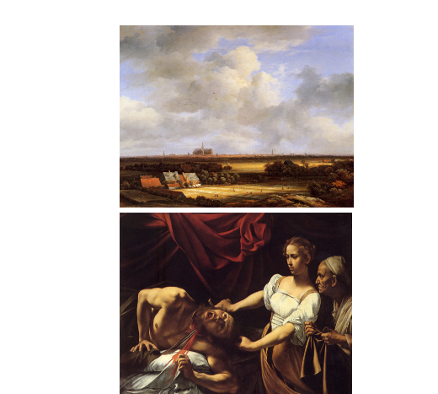

Light and Color / Caravaggio / Ruisdael
- Practice art terminology in group settings and class discussions.
- Compare and contrast the formal elements in selected artworks.
Compare and contrast the paintings by Caravaggio and Jacob van Ruisdael. Both of these artists painted during the Baroque period, but they used light in very different ways. Describe their similarities and differences using the following terms: tint, shade, chiaroscuro, sfumato, tenebrism, local color, saturation, and atmospheric perspective. The definitions for these terms are in the Light and Color modules; however, not every term listed above is relevant to these paintings.
You will write nine to ten complete sentences for your original comments.
Your comments are meaningless without descriptive writing. Describe how the techniques or styles effect the appearance of each painting. Describe the light and shadow of their paintings. Which artist used atmospheric perspective? Which artist used tenebrism? Use only the terms that best describe their paintings.
Do not use the words I, me, my, you or your.
I will start the conversation by giving you a little information about these two paintings; however, this information should not be repeated in your comments. The Baroque period spanned the years 1598 to 1675. The painting of Judith and Holofernes by Caravaggio was made at the beginning of the Baroque period around 1598. At that time Caravaggio became famous for inventing of the painting style known as tenebrism.
Ruisdael painted the View of Haarlem with Bleaching Grounds (page 470) at the end of the Baroque period around 1672. Can you identify the techniques he used to create the deep space in his painting? Watch the video about Ruisdael's painting below.

N.B. Student instruction:
After writing the original comment, please write two separate paragraphs with a minimum of five informative and constructive sentences each to support your original comment.

