Organizational Chart
Queenneidra Quarles
UOP
MGT/526
February 24, 2020

Apple Organizational Chart
As shown in the chart below, it is evident that Apple's organizational chart is a hierarchical structure. According to Lashinsky (2012), this structure was started by the founder and former CEO, the late Steve Jobs, to facilitate the realization of innovative ideas and vision for the organization. However, the structure has undergone a few changes that were facilitated by Tim Cook in a bid to embrace the aspect of decentralization of decision making to encourage creativity and innovation at different levels (Freedman & Vohr, 2009). However, it is evident that the structure is predominantly hierarchical with different management layers. The adherence to the structure has been facilitated by the need to manage the 132,000 employees effectively in that it allows tight control by the senior management to all the different aspects of the business.
This structure also presents various promotion opportunities that motivate employees to perform well since there are diverse levels of responsibility and authority. However, the company affects the flexibility of the organization to reflect its differences in the global market. The company’s Board of Directors is made up of eight members who have distinct leadership prowess that has been acquired from a wide range of industries. Three of the members act as CEOs while two of the members served as formers CEOs ad Chairman in global organizations. Others include the previous US Vice President Albert Gore Jr, Susan Wagner, the director and co-founder of BlackRock, and James A. Bell, the former Corporate President and CFO Boeing Company.

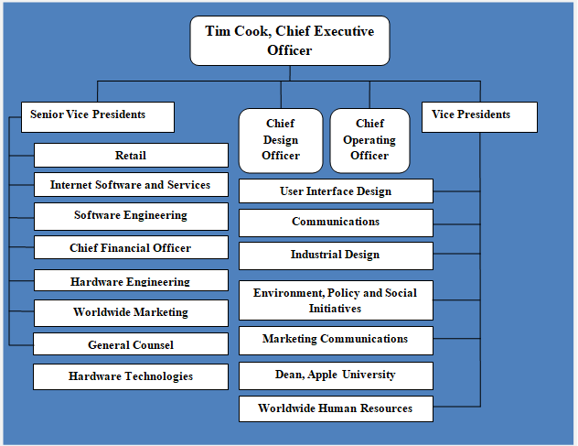
The chart above shows a hierarchy that prevents the levels lower in the structure to respond to business demands and market needs. For instance, the produce-based divisions should wait for instructions from the CEO among other top executives in order to implement changes that address market trends for different consumer electronics. However, the CEO, Tim Cook, has made deliberate efforts to increase collaboration amongst diverse levels of the organization, an aspect that increases the company's flexibility significantly. Nevertheless, the structure is not quick to respond to rapid changes since all aspects of the organization must be approved by the top management.

References
Freedman, R. D., & Vohr, J. (2009). Apple Computer, Inc. New York University, Leonard N. Stern School of Business. Last accessed, 16.
Lashinsky, A. (2012). Inside Apple: How America's most admired--and secretive--company really works. Hachette UK.

