Coming up with a Proposal is the first stage of your research. After your Proposal has been accepted, you will proceed on to write your First Draft . Writing your paper is about directing your own learning on a specific subject. The expected outcome is for you to understand the subject in sufficient depth so as to be able to explain it to your audience (your peers and the economics faculty) in a clear, precise, structured and self-contained manner. You are not writing for a general audience, but for a specialized one. They may also include hypothesis design and formation, and interpretation of data.​
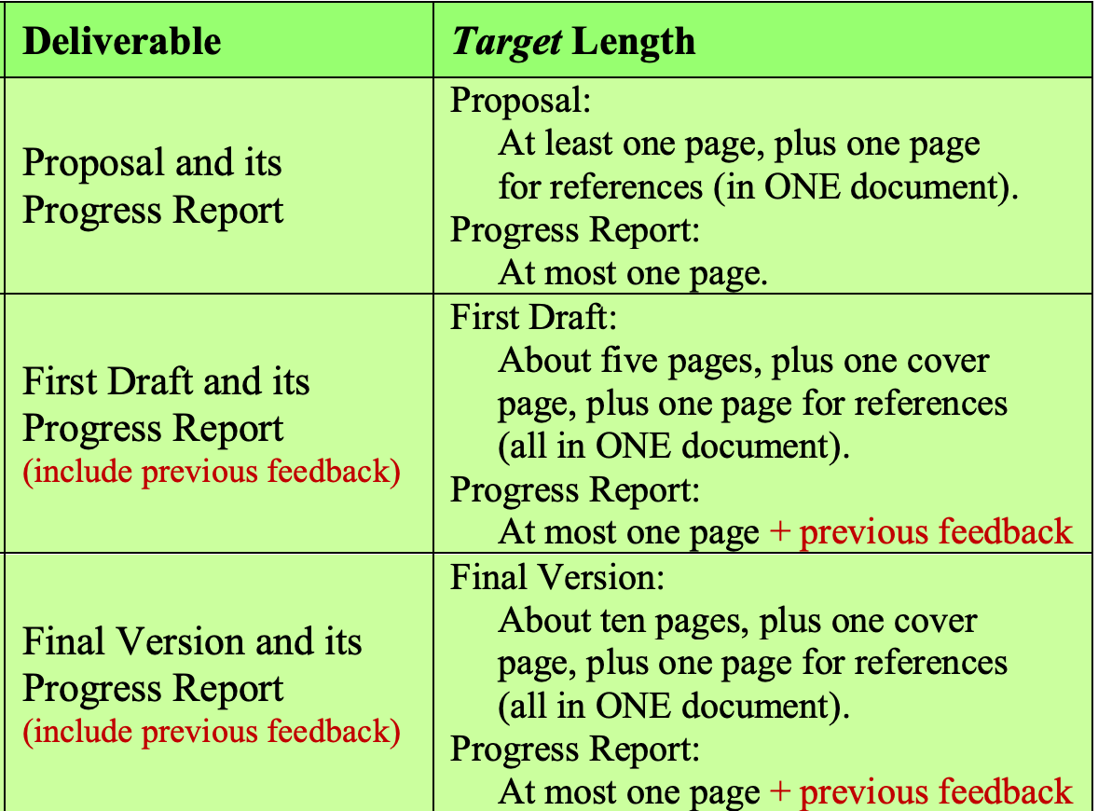

How to Proceed;
The Proposal stage is about discovery and examination of ideas. You will need to do active thinking and engage critically with your subject of choice. This is the phase where you are ‘figuring out’ and refining what you think before you proceed to communicate it in a more formal way (to be done in the First Draft and Final Version of your paper). These are the steps you should follow:
1. Identify a topic within economics that interests you (or any topic that can be approached from an economic perspective).
2. Establish the purpose of your research and the format of your paper.
3. Undertake a background search.
4. Identify a specific issue within the topic.​
List of topics:

- Monetary policy.
The role of monetary policy in stabilizing business cycles. How do central banks design monetary policy? What metrics need to be taken into account? How? Should monetary policy be independent of fiscal policy? Should it not? Why? Monetary policy and the zero lower bound. Liquidity traps. Impact of negative interest rates on bank profitability and asset valuation (‘bubbles’)
- Population and population growth.
What are the economic drivers of population growth? How does population growth impact economic growth? How does economic growth impact population growth? What do we know? Case studies? Are developing countries getting old before they get rich? What are the reasons? Effects? The ‘demographic momentum’: what is it and why does it matter
- Small and medium enterprises (SME).
How important are they for production? Employment? Innovation? What specific problems do they face? Do they fail more than larger firms? How can policies help them?
- Income distribution and inequality.
Causes, evolution, measurement, consequences. Policies? The wealth gap in the US. Evolution. How does it look? What drives it? Can it be closed? How?
- Technological progress, technology transfer.
What is the role of technological innovation in economic growth? Are there specific policies that can spur economic growth? Or kill them? Is ‘premature deindustrialization’ a characteristic of the ‘new’ economic growth model for developing countries? Is this the case for, say, China?

Structure and Required Elements

Your Proposal must include the following elements (to be reviewed and worked on later): 1. Tentative title.
Choosing the final version of your title is one of the last things you will do (you read that right!). However, at this stage you still need to provide a title. It is your presentation card. Make your title as descriptive and revealing as possible. Be very specific and aim for a title that clearly reflects the main theme, issue or position of your paper. Use a subtitle if necessary. E.g. “The Impact of Health on Economic Growth: Effects of the HIV/AIDS Epidemic on Uganda’s Economy.”

2. Purpose of research and type of paper.
What do you want to accomplish? What is the most appropriate format to accomplish it? State clearly the purpose of your research (check again Step 2 in ‘How to Proceed’ above). Propose the format that will most effectively attain this objective. For example, if you want to defend a stance in a particular issue or debate, you will write an issue or position paper. But if you wish to summarize what is known about a topic and issue, you will write a literature survey on this subject.
3. Motivation.
Since you chose your subject, you are clearly interested in it. However, you must convince your audience your subject merits their interest if you want your paper to be read. In other words: you must motivate your audience. Explain to your audience why this topic/issue is worth learning and reading about. Provide a convincing answer to the following: Why is your subject relevant for the field of economics? Why is it relevant for society as a whole? Why should we (your peers and economics faculty) want to read about it? Think carefully about your own motivation, analyze it, and use what you find to motivate your audience.

4. Rough overview.
Later, this will take the form of a proper ‘Literature Review’ or a ‘Background Review.’ At the Proposal stage, use broad strokes to place your topic and issue within the field of economics. Where does this topic/issue stand in relation to others in economics? What do we know about it? What do we not know? What should we know? What is the state-of-the-art with regards to it? What is the consensus view? Are there any alternative or dissenting views? Are there unexplored areas we should be aware of? What are the policy implications? Consulting the relevant chapters of a good textbook may provide you with an excellent frame for your subject. If so, use your own words to explain it to us, and do not forget to cite and reference the textbook properly (see the last point of this list).
- Your original contribution.
Do not be intimidated by this component; it is simpler than it reads. Do you have any specific question or hypothesis in mind? Are you reviewing a concrete topic (perhaps for the first time)? Are you trying to establish a link between two ideas? Do you have a specific policy proposal? Are you planning to do a literature survey and map what is known/not known to your audience? Do you want to apply a model, a concept, a theory or a technique to a specific case (a country or an industry, for example)? Any of these will constitute your original contribution. Make sure to tell your audience. 6. Methodology. Explain how you plan to work on your subject. Give us an outline. How will you organize your ideas, and all the information and research you have gathered? Are you going to rely on prior empirical work and secondary data sources? Is your analysis more qualitative, historical, theoretical, etc.? What other types of sources are you planning to use? Why have you chosen this particular methodology? Try to break your assignment into sub-tasks and pencil the sequence of actions you will undertake. And, while you are at it, plan your steps throughout the semester, so you can time and manage your deliverables more effectively. Writing a good economics paper requires time. Lack of time spent on research, analysis, organization, etc. will show.
- List of references, APA style.
In the last page of your Proposal document: provide a list of the readings you have used while ‘figuring out’ what you will work on and how you plan to do it. At the Proposal stage, you do not need to do in-text citation (unless you are ready to do so, which is excellent), but you do have to submit a list of references following the American Psychological Association (APA) guidelines, which is the style most social sciences adopt. Follow instructions in the presentation that I have uploaded in the Documents section of Blackboard. In it, you will also find links to more detailed instructions. Follow these rules to elaborate your List of References:
1. This section should be in 12pt font size.
2. Each reference should be single spaced; references should be separated by a double space.
3. Each reference must have a hanging indent of ½ inch.
4. List should be alphabetical by author or editor. Get used to this style early on and you will save yourself time and effort. Otherwise it will be more complicated and time consuming to do so later!

