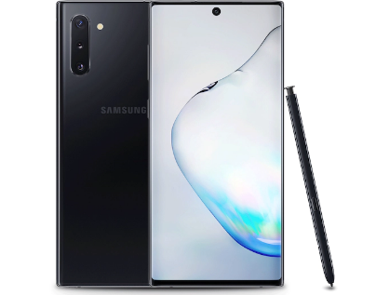

**Samsung Galaxy Note 10**

Samsung introduces a new smart phone in the market “Samsung Galaxy Note 10” it offers great experience that other products before.

The products comes at a friendly price that is affordable.

It has unique features which enables it to capture great image despite brightness

It is now available at all Samsung dealers all over the world.

**Product Description**

The phone is unique in comparison to previous versions as it offers intelligent features

It has a better camera, display, memory and Ram that is greater than that of other devices.

The color of the phone differs to fit the taste of the consumers.

The battery life is better, which last longer. The phone has both wireless and wired charging.

The memory of the phone differs where Galaxy Note 10/Note10 5G has ram of 8-12 GB and internal storage of 256 GB.