Your assignment, if you choose to accept it is to write a fully fleshed out Poetry Analysis Essay (3G) that defends a thesis you developed through a close critical reading/analysis of three (or more) works of poetry listed on the syllabus. Your analysis relies mainly on textual support from the primary text, but can also include at secondary sources that support/sustain your argument. Do not confuse “critical analysis” with “plot summary;” the goal is to develop, sustain, and advance a thesis based on a critique of the primary text that clearly demonstrates the presence of a major themes in the chosen collection of works.
Excellent papers will include support from at least one secondary source
Consider the following sample thematic elements (note that these are not themes in and of themselves, but abstract terms that can be used to construct themes. A theme is an observation on life or the human condition. What does your chosen work say about any of these ideas?):
Love and Hate
Grief
Innocence and Experience
Identity in America
American Dreams and Nightmares
Law and Disorder
War
Fathers and Sons
Death and Dying
Religion
Nature
Art
Feminism
Masculinity
Parents and Children

Sample Approach: Poetry Analysis
Topic: Fathers and Sons in Three 20th Century American Poems
Thesis: In poems by three American poets, sons recall their fathers with regret, a hint of violence, and a sense of legacy, in each case dealing with the complexity of filial love. (Explication/Thematic analysis)
Quoting Poetry: Each section must be supported by a quote or quotes from the literary texts. For quoting poetry, usually line number(s) is enough:
e.g. The speaker in Raymond Carver’s poem “Photograph of My Father in His Twenty-second Year” (1988) describes his father’s “sheepish grin” (l. 3), which suggests his father is perhaps embarrassed or shy.
The rhythm of the opening of “My Papa’s Waltz” mimics the action it describes: “The whiskey on your breath/ Could make a small boy dizzy” (ll. 1-2).

Remember Fremlin’s four steps to quoting:
1) Introduce the quote smoothly;
2) Cite the quoted words accurately, with quotations around direct quotes and / to indicate original line endings [use block format for more than four lines];
3) Cite text/author/line or page numbers;
4) Discuss the quote’s significance to your analysis [don’t expect the quote to speak for itself].

Your essay should contain a thesis statement that gives me an idea of how you will back this point up and how your support will be organized throughout. It should also fulfill the other requirements of your rubric.
750 words (two-three pages double spaced 12 point font). Please include your name, a title, the date, and your class hour at the top, as well as page numbers throughout.

Assignment 3A: Close Readings
Your first assignment in the creation of your Poetry Analysis Essay is to choose one of the assigned readings for this module, reread it closely, keeping in mind the concepts of critical reading discussed in class, and then answer the following questions to help generate ideas for your Poetry Analysis:
- Is the poem narrative or lyrical?
- Who is the main speaker in the poem? How does their “voice” or perspective influence how the poem is read? Can their perspective be fully trusted?
- Does the poem have any word play that draws attention to itself? Could the poet be indicating anything deeper with these words?
- Where physically is the poem set? Does this setting inform how the poem should be read? If so, how?
- Is there any imagery or any references the play uses to tell the reader something? Are there any major symbols?
- What is the dominant theme of this piece?
- How do you know this theme exists?
- How is this theme explored similarly or differently than in other poems you’ve read for this class that explore the same theme?
- What insights, if any, can be revealed by applying different critical lenses?
In answering these questions, you should demonstrate a thoughtful reflection on the piece, including key takeaways, aspects you agree or disagree with or were particularly struck by, and important questions for future consideration. This can be done in the free-flowing style of a pre-writing activity rather than the formal formatting of an MLA essay.
Your close reading activity should be at least one full page in length.
If you decide you want to use this reading as the focus of your poetry analysis, then at the bottom of the last page of your assignment, write down a one sentence description of your narrowed topic for this paper.

Assignment 3B: Thesis Statement
Your second assignment in the creation of your Poetry Analysis Essay (3G) is to create your thesis statement (3B). For this exercise you should use this sheet as your guide and create a printed one page assignment that identifies your TOPIC, your STANCE on that topic, and three SUPPORT POINTS that you will use to back up that stance in your paper. Please include your name, date, etc., as you would on any other assignment and bring 3 hard copies to workshop (see Course Schedule Announcement for dates).
Thesis Statement Breakdown
- Topic:

- Stance:

- First support:

- Second support:

- Third support:

Sample Layout
Due to/Because of
1) (First Support Point)____________________________________________________,

2) (Second Support Point)__________________________________________________,
and
3) (Third Support Point)___________________________________________________,

4) (Topic and Stance)______________________________________________________.
If you have any questions, please don’t hesitate to ask!

Assignment 3C: Annotated Bibliography
Your third assignment in the creation of your Poetry Analysis Essay (3G) is to create an annotated bibliography (3C). An annotated bibliography formalizes your research process. It forces us to spend a bit more time thinking about the sources we’re using, whether we can trust them, and how we are using them in our writing.
For this assignment, we are considering outside literary criticism as a means to complement our own analysis of texts. As such, you should take your questions and assumptions from the pre-writing exercise (3A) and your thesis statement (3B) and challenge them by locating one or more sources of academic quality that provide insightful literary criticism on your chosen literary piece (no Sparknotes, Cliffnotes, etc. will be accepted).
You will need to use library resources to find one reliable source. Your annotated bibliography should include four distinct parts:
- A full citation of that source in MLA Style as it would appear on your Works Cited page.
- A one paragraph summary of the important information contained in that source.
- A brief explanation of why you found this source to be credible.
- A brief explanation of how you could use this source to support your thesis.
Other than the citation, each part of your annotated bib should consist of complete sentences. Make sure to visually distinguish each part of the assignment.
Your research will start as an in-class activity, but you do not have to complete all parts of the assignment in class. Your source must be run by me during class, in the library, in order to verify that it is of academic quality. Be prepared to summarize your source and explain its credibility when you share it with me.
Sources can be electronic or print, but should be of academic quality (no .com, no wiki, no dictionaries or encyclopedias).
Type the results of this assignment to submit electronically with your final draft (Assignment 3G).

Assignment 3D: Outline
Your fourth assignment in the creation of your Poetry Analysis (3G) is to take your thesis statement (3B) and expand it into an outline (3D). For this exercise you should use this handout as your guide and create a printed two-to-three page assignment that outlines a five paragraph structure for your essay based on an introduction, three support paragraphs, and a conclusion. Per our discussion in class, the three support points from your thesis should be the basis for your three support paragraphs.
Since you’ll be including source material for this paper (your chosen reading), you can record key quotes or paraphrases (and their in-text citations) as examples where appropriate. Make sure to include your explanation or analysis of the source material you choose to use.
Please include your name, date, etc., as you would on any other assignment and bring one hard copy to conferences (see Course Schedule Announcement for dates).
See the next two pages for a helpful breakdown of how to assemble a complete outline.
If you have any questions, please don’t hesitate to ask!

Outline Breakdown
Introduction
Hook___________________________________________________________________

Background______________________________________________________________

Point 1) _________________________________________________________________

Point 2) _________________________________________________________________

Point 3) _________________________________________________________________

Thesis __________________________________________________________________

Support One
Topic Sentence ___________________________________________________________

Example or Citation 1a)____________________________________________________

Analysis/Explanation 1b)__________________________________________________

Example or Citation 2a)____________________________________________________

Analysis/Explanation 2b)__________________________________________________

Example or Citation 3a)____________________________________________________

Analysis/Explanation 3b)__________________________________________________

Explanation (relates back to thesis) __________________________________________

Transition _______________________________________________________________

Support Two
Topic Sentence ___________________________________________________________

Example or Citation 1a)____________________________________________________

Analysis/Explanation 1b)__________________________________________________

Example or Citation 2a)____________________________________________________

Analysis/Explanation 2b)__________________________________________________

Example or Citation 3a)____________________________________________________

Analysis/Explanation 3b)__________________________________________________

Explanation (relates back to thesis) __________________________________________

Transition _______________________________________________________________

Support Three
Topic Sentence ___________________________________________________________

Example or Citation 1a)____________________________________________________

Analysis/Explanation 1b)__________________________________________________

Example or Citation 2a)____________________________________________________

Analysis/Explanation 2b)__________________________________________________

Example or Citation 3a)____________________________________________________

Analysis/Explanation 3b)__________________________________________________

Explanation (relates back to thesis) __________________________________________

Conclusion
Restated Thesis __________________________________________________________

Recap Point 1) ___________________________________________________________

Recap Point 2) ___________________________________________________________

Recap Point 3) ___________________________________________________________

Take Home _____________________________________________________________

Assignment 3E: First Draft
Your fifth assignment in the creation of your Poetry Analysis Essay (3G) is to take your thesis (3B) and expand it into a full draft of your paper (3E). For this exercise you should use this handout as your guide and create a printed two-to-three page assignment that follows the five paragraph structure of your outline, but is fleshed out into complete sentences, and includes a clear introduction, support paragraphs, concrete examples, and a complete conclusion. Per our discussion in class, the three support points from your thesis should be the basis for your three support paragraphs. Please include your name, date, etc., as you would on any other assignment and bring one hard copy to conferences (see Course Schedule Announcement for dates).
Remember, this paper should include significant textual evidence (properly documented quotes or paraphrases from your chosen reading) to support your thesis, as well as sufficient analysis and concrete examples. In addition, since we are part of a larger conversation about literary analysis, the use of (properly documented) outside literary criticism is welcomed and encouraged.

Assignment 3F: Revision Exercise
Your sixth assignment in the creation of your Poetry Analysis Essay (3G) is to take your first draft (3E), to do a revision exercise on it (3F), and then to fully revise and edit your first draft to create a final draft (3G) for submission in class.
3F: Revision and Editing Exercise
For this exercise you should review (look again) at your first draft and type full sentence answers to the following prompts:
- What part of your paper, if any, can use expansion and what specific information can you add there to make it stronger?
- What part of your paper, if any, gets off topic, and what can you remove to help?
- Is your organization strong? If so, what makes it strong? If not, or if it could use improvement still, what can you move or substitute to help? Consider creating a reverse outline to help.
- How credible are the sources you used? How do you know?
- Examine your paper’s tone. Is it too informal or conversational? If so, what can change?
- Do you have any word choice errors that spellcheck wouldn’t find?
- Do you have any coma-splice errors, run ons, or sentence fragments?
- Do you have any fluffy word choices?
- Are all of your sources properly documented in MLA style?
- What is one specific step you can take to improve your paper before submitting it?

- Because I could not stop for Death by Emily Dickinson p. 577,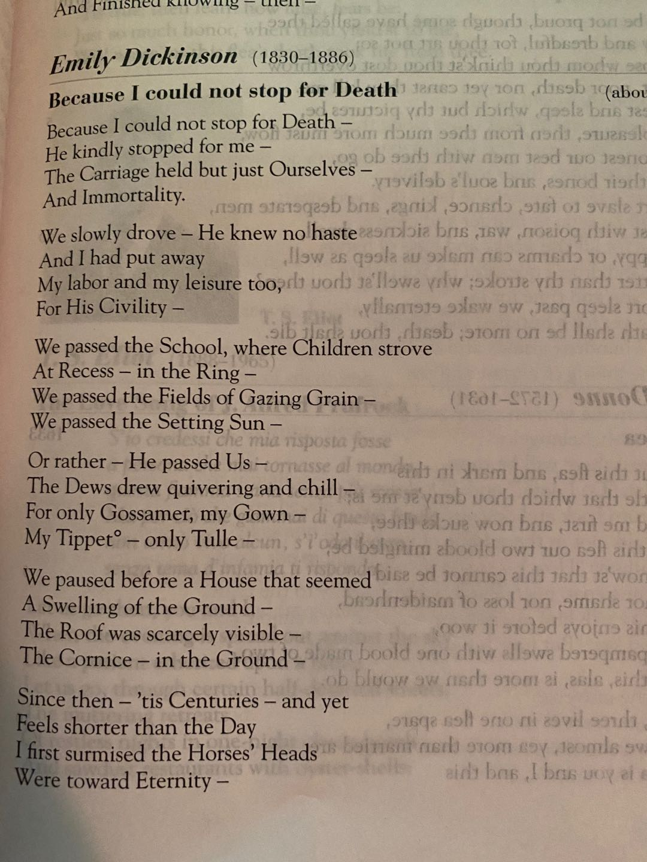

- Do not go gentle into that good night by Dylan Thomas p. 506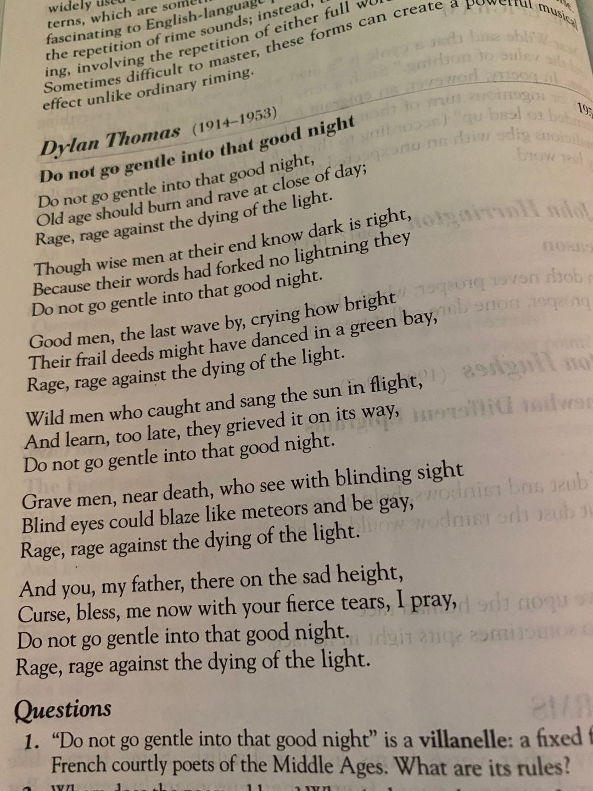

- To an Athlete Dying Young by A.E. Housman p. 593,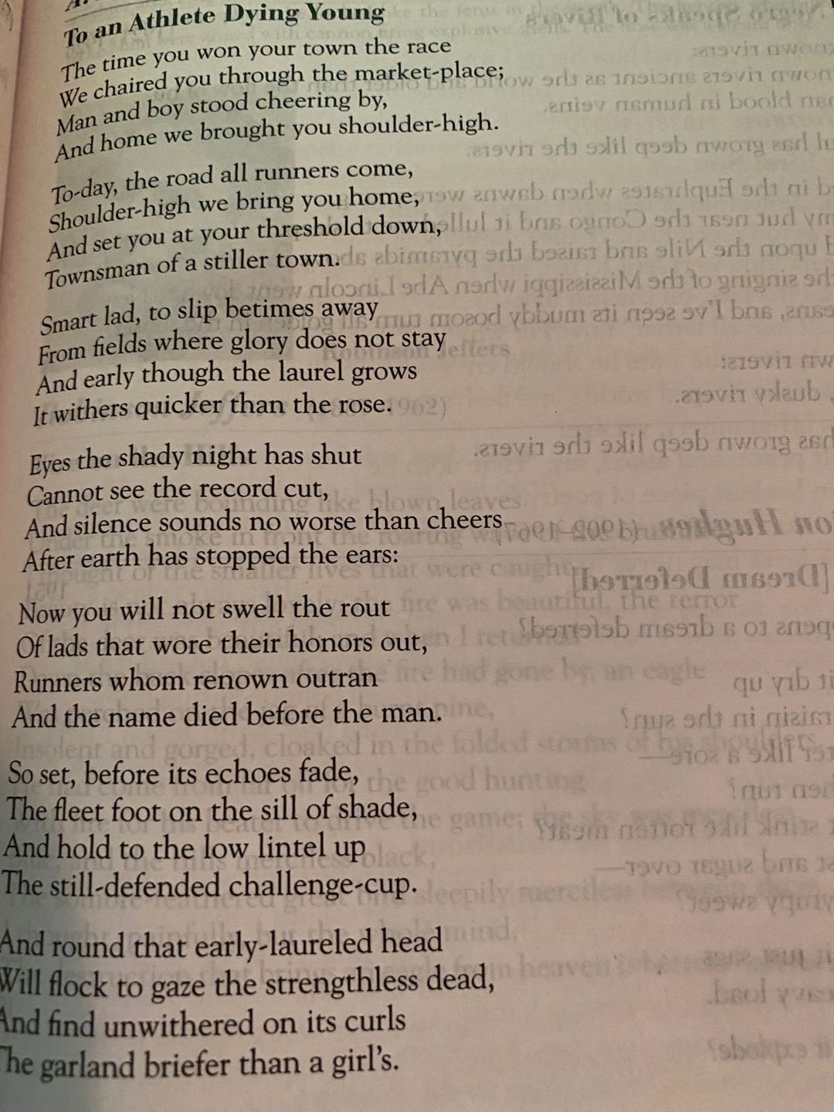

- On the Death of Friends in Childhood by Donald ，Justice p. 596 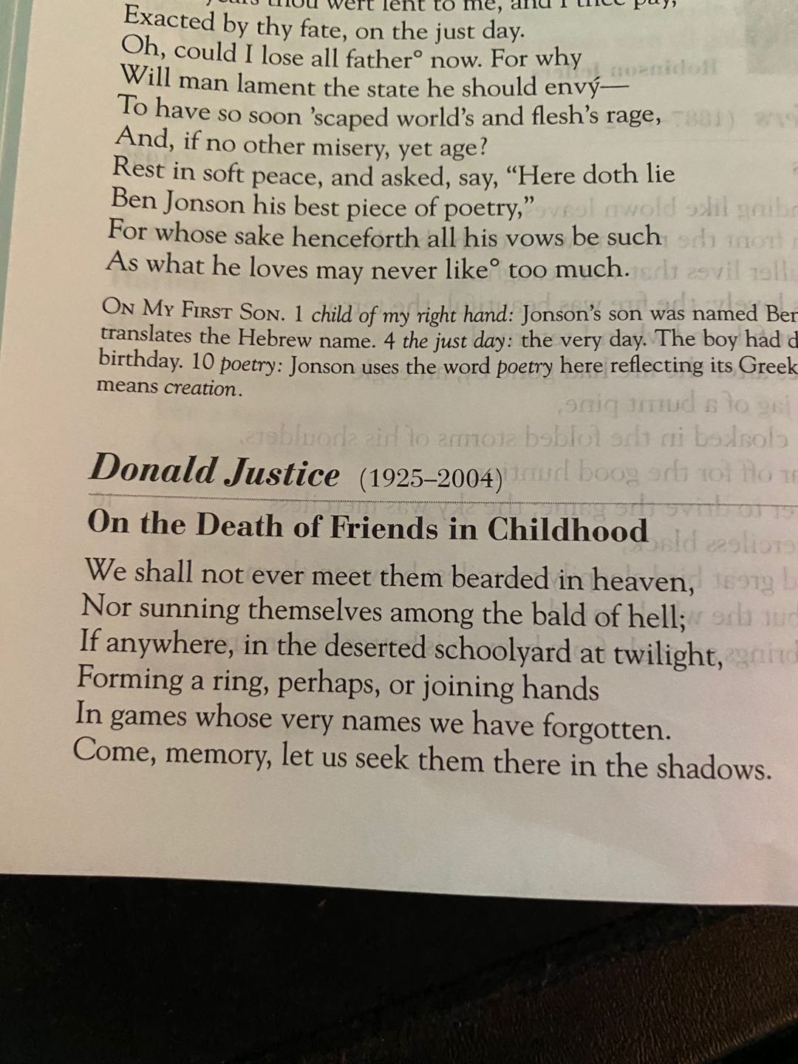

- Stopping by Woods on a Snowy Evening by Robert Frost p. 586. 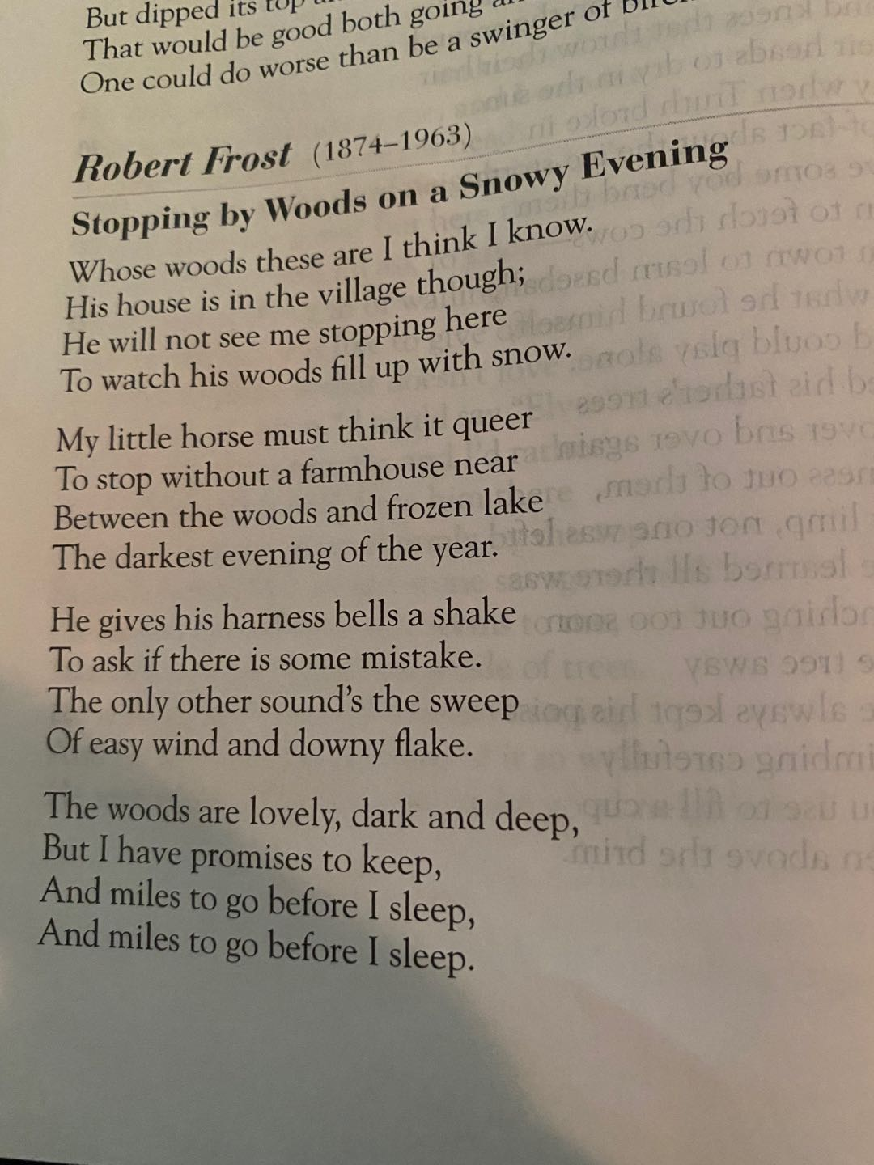

- The Road Not Taken by Robert Frost p. 534, 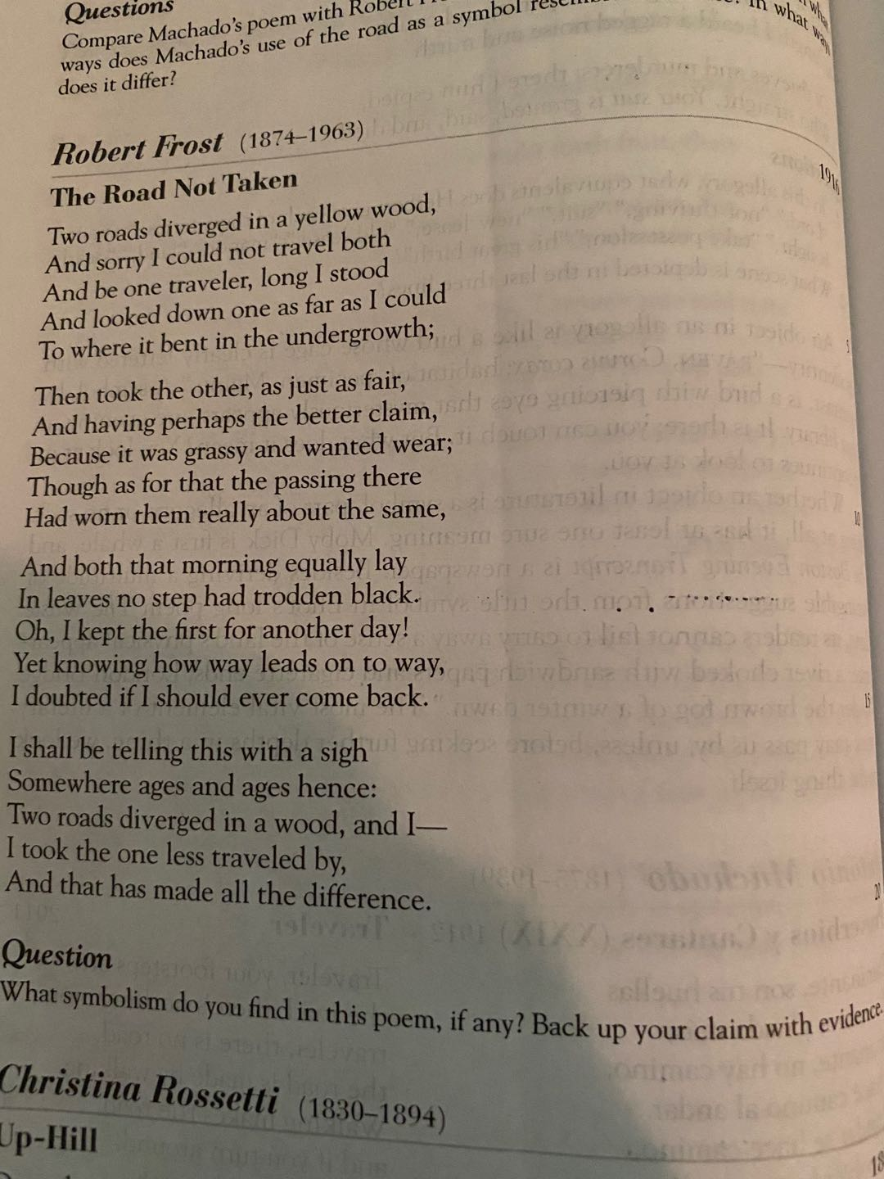

- We Real Cool by Gwendolyn Brooks p. 482,
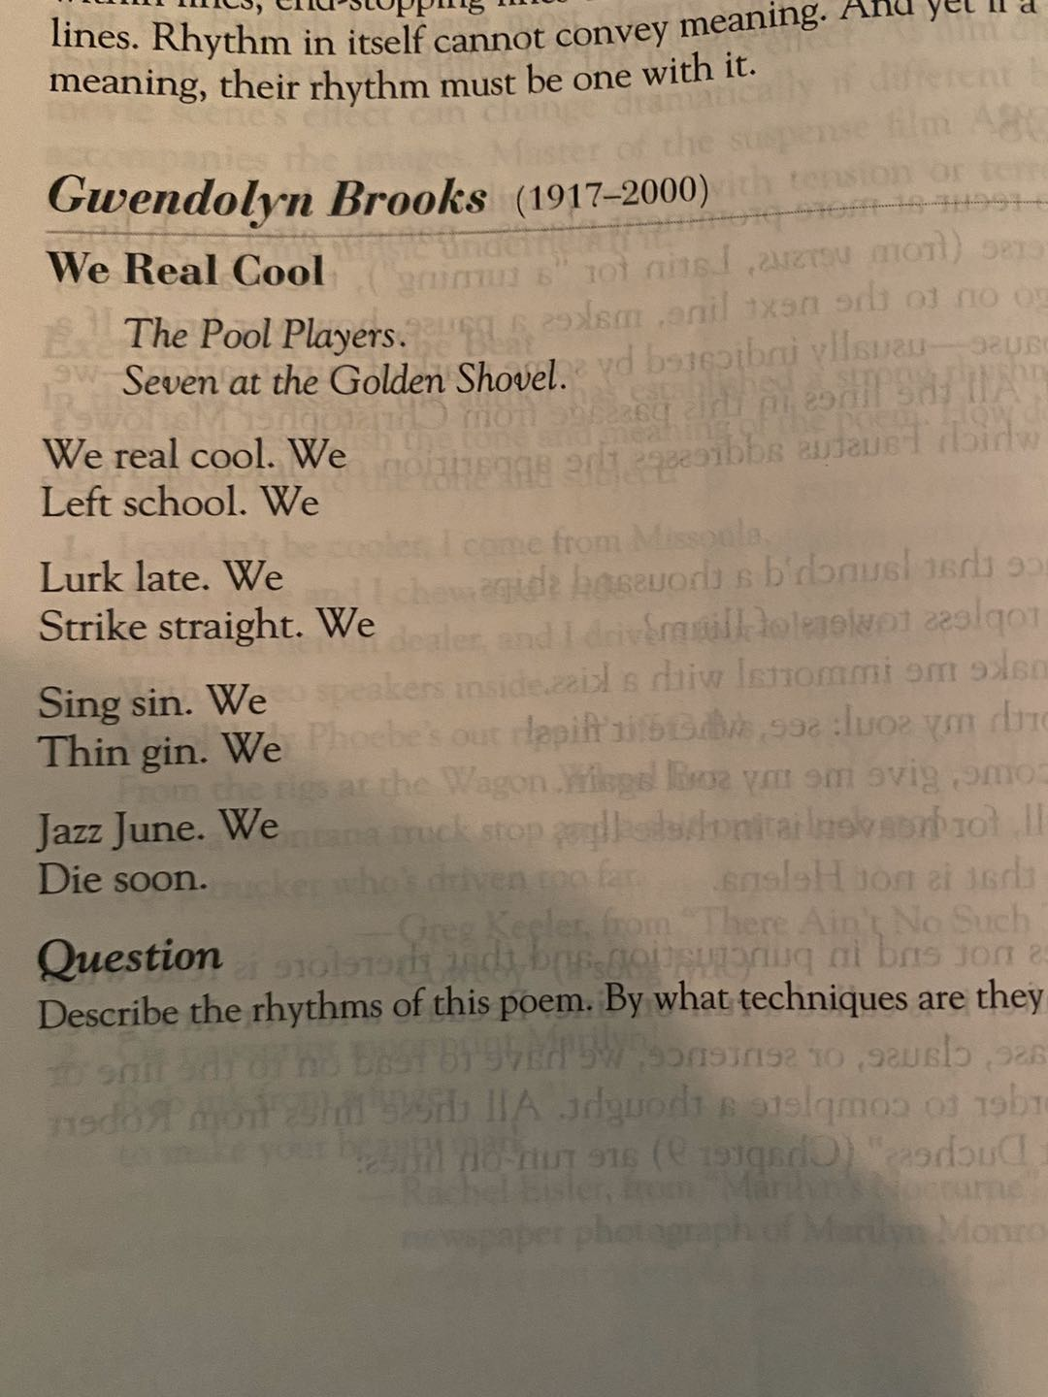

8. Shakespearean Sonnet by R.S. Gwynn p. 504
The Facebook Sonnet by Sherman Alexie p. 504
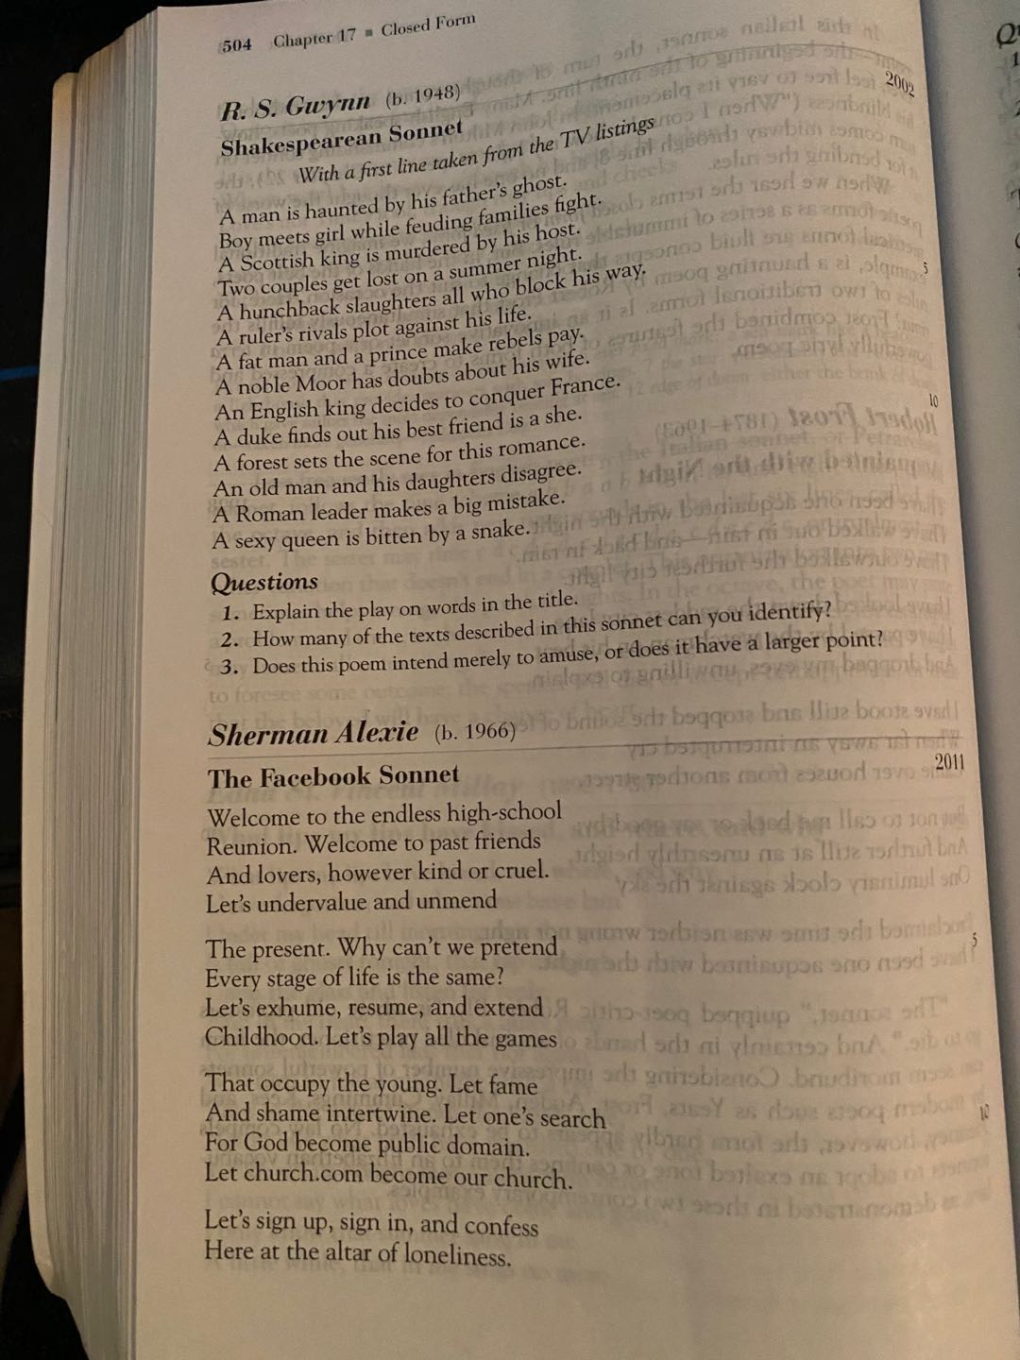

- Waltz by Theodore Roethke p. 380
