Explore your community for evidence of renewable energy sources (wind power, solar power, geothermal, or nuclear. Take pictures of how it is implemented. What are these renewable sources doing for your community?

Discuss what sources are available and how they could be implemented.

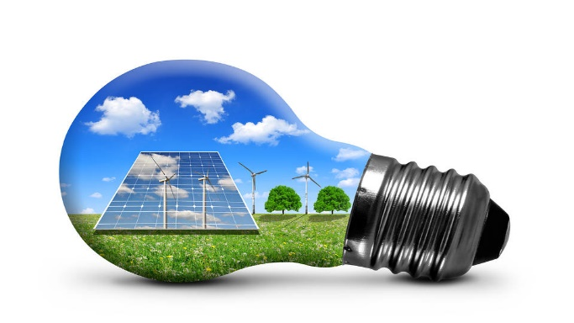

Household Energy Consumption

Use an energy calculator to determine how much energy your household consumes. Could also read your bills. Discuss how you could lessen the amount of energy consumed. What types of energy is used? Are any of the sources from renewable energy sources – which ones?

What is the impact of using nonrenewable energy?

# Energy & Renewable Energy

References