|  |  |  |  |  |
| --- | --- | --- | --- | --- |
| Insert image of your community. If necessary reference the image on the References page. |  | |  | | --- | | Environmental Literacy Plan | | Insert Community Name here | |
|  |  |  |
|  |  |  |

Insert image of your community. If necessary reference the image on the References page.

Insert image of your community. If necessary reference the image on the References page.

Label Label

Insert image of your community. If necessary reference the image on the References page.

Insert image of your community. If necessary reference the image on the References page.

Label Label

# Habitats

**Types of Habitats:**

Using Google Earth, locate your community. Take a screenshot of your community from an aerial view. Mark the habitats on the map. Make a note of habitat degradation, fragmentation, and destruction.

Insert community population graph here.

# Population

**Current Population:**

**Prediction of Population (in 5 years):**

**Population per Sq. Mile:**

Locate census data for the population of the community over the last 5 years. Plot it on a graph to show how the population has changed over the last 5 years. Based on the information can you predict what the population will be 5 years from now? Include the prediction on the graph as well.

Insert Google Earth image here. Use the drawing tools in Word to mark up the map.

Demographic Information

Does the community attract a seasonal population? Why is this a danger to environment of the community?

Median Age and Sex:

Education:

Race and Hispanic Origin:

Housing:

Economy:

Transportation:

Economic Health & Vitality:

How does the demographics of a community affect the environment? Provide three examples:

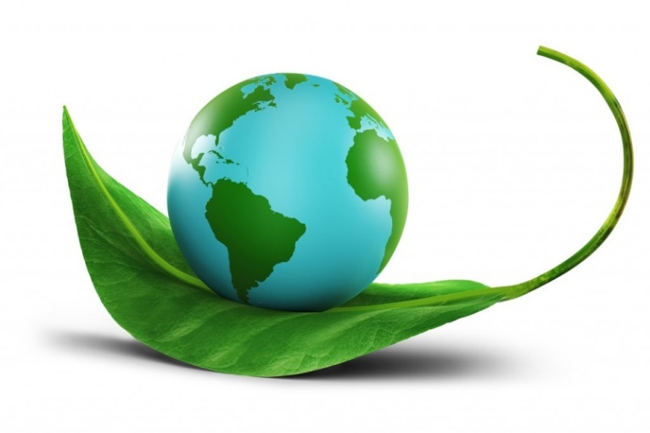

Does your community have an environment center or group? Could be included in the Parks Department. Make sure to note what they do for the community.

# Community Environment Center

*Community Center Information (Location, Hours, Contact Information)*

Community events

Insert community events happening. Trash pickups, mandatory recycling, leaf pickup, etc.

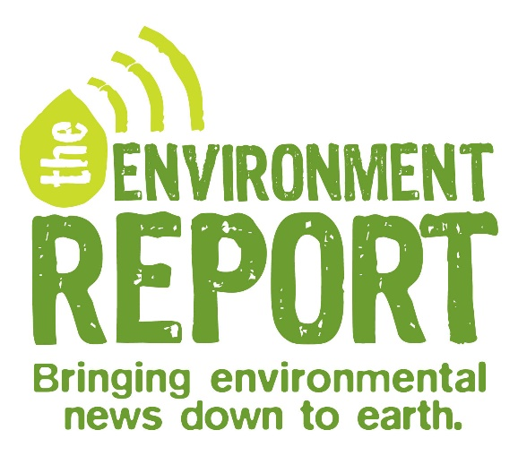

IMPACT

What is the impact of the choices of the community on the habitats and environment around you?

Do a local media search to see what types of environmental issues have been covered by the media (Global Warming is a hot topic right now). Include a summary of three (3) articles that you find and describe the nature of those issues. Cite and reference the articles in APA on the References page of the document.

# The Environment in the News

References