Thomas Oshoko
Strayer University
Database and Data Warehouse Design
CIS499

Dr Reddy Urimindi
November 4, 2019

Database and Data Warehouse Design
Need for Data Warehousing in my Company
The concept of data warehousing denotes the collection and management of information from different sources in efforts to offer essential business understandings. It also includes a blend of innovations and elements that assist in the strategic utilization of information or data. In my experience, not many firms have a data warehouse as one would expect. Most of those that claim to have it usually do not have a real warehouse, preferably something else or like a data warehouse. For an organization to thrive in the future there is need for effective decisions. Besides, the most successful choices often involve all the appropriate data consideration. As such, the best source for managing data is having a well-developed data warehouse.
Thus, the concept behind data warehousing is straightforward: information is mined on a regularly from source areas or systems, using technologies such as ERP applications that possess vital data. Information from these systems is then transferred to dedicated servers, which contain data warehouses. However, while this data is being moved, it is prepared, organized, authenticated, reformatted, as well as summarized and improved using information from other areas. This subsequent data warehouse becomes the major source of information for generation of reports, analysis, in addition to reporting, where such tools as canned reports, consoles, as well as ad-hoc queries are used.
One importance of data warehouse is information integration. An organization’s data is often vast and multifaceted, usually spreading out through a diversity of various in-house and peripheral systems. Equally, there is also a need to assess a business’ data across its different systems by period, station, in addition to the location. Therefore, data integration remains vital to ensure that data is gathered, prepared, and securely warehoused in one place. Data integration also plays an integral part in saving time and the lengthy processes that are frequently seen in producing reports due to several steps that are needed in extracting information from one source and sorting or merging it, then enriching it to guarantee accuracy.
The need for data warehousing is also based on superior reporting and analytics. Here, the most critical design plan for data warehouse includes supporting querying, analysis, as well as analysis. It is, thus, clear that data warehouse works to facilitate easy understanding of complex information through the use of simplified analyses and reporting. Another vital need for data warehousing regards knowledge discovery as well as data extraction.
Similarly, there are several best practices that organizations might adopt in efforts to ensure adherence to when designing data warehouses. The first practice is using data models that are appropriately optimized for data retrieval. In particular, such models should also be based on hybrid approaches. The second practice is information acquisition. Here, the process needs to be carefully developed to ensure proper acquisition and organization process for accuracy reasons. The third practice is ensuring Metadata, where data must be developed in such a way that it permits easy sharing among different elements of the data warehouse system. The fifth practice entails quality of data in the warehouse, which is important for guaranteeing successful data warehousing. Essentially, the way in which data is transported from different sources into the warehouse must not jeopardize the quality of reporting and querying expected. Last but not the least, communication and training also remains important for an effective data warehouse. In a way, training is an important component when ensuring a successful warehouse as it offers the company’s staff the most appropriate skills.

A Schema Supporting the Company’s Business and Processes
Put in simple terms, and in relation to database, a schema is understood as an organization’s and the structure of its database. It especially contains objects that may comprise tables, views, keys, data forms, as well as associations among different elements. Such a schema could also be shown using a visual diagram, demonstrating the different objects and their relationships with one another. To define my organization’s schema, the diagram will be separated into four important parts as follows.
- Customer information – here, the business’ data is associated with the company’s customers, including their names, locations, as well as addresses in addition to other important identifying information.
- Business – this is the second section, where data is necessary in running the company. In particular, some of the information featured here includes data related to employees, the company’s store locations, as well as salary details among other data.
- Inventory – With this section, important information pertaining to the company includes details on different items. In this case, the items are movies. Therefore, it consists of data such as movie categories, actors, and related movie titles.
- View – this is the last section, which includes special view on information used for assessment purposes.
Therefore, the following diagram presents the major tables of the database schema from the above given information.

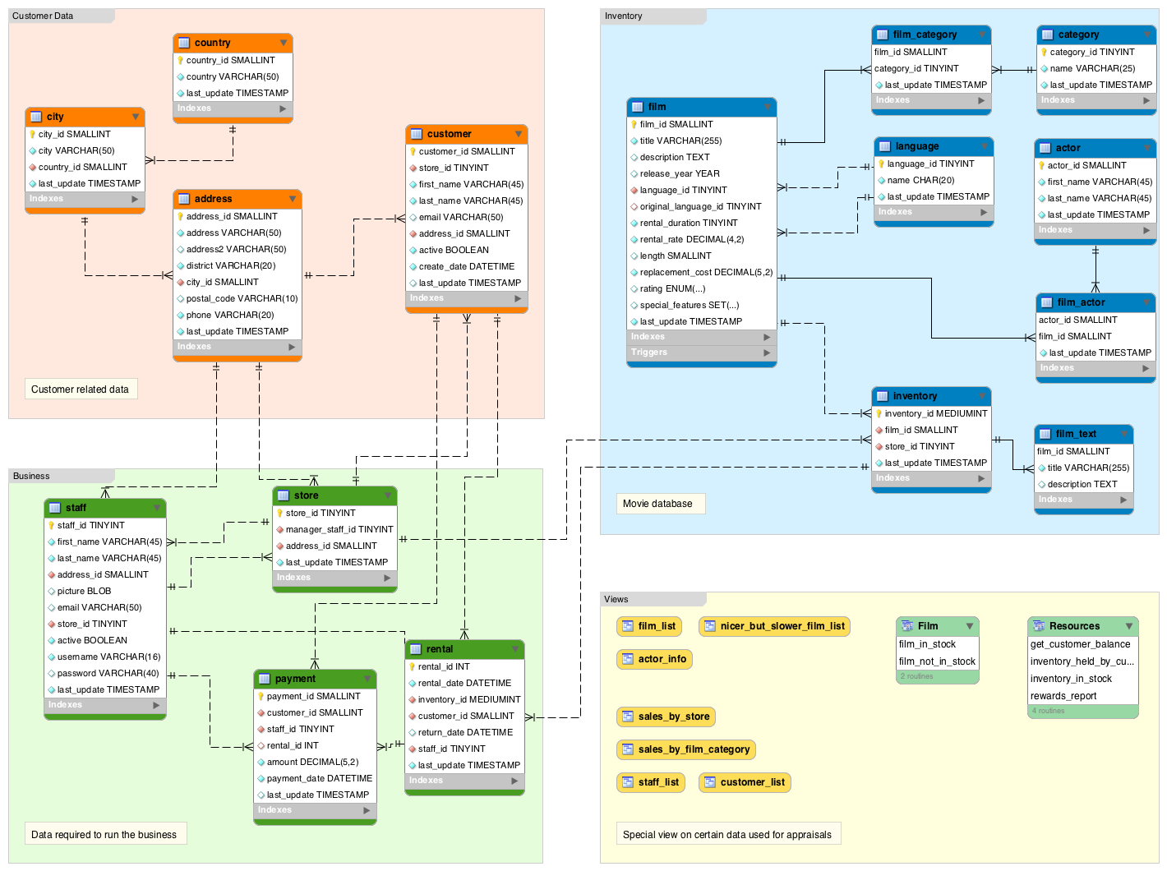
An Entity-Relationship (E-R) Diagram
The E-R diagram fundamentally represents the main components that would usually form the basis of the company. However, these are independent elements that would usually work to promote suitable information collection and transfer of such information into the data marts. Here, the customer data establishes the database’s first component in the company. At this stage, client information, including their names, addresses, as well as locations is recorded and stored for business use. At the business level, the company notes these details. Here, different groups of people work on the given data to produce meaningful, yet vital business insights. Other types of data that were not previously collected are also discussed and appropriate amendments done in efforts to ensure accuracy and quality of information. At the inventory stage, important data concerning the company is also assessed. It especially includes details on different products that are produced by the organization. In this case, the items are movies. Hence, it consists of data such as movie categories, actors, and related movie titles. The last stage is the view component, where information is again appraised for errors. The following table shows my organization’s E-R diagram.
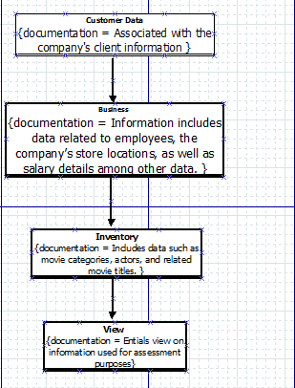

Data Flow Diagram

