[Title Here, up to 12 Words, on One to Two Lines]
[Author Name(s), First M. Last, Omit Titles and Degrees]
[Institutional Affiliation(s)]

Author Note
[Include any grant/funding information and a complete correspondence address.]

Table of Contents
Abstract 3
[Title Here, up to 12 Words, on One to Two Lines] 4
[Heading 1] 4
[Heading 2] 4
[Heading 3] 4
References 5
Footnotes 6
Tables 7
Figures 8

Abstract
[The abstract should be one paragraph of between 150 and 250 words. It is not indented. Section titles, such as the word Abstract above, are not considered headings so they don’t use bold heading format. Instead, use the Section Title style. This style automatically starts your section on a new page, so you don’t have to add page breaks. To apply any text style in this document with just a tap, on the Home tab of the ribbon, check out Styles.]
Keywords: [Tap here to add keywords.]

[Title Here, up to 12 Words, on One to Two Lines]
[The body of your paper uses a half-inch first line indent and is double-spaced. APA style provides for up to five heading levels, shown in the paragraphs that follow. Note that the word Introduction should not be used as an initial heading, as it’s assumed that your paper begins with an introduction.]

[Heading 1]
[The first two heading levels get their own paragraph, as shown here. Headings 3, 4, and 5 are run-in headings used at the beginning of the paragraph.]

[Heading 2]1
[To update the table of contents (TOC), apply the appropriate heading style to just the heading text at the start of a paragraph and it will show up in your TOC. To do this, select the text for your heading. Then, apply the style you need.]
[Heading 3]. [Include a period at the end of a run-in heading. Note that you can include consecutive paragraphs with their own headings, where appropriate.]
[Heading 4]. [When using headings, don’t skip levels. If you need a heading 3, 4, or 5 with no text following it before the next heading, just add a period at the end of the heading and then start a new paragraph for the subheading and its text.] (Last Name, Year)
[Heading 5]. [Like all sections of your paper, references start on their own page, as shown on the page that follows. The body of the References section uses the Bibliography style. For more detailed information on formatting references, see the APA Style Manual, 6th Edition. (Last Name, Year)

References
Center For Disease Control:http://www.cdc.gov/h1n1flu/general_info.htm
Center For Disease Control How viruses Change: Drift and Shift:
http://www.cdc.gov/flu/avian/gen-info-viruses.htm#virusoverview
Center For Disease Control: http://cdc.gov/h1n1flu 08/11/2010

Footnotes
1[Add footnotes, if any, on their own page following references. For APA formatting requirements, it’s easy to just type your own footnote references and notes. To format a footnote reference, select the number and then apply the Footnote Reference. The body of a footnote, such as this example, uses the Normal text style. (Note: If you delete this sample footnote, don’t forget to delete its in-text reference as well.)]

Tables
Table 1
[Table Title]
Column Head | Column Head | Column Head | Column Head | Column Head
Row Head | 123 | 123 | 123 | 123
Row Head | 456 | 456 | 456 | 456
Row Head | 789 | 789 | 789 | 789
Row Head | 123 | 123 | 123 | 123
Row Head | 456 | 456 | 456 | 456
Row Head | 789 | 789 | 789 | 789
Note: [Place all tables for your paper in a tables section, following references (and, if applicable, footnotes). Start a new page for each table, include a table number and table title for each, as shown on this page. All explanatory text appears in a table note that follows the table, such as this one. Use the Table/Figure style to get the spacing between table and note. Tables in APA format can use single or 1.5 line spacing. Include a heading for every row and column, even if the content seems obvious. To insert a table, on the Insert tab, tap Table. New tables that you create in this document use APA format by default.]

Figures
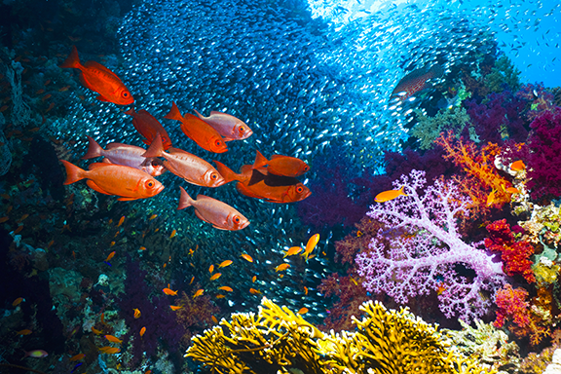
Figure 1. [Include all figures in their own section, following references (and footnotes and tables, if applicable). Include a numbered caption for each figure. Use the Table/Figure style for easy spacing between figure and caption.]
For more information about all elements of APA formatting, please consult the APA Style Manual, 6th Edition.

