**12 Social psychology and modern organizations: balancing between innovativeness and comfort**

KAREN VAN DER ZEE AND PAUL PAULUS



Imagine that you have just obtained your master's degree in social psy­ chology and that you are hired by a large company such as Shell or British Telecom. What would you be able to offer your company from your recent stud­ ies in social psychology? In this chapter we will approach important themes of modem organizations from a social-psychological perspective. We will first briefly describe the societal context in which modem organizations operate and its implication for the workplace. More specifically, we will focus on two important developments. In the dynamic world we live in nowadays organizations continu­ ously have to adjust their strategies to new environmental demands, for example, by bringing new products on the market in response to changing needs of cus­ tomers. In addition, globalization and migration forces, as well as the increased number of women and older employees in the workplace, cause the workplace to be more and more diverse. Both developments tum the workplace into an envi­ ronment that has a higher potential for group creativity and innovation, but that at the same time is less likely to be a source of safety and provide a sense of belonging.

In this chapter, we will use theoretical perspectives from social psychology to explain why *change* and *diversity* promote creativity and innovation. Perspectives on cognitive stimulation are particularly helpful in this regard. Moving on from social identity theory, we will show that both change and diversity may at the same time also endanger feelings of safety and belonging. We will close the chapter by discussing how organizations can, in their policies and in group- and individually based interventions, build on these theoretical perspectives in trying to generate positive outcomes in the modem workplace. In addition, we will discuss how social-psychological insights can be combined with insights from different disciplines that address the same issues.



Nowadays, we live in a world where rapid technological develop­

ments and individualistic customers continuously challenge companies with new

271

demands for products and services. Well-known examples of this are detection methods for explosive substances in response to terrorist threats, new computer technologies and mobile phones. As a consequence, organizations have to be flex­ ible in redefining their goals and policies in order to respond effectively to new demands from the environment. This makes organizational life less predictable and stable. Consequently, employees are faced with organizational changes, and they have to deal with the uncertainties that these changes evoke. In order to remain effective in such a dynamic environment, organizations have come to rely less on bureaucratic and formal arrangements and more on collaborative processes, often organized in small and temporary project teams. The end of the traditional hierarchical approach to organization provides a work context that may be more positively challenging to employees, causing them to be happier and more productive, but it clearly has its price. More flexible and temporary forms of collaboration may not provide a social context where employees feel safe and at home. Modem work structures are therefore less potent in creating a sense of belonging and safety for employees. Thus, whereas rapid changes in the modern workplace may tum work into a more challenging and exciting experience, under some conditions it may also pose a threat to employees' well-being. It is therefore important for modem organizations to know under which conditions change goes with happiness and under which conditions it does not.

Another important aspect of the changing social context in which modem orga­ nizations have to operate concerns the composition of the workforce. Due both to migration and to a growth in international assignments, work units are more heterogeneous. The entry of women into managerial and professional careers has diversified the workforce (see also Chapter 9). Due to increasing life expectancies and the economic necessity for people to work longer, age also has become an important source of diversity for companies. The literature has repeatedly stressed the potential of diverse groups to be more creative and to generate better deci­ sions (e.g., Mannix & Neale, 2005; Van Knippenberg, De Dreu & Homan, 2004; Williams & O'Reilly, 1998). With more ways of viewing a situation available, there is a greater potential for reaching the 'right solution'. Moreover, research has shown that multicultural groups develop more and better alternatives to a prob­ lem. They also seem to incorporate better criteria for evaluating those alternatives than do culturally homogeneous groups. It is not hard to imagine that this may be beneficial in a dynamic world that asks for continuous creativity and innovation. However, at the same time, being faced with norms and values that are different from one's own may be experienced as threatening. Hence, interactions among individuals with different norms and perspectives may easily create conflicts and tensions that may frustrate feelings of well-being and productivity.

In sum, modem organizations seem to be characterized by rapid changes, flex­ ible and temporary work structures and by increased diversity of the workforce. Organizational flexibility and diversity allow for an exploration of new develop­ ments and mutual differences by co-workers. However, the literature on cognitive and social processes in groups suggests that there are strong psychological forces

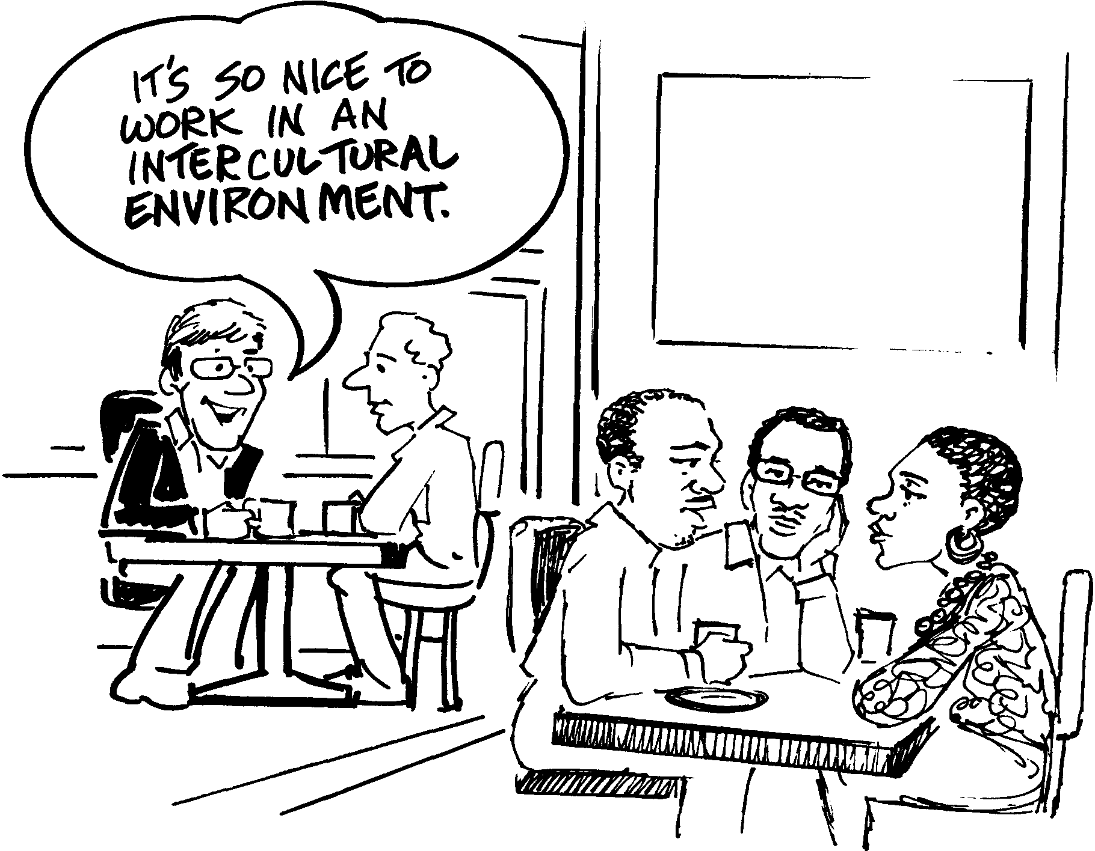

**Figure 12.1** *Intercultural working environment*

against such an exploration (Figure 12.1). These forces seem to result from the threat that open exploration poses to group members' positive sense of self and feelings of belonging at work.



In principle, organizational change may be beneficial to the satisfaction and performance of employees and work groups. Why is this the case? From a motivational perspective, being engaged in new developments may be challeng­ ing and enhance intrinsic motivation. The creativity that is evoked by the pleasure provided by new tasks and challenging goals will easily stimulate innovative activ­ ities. Moreover, being confronted with new tasks seems to evoke more thorough and active modes of information processing. When groups are confronted with routine tasks or the same tasks over a longer period of time, they may fall back on unconscious, automatic behaviours (Louis & Sutton, 1991). This may cause them to become rule-determined and insensitive to context. A typical example is an employee of a university housing office in a rural town who refuses to help an international student because she has neither a familiar student registration number nor a local address. Being used to the standard routine of dealing with

Table 12.1 *Stages of cohesion and locomotion in groups*

Cohesion too low

Insecurity about behavioural expectations and norms

Tensions and conflicts between group members

Subgroup formation

Mutual stereotypes

Disagreements are easily perceived as personal conflicts

Low satisfaction

Low performance and creativity

Cohesion too high

Sense of invulnerability

Issues are no longer discussed

Group members agree easily

Different problems are solved in the same manner

Little new information is exchanged in the

group

Low curiosity for new information or newcomers in the group

New initiatives are easily

discouraged

High satisfaction

Low performance and creativity

Optimal levels of cohesion and locomotion

Reflection on goals and performance

Enthusiasm for learning

Disagreements are perceived as constructive and stimulating

Ideas are put forward in the group

Original input is rewarded

Individuals feel free to express their views, even if these are controversial

High satisfaction

High performance and creativity

registrations, the housing officer feels unable to handle such an exceptional case in filling out the standard application forms. In contrast, when employees encounter new events or perspectives on a regular basis, they are more likely to switch to more active modes of processing (Louis & Sutton, 1991). An officer who is employed at the housing office of an international business school in New York will more probably start trying to understand the specific situation of each student, focusing on a solution to the problem at hand. Cognitive and learning theories have pointed at the positive aspects of active processing in generating high quality decisions (Argyris & Schon, 1978). Thus, organizational change may promote active processing of information by employees or work groups, which seems beneficial to **group creativity** and **innovation.** Whereas group creativity refers to the fluency, flexibility and originality of thoughts that are produced by groups, innovation can be defined as the introduction of new and improved ways of doing things in organizations. Active processing is particularly important in dynamic and complex situations that require troubleshooting, environment scanning and complex decision making.

Effortful cognitive processes are motivated not only by change, but also by diversity of inputs. Hearing ideas from others that differ from our own may activate knowledge that has not been previously used. Models of cognitive processes in

idea generation assume that knowledge is represented in associative networks. Associative networks are network structures of ideas in the brain in which the closest connections are between those ideas that are semantically related (e.g., toothpaste and toothbrush) and more indirect and distal connections are between ideas that are less closely related (e.g., toothpaste and lip gloss). Exposure to ideas is believed to lead to the activation of knowledge through a process in which activation of one knowledge area leads to activation of adjacent areas in the network and is subsequently spread out to other areas (see, e.g., Nijstad, Stroebe

& Lodewijkx, 2002). In order for such a process to occur, ideas must actually be able to activate knowledge, or have associative value (Dugosh & Paulus, 2005). This requires that ideas do not overlap too much with the information that is already available. Too much overlap may be a wasteful duplication of knowledge and effort. In this regard, the necessity for a certain degree of inter-member difference seems obvious, and diverse groups do a better job in this regard than homogeneous groups. Indirect support of this view is provided by a recent study by Nakui and Paulus (2007) on group brainstorming. This study revealed that culturally diverse groups performed better than homogeneous groups. The authors instructed brainstorming groups to generate ideas on a specific topic. Although the multicultural groups generated fewer ideas, these ideas were of higher quality than those of monocultural groups. It must be noted that in order to have associative value, ideas should also not be too distal, because if they are they will evoke no further associations. For example, if a biologist comes up with a biochemical concept in a meeting with experts in medieval history, the historians may not at all be stimulated by the idea, since they have no sense of what the biologist is talking about.

To conclude, change and diversity both seem beneficial to exploration of prob­ lems and new ideas. Despite the necessity for work groups to explore new oppor­ tunities, ideas and products, the reality is conservatism in work approaches and a strong resistance to change the status quo (see, for instance, Dirks, Cummings & Pierce, 1996). Moreover, research on group decision making suggests that there is a strong tendency for group members to focus on ideas that are familiar to all group members. For example, research on the selection of ideas in brainstorming suggests that, as compared to conditions in which individuals select ideas from brainstorming on their own, groups have a preference for ideas that are less original and more feasible (Rietzschel, Nijstad & Stroebe, 2005). In a similar vein, other studies suggests that, even if diversity in perspectives is present in groups, there is a strong tendency for group members to focus on those knowledge elements that they have *in common,* rather than on the pieces of knowledge that are uniquely available to one or a few group members. If, for example, we communicate with colleagues about a destination for a field trip, we tend to share experiences about familiar destinations known to all, instead of exchanging information about less obvious places that may be more exciting to explore together. This decreases the quality of the decision-making process (see, for instance, Stasser & Titus, 1985). Finally, it has been suggested that too much novelty in ideas is threatening and may

actually reinforce automatic and rigid forms of processing. This phenomenon is referred to as the **threat-rigidity effect** (Staw, Sandelands & Dutton, 1981) refer­ ring to a pattern of rigid thinking that is the result of feelings of threat, caused by stress, anxiety or physiological arousal. Threat-rigidity effects have also been linked to 'too much' diversity in work groups (Austin, 1997). What makes groups and individuals in organizations so reluctant to openly explore new ideas and developments?



One theoretical perspective that may explain limited exploration in organ­ isations is **social identity theory** (SIT). Individuals derive part of their identity from the social groups to which they belong, in SIT referred to as **social identity** (see, for instance, Tajfel & Turner, 1986). Moreover, SIT assumes that people have a need for positive self-esteem: they strive to feel good about themselves relative to others. In order to further strengthen the sense of self-esteem they derive from group membership, individuals tend to assimilate information about ingroup members **(ingroup assimilation)** and to contrast information about out­ group members **(outgroup contrast).** In other words, individuals tend to exag­ gerate similarities with ingroup members and they tend to exaggerate differences with outgroup members. This is illustrated by the example of employees of a sales department who regard employees of a research and development depart­ ment (R&D) as less ambitious and less willing to work overtime. At the same time they perceive their sales colleagues as being just as ambitious and as just as willing to work extra hours as themselves. In fact, the two departments' attitudes to work may not differ strongly. However, to support their view, a sales colleague who leaves at half past four is perceived as having a late meeting, whereas an R&D colleague leaving at the same time is perceived as probably leaving to go home. These perceptions become a reality that reinforces existing boundaries between the two groups. The likely consequence is that sales employees feel good about their own sales department and keep identifying strongly with their sales colleagues.

Being a member of a work organization provides an important social identity:

work organizations and work teams not only provide a context of belonging, but they also set goals and provide rewards for reaching those goals. Organizational identification is associated with increased efforts towards organizational goals, work satisfaction and commitment (see, e.g., Dutton, Dukerich & Harquail, 1994). Despite these positive effects associated with organizational identification, strong identification with the organization may become problematic if the organization aims to change. If planned change confirms the existing organizational identity, such as in the case of organizational growth due to new products or markets, individuals who strongly identify with the organization will be inclined to assist the organization in realizing its new goals (see, e.g., Dirks *et al.,* 1996). In many

cases, however, organizational change can be seen as a threat to one's identity as a member of the organization. When the sales department from our earlier example has to merge with the R&D department, the sales people will be likely to try to maintain the 'good old sales identity'. This in tum may increase attachment to the status quo and a strong resistance to change.

Strong social identities may evoke resistance not only to organizational change but also to inclusion of members with non-shared characteristics in the team. Subgroup formation of members who share specific characteristics such as age, race or gender may harm constructive group processes, which may negatively affect group outcomes. Illustrative in this regard is a study by van der Zee, Atsma and Brodbeck (2004) who followed culturally diverse groups of business stu­ dents who collaborated on a joint assignment over time. Among these students, strong identification with their own cultural background negatively contributed to satisfaction and commitment to the team, whereas identification with their team positively affected group outcomes. Apparently, if team members primarily stress their membership in a subcategory (e.g., being a white male), the emphasis in interactions will be on category values and perspectives, which differ for the different subgroups within the team (see Tajfel & Turner, 1979). Detectable dif­ ferences will then result in fragmentation within the group and this may result in low trust among group members. Box 12.1 describes how organizations can use the insights from SIT in order to explain and reduce tensions between subgroups in diverse teams.

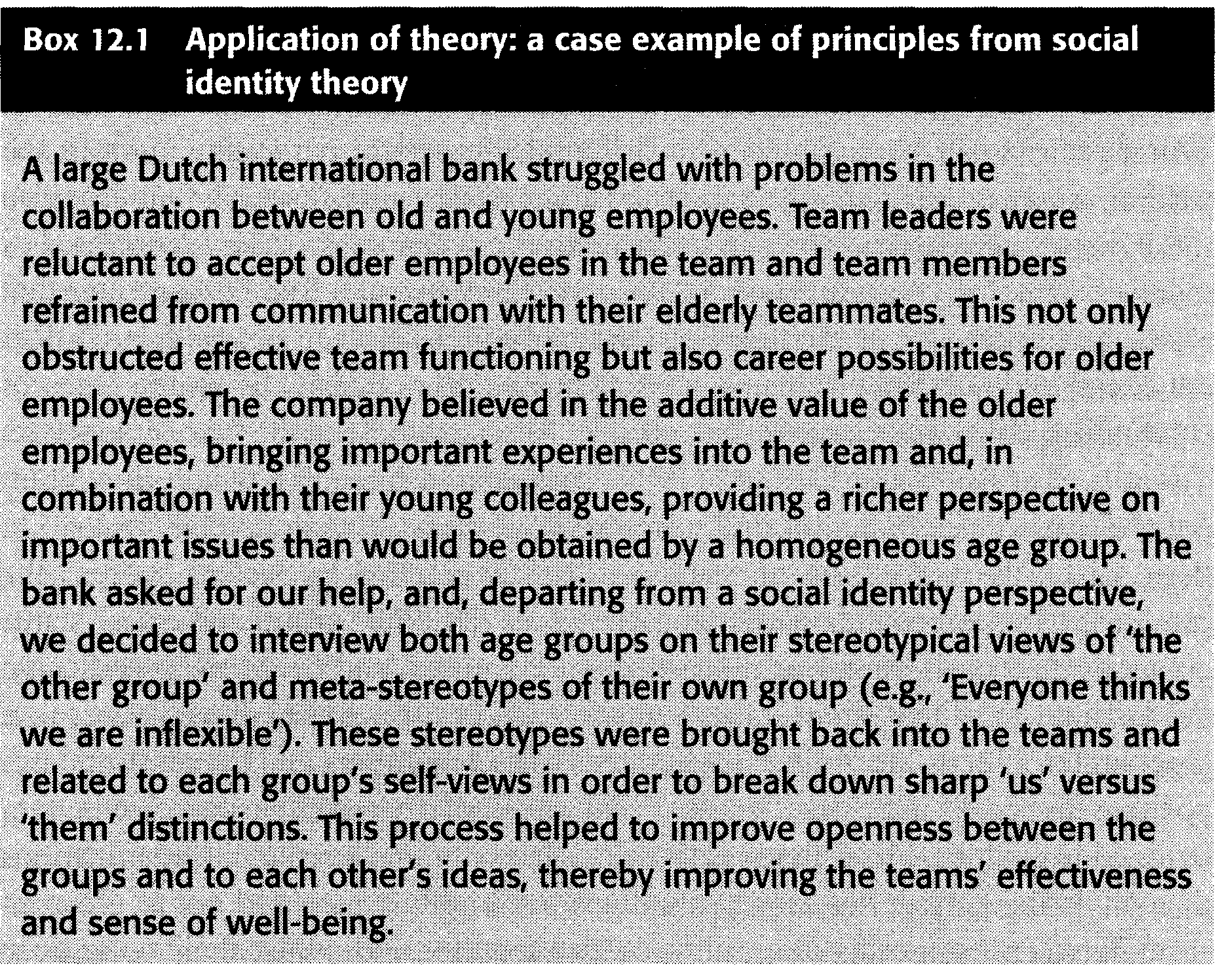

In sum, threat to identity may result in a perception of group members in terms of 'us' and 'them', which may lower work satisfaction and may preclude group members from benefiting from the new perspectives that other subgroups bring into the team. In order to reduce this threat, group members in diverse teams may primarily focus on ideas of ingroup members. A preference for ingroup ideas was supported by recent findings by Dugosh and Paulus (2005) that participants in a brainstorming session who were presented with a large number of ideas were sig­ nificantly more productive when they believed that these ideas had actually been generated by students with a similar creative aptitude than when they believed these ideas had been presented by a computer program. Prevention of ingroup threat may also explain the strong preference for shared information that was reported by Stasser and Titus (1985). Stressing those aspects that group members have in common rather than what divides them creates a shared group identity, which may serve important group needs and therefore enhance team satisfaction. Although we may eventually benefit more from dissimilar input, in many cases we feel more strongly motivated by ideas that confirm important social identities rather than those that provide the best source of exploration.



The processes described in the previous sections pose an interesting dilemma. Organizations need novelty to survive, but at the same time organiza­ tional members dislike and resist novelty, and they fall back on rigid functioning. This dilemma can be recognized in different theoretical paradigms both in the field of organizational change and in the areas of diversity research that focus on the *gains of new perspectives* in contrast to the *value of existing identities.* For instance, in research on diversity of the workforce, we can find perspectives that stress the importance of highlighting communalities between people from differ­ ent social and cultural groups, as well as perspectives that focus on the gains of celebrating differences among such groups. As an example of the first perspective, Triandis, Kurowski and Gelfand (1994) presented a model in which they point out the importance of promoting *perceived communalities* in diverse groups. In their model the perception of communalities is reached by factors such as the presence of superordinate goals, knowledge of the other group and equal status contact (cf. contact theory as discussed in Chapters 2 and 6). More specifically, the assumption is that equal status contact helps in coping with diversity because it generates a focus on similarities between group members and hence stimulates positive outcomes in diverse groups. The similarity perspective can also be rec­ ognized in **'colour-blind perspectives'** to diversity management. Organizations that subscribe a model of colour-blindness are highly concerned not to discrim­ inate between categories of employees and monitor and adjust their policies to ensure that this is the case. This focus on equal treatment makes them reluctant

to stress or even actively use potential differences between groups. In contrast, value-in-diversity approaches to diversity management warn against ignoring dif­ ferences between people (as in the colour-blind models) and suggest exploration of differences as an important strategic source for the organization (Harquail & Cox, 1993; Van Knippenberg & Haslam, 2003). For example, a consultancy aimed at promoting the welfare of children in different parts of the world may use the different cultural backgrounds of its employees to develop different versions of a child-support training module. Doing so enables them to be more effective across cultures. In this regard, Harquail and Cox (1993) argue that diversity is associated with positive outcomes in companies that are characterized by an intercultural group climate, that is, a climate in which diversity is positively valued, uncer­ tainties are tolerated and only few behavioural descriptions exist. By making the positive value of diversity explicit, group members will start to like differences more and be more sensitive to them. This can be done either by the strategic choice to use diversity actively or by radiating a group norm that diversity is a positive thing, This may ultimately stimulate well-being and performance in diverse groups. Consistent with this view, Nakui and Paulus (2007) showed that the superiority of diverse brainstorming groups in generating higher quality ideas was particularly prevalent when participants were told that their fellow group members appreciated diversity.

We believe that both communality and difference-focused perspectives are

useful and need to be on the agenda of companies. Lewin (1935) argued that all activities in groups evolve around two processes: cohesion and locomotion. Group members have a need for relational belonging and safety (cohesion goals) and a need to move towards the achievement of group goals (locomotion goals). According to Lewin, groups must have reached their cohesion goal in order to function effectively as a group; thus, the fulfillment of cohesion goals is a nec­ essary requirement for the fulfilment of locomotion goals. We believe that the communality and differences perspectives that can be distinguished in the liter­ ature on innovation, organizational change and diversity that we have discussed differ in their focus on cohesion and locomotion goals. In order to deal effectively with processes of change and diversity, organizations have to switch between a focus on similarities and differences in a dynamic way, dependent upon aspects of the organizational and team context.

Figure 12.2 presents processes of cohesion and locomotion in organizations as a function of the organizational and team context. At the organizational level, as we have discussed already, an organizational climate characterized by colour­ blindness primarily stimulates cohesion goals. In contrast, organizations who are more strongly oriented towards learning tend to emphasize locomotion rather than cohesion. Opportunities such as a sudden market for new products may also change the patterns of interactions of group members and their input in the group process, promoting locomotion. Moreover, both external and internal threats change the need for relational belonging and safety and thereby 'force groups' to switch from cohesion into locomotion and vice versa. On the one hand, a threat such as being faced with a common enemy (e.g., a competitor

Context factors Organizational climate Opportunities (new markets, technological developments) Threats (downsizing, competition)

Group/team factors

Group climate

Group composition (individual characteristics, demographic and functional diversity)

Time phase

Group threats (turnover, competition)

**Figure 12.2** *Processes of cohesion and locomotion in organizations as a function of organizational and team context*

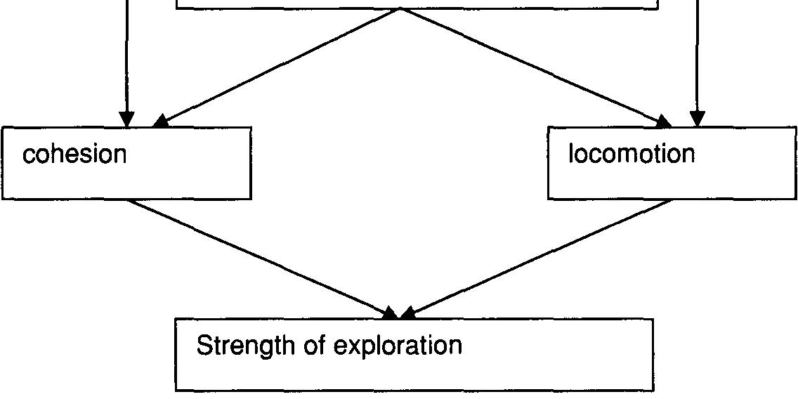

bringing a comparable product onto the market) may stop team members from an R&D department from focusing on their incompatibilities, which facilitates cohesion. On the other hand, an extra bonus for one of the teams may evoke competition and emphasis on mutual differences (locomotion).

In a similar vein, at the team level, the age of teams - that is, how long they have been in existence - seems to be an important context factor that influences which focus becomes dominant for effective functioning. It is well known that groups change over time, both in the way in which the group members relate to each other and in the activities that they perform. In this regard, recent formation seems to be related to a predominance of cohesion goals; over time locomotion goals become more important. It seems that group members first need some time to get used to each other and to form expectations and relations in order to be able to perform important aspects of group performance. In later phases they need to focus on locomotion in order to reach important performance goals. If teams in organizations fail to match their focus on either cohesion or locomotion to the requirements of the organizational and team context, sub-optimal function­ ing will be the outcome. If groups fail to reach reasonable trust in their earlier phases, focusing on differences in later phases is likely to result in emotional conflict. If groups are successful in reaching a similarity focus early on, but do

not switch to a focus on differences later, groupthink occurs, also preventing groups from becoming creative. **Groupthink** refers to the tendency for members of highly cohesive groups to conform so strongly to group pressures that they fail to think critically, rejecting the potentially correcting influence of disconfirming information or alternative perspectives.



How can work organizations intervene with the context factors men­ tioned in Figure 12.2 and the psychological processes that they evoke? How can they promote cohesion in periods of insecurity, tension and conflicts? How can they move their organization or teams within the organization from a cohesion to a locomotion focus in order to reach a healthy balance between comfort and innovation? Below we will discuss interventions aimed at changing the organi­ zational or team *context* and interventions that are directly aimed at changing patterns of *behaviour, cognitions or affect* that are the result of characteristics of that context.

**Promoting cohesion**

Interventions that are aimed at promoting cohesion have predominantly departed from a social identity perspective. As we have already discussed, identity threat posed by organizational change asks for gradual changes in the definition of organizational or team identities, and confirmation of those identities. The 'new' identity of the team can be made salient, for example, by articulating group mis­ sion statements, or celebrating group achievements in the direction of new goals. In a similar vein, when organizational groups are united into one group (as in the case of mergers), or if diversity causes subgroup formation in diverse teams, it may be useful to stress common group membership by activities such as formu­ lating a group dress code or creating a group logo, or by defining superordinate goals (such as adopting a school in a developing country as a team). Both in the case of organizational change and in the case of mergers, it may be important to be concerned about team stability, keeping the composition of groups similar over a certain period of time, in order to create a stable and identifiable context (Edmondson, 1999).

Cohesion may also be facilitated by changing the nature of the task. Whereas some tasks may foster a focus on communalities, others foster a focus on dif­ ferences. This is an issue that has been largely neglected in the literature (for an exception see Postmes, Spears & Cihangir, 2001). In general, communality­ focused tasks seem to be characterized by shared information and a joint solution that can be logically inferred from the information. A typical example is when all team members have a financial overview over the past year and have to compute the profit that was made. Moreover, tasks that facilitate a focus on communalities seem to be characterized by routine. When a task is simple and well understood,

group members can rely on standard operating procedures. Under these circum­ stances, debates about task strategy are unnecessary and unlikely, and everyone shares the same approach to the task.

**Promoting locomotion**

An effective way of promoting locomotion is to take measures to stimulate group members to express their unique viewpoints in the group. In this regard, introduc­ ing a 'devil's advocate', who has the explicit assignment to stimulate creativity in the group, is sometimes also advocated. A way to achieve this is to invite an outsider into the group (for example, a colleague from another department, or an external advisor) to take this role in the group process. It is unclear if it is more or less effective when a devil's advocate criticizes existing viewpoints in the group than when the same criticism is simply put forward by a group mem­ ber. The open and honest expression of disagreements that are naturally present in groups is usually referred to in the literature as **authentic dissent** (see Nemeth

& Nemeth-Brown, 2003, for a discussion). There is evidence to suggest that a

devil's advocate stimulates thoughts that confirm, rather than challenge, existing viewpoints. These studies suggest that groups with a devil's advocate are not motivated to explore the benefits of challenging views, nor do they display a stronger tendency to engage in **divergent thinking** (Nemeth & Nemeth-Brown,

2003). Divergent thinking refers to the process of reframing familiar problems in unique ways.

A way of promoting dissent in groups is to use *structured discussion and*

*brainstorming methods* (see also Box 12.2). Groups using these methods are instructed to (Osborn, 1957):

1. Concentrate on the quantity of ideas.

2. Don't criticize others' ideas.

3. Elaborate and build on others' ideas.

A focus on locomotion goals may also be stimulated by specific kinds of tasks. Examples are divergent thinking tasks or tasks that require a joint solution which is optimized if group members combine individual information or different perspectives (e.g., deciding on a holiday destination under conditions where each group member has information on a different destination and there is no shared knowledge on a specific destination). In this regard, a study by Postmes *et al.* (2001) indeed showed that if group members first engage in a critical thinking task they will be more inclined to share unique information in subsequent decision­ making tasks. In a more general sense, a focus on differences is likely to be evoked by complex tasks that require problem solving, have a high degree of uncertainty and have few set procedures. These tasks have in common that a wide variety of inputs is required in order to perform effectively.

A useful intervention based on social identity theory in this case is also **recat­**

**egorization,** aimed at making subgroup identities salient. Identification patterns

Box 12.2 Interventions:application of structured brainstorming methods in practice

•·. :·=·.··•.·· ·.·· :. •.••. •·. .• •.:::•.:·.··.. .•.•. ·•..:.···•.•...• ·.•.. '.....;;.•. ·•..;. ·..·...·•. ·.::·

:.··.. ;:' :··•... •·.•• :•.:.·•.·•.••.·•..•·•.·::.. ;.•: .:..··.•:.•:.:. ·...·.•..·.:•:.•. ••··.·. ;'• .·. •.·.=•:·.••••:..•:.·.:....·:

:••.·.·.·.'••:.·••:.··:.·.;·····. ·.:.-.•.= :..• •.·.•. • ••..·...·• ·=•••••..••••·•••:..•.··•..•=. :••••••···••.;:. .:•.:.•••··.·.=.:.

•.• ..•••·.•.••.·•••.· ••.·.:. •.• . •. ••••. •.·•••·. ·..•.;.. •. :•·•••·•. •••· ..••·.•..••. .·.. ·•• .·..·•.·••·• .••·. •• ·.•.•• ···•••·..••..•·

Stlttond Hr .....•.............•............. )·.······•·•···· i ;() r,instpr ing

gr upsi ··IE) ,•·• r n)P'ny.· bat p cja·li esin•. ign..••1Jl J se r hers

i ··

a eet

... i ' n i¥ 1t!eii H ·o·..·...·..·.···.··········· ..... tearT)s f r e hs, Ttf()rJ11ed

r tros ·i..·.·.·..• •.·.· •..·.·..··.··..·.·······•··· · t)..·.. • ·......•.·..·· ·•·.··················.·.. E t is o pany

brain ()rn1i . ·· es were.pri(lte cm•·tt. .•wallsef e···c P J'tY···l"l)e study

method did not al testin . olo termsof·elfeaive idea

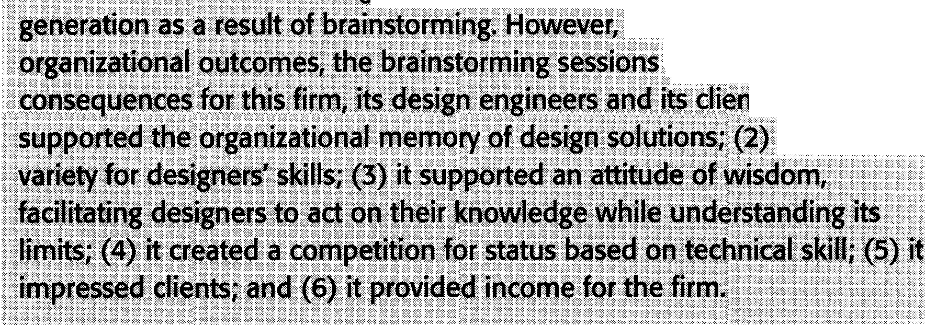

fotus· t>ader

hei4 jimpgrtailt

ts=•·(ll•·it

it. provided

with subcategories can be enforced by recategorization procedures, such as using symbols or by paying explicit attention to the different backgrounds in a team, to make category memberships salient (Gonzalez & Brown, 1999). Introduc­ tion of 'threat' has also been advocated as a means of 'unfreezing' strong identification with the status quo (Lewin, 1958). For example, willingness to change among employees can be gained by presenting data that indicate that a serious problem exists in the organization, or by describing the negative con­ sequences of not changing the status quo for the future of the team and its members.

**Flexibility in cohesion and locomotion**

It is obvious that organizations cannot continuously influence the focus of employee identities in different directions, in order to serve cohesion and loco­ motion purposes, or create different tasks dependent upon the stage at which they find themselves. Two aspects of organizational climate that have been mentioned in the literature and that may benefit both cohesion and locomotion goals are psy­ chological safety and innovation. The first aspect, psychological safety, refers to a shared belief that well-intentioned interpersonal risks will not be punished (Edmondson, 1999). Psychological safety allows for the expression of concerns, without the fear of losing one's job or opportunities for advancement. Moreover, it promotes behaviours such as experimentation and help seeking that are important for learning and responding to organizational change. According to Anderson and West (1998) an organizational climate that stimulates innovation is characterized by:

• vision: a sense of valued outcomes represented by clear goals and motivating forces;

• participative safety: involvement in decision making occurring in an interper­

sonally non-threatening environment;

• task orientation: shared concern over excellence of the quality of task performance;

• support for innovation: stimulation of attempts to introduce new ways of doing things in the work environment.

All these dimensions share a concern with cohesion, as indicated by a sense of sharedness or organizational support as well as a concern with locomotion, as indicated by goal setting, standards of innovation and a concern with excellence.

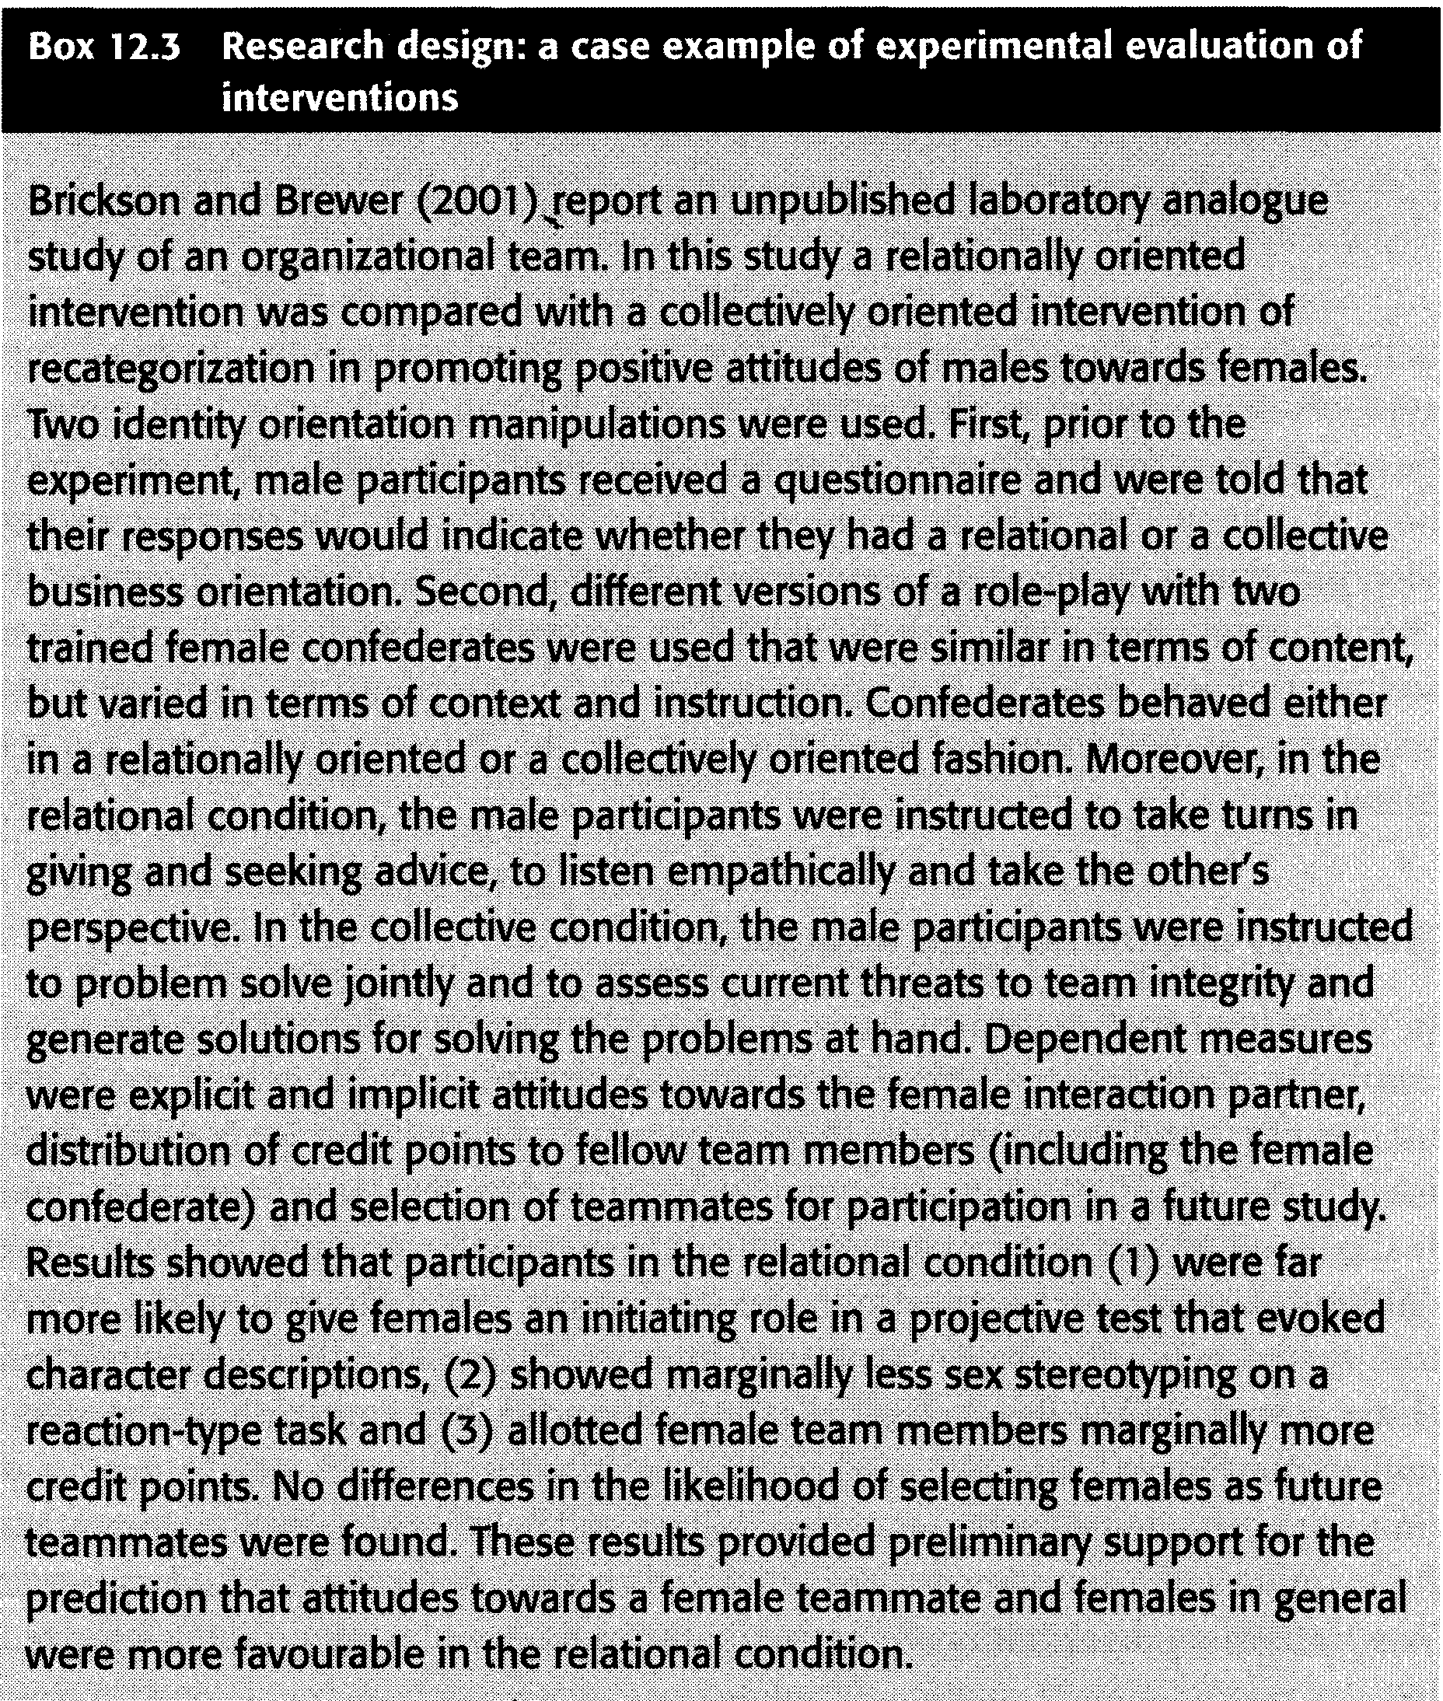

At the level of employees, a balance between a focus on communalities and differences may require identity orientations that are more flexible than the social category memberships that we discussed in the previous sections (team versus subgroups). It has been recognized only recently that the social self is not neces­ sarily based on group identities but can also revolve around personal bonds with other individuals. Brewer and Gardner (1996) referred to the part of the social self that includes representations of (close) relationships with others as **relational identity orientation.** When a relational identity orientation is salient, the situ­ ation is defined in terms of mutual relationships rather than in terms of group membership and constituent norms. A focus on relationships with other individu­ als at work goes along with empathy and positive affect. Imagine the example of an employee who mentors a colleague in weekly meetings where they discuss the latter's uncertainties and problems at work. This promotes mutual understanding and enhances constructive collaboration. Interpersonal relationships may repre­ sent a better ground for cohesion and locomotion than groups: within relationships there seems to be a continuous switch between emphasizing communalities that form the relationship and empathizing with the unique needs and thoughts of the other person, while in larger, more impersonal collectives such as teams, there seems to be a strong pressure towards uniformity. A relational orientation within organizations is promoted by organizing work in small-scale and temporary work structures, creating opportunities for informal contact and mentorships (Erickson

& Brewer, 2001; see Box 12.3 for experimental procedures).



Of course, issues of change or stability cannot be completely understood solely from social psychological perspectives. Economists, for example, have a longstanding tradition in trying to understand innovative endeavours from the eco­ nomic advantages they bring. Since the driving force for companies will always be their need to survive and therefore to be profitable, strategic change in organi­ zations cannot be understood simply from social cognitive and social motivational factors. Therefore, social-psychological analyses need to be complemented with rational analyses of expected utilities of strategic change in response to chal­ lenges or threats in the environment. An interesting example in this regard is the current economic growth in Asian countries, which is overshadowing that of Europe and the United States. The major response in the Western world has been one of fear of Asia 'taking over the world market' as well as fear of losing jobs as a result of outsourcing labour. This response can easily be understood from the identity and threat perspectives that we have discussed in this chapter. However, a recent economic analysis by Grant Thornton *(International Business Owners Survey,* 2006) suggests that the economic developments in Asia may promote rather than threaten business opportunities for Western countries. The Chinese economic boom, for example, is perceived by international companies

in the United States and in Europe (e.g., Sweden, Germany and the Netherlands) to increase rather than to reduce their business opportunities. These opportunities include both import opportunities, particularly from China, and, to a lesser extent, export opportunities for commodities and machinery. Such economic analyses are undoubtedly of major importance and may in Lewin's (1958) terms eventually even work as a 'defreezing factor', reducing resistance to innovative responses to such developments on the global world market.

We have tried to clarify that also at the more detailed level of *actually produc­ ing* the creative ideas that underlie organizational innovations or change. Social psychologists tend to take a cognitive or social perspective, focusing on stimu­ lating and inhibiting forces that influence idea generation and sharing in work groups (e.g., the presence of ideas that have associative value, group pressures or psychological safety). For example, in approaching the issue of psychological safety, social psychologists usually point at the importance of climate factors, col­ laboration or leadership behaviour. With this focus social psychology has tended to overlook the importance of more formal incentives or threats that are attached to being creative. What if your individual ideas are stolen by someone else? Or what if the company comes up with a new formula for shampoo that is copied by its competitors? Scientists in economics and law have paid much more atten­ tion to these issues. A rich literature can be found that deals with the issue of how to ensure recognition of creative ideas of single individuals while at the same time stimulating the sharing of knowledge that is necessary for innovation. This is usually done by analysing the outcomes of antitrust laws and different ways of protecting intellectual property. These formal protections have a strong impact on employee and company behaviour. We definitely need to take these issues into account when we put effort into changing cultures or leadership. In approaching problems of innovation and creativity, it is therefore important to seek collaboration with economists and law scientists and to integrate their per­ spectives with social-psychological approaches. The same openness to different viewpoints that benefits innovation also seems crucial to scientific progression in a complex world.



We have argued that the dynamics of modern organizations require con­ tinuous exploration of differences and new developments. From social identity theory we explained that individuals will strive for temporal stability of their identities, as well as stability in their perceptions of ingroups and outgroups. This may explain why in organizational practice resistance to change is strong, and diversity is surrounded by intergroup tensions. Up till now, social and cognitive approaches to issues of change and diversity have lived relatively separate lives (see also Van Knippenberg *et al.,* 2004). In order to benefit from the insights of social psychology, there is a strong need for such integrative endeavours. We have

argued that effective functioning of modem organizations therefore requires that exploration activities that serve locomotion purposes of organizations need to be balanced with concern for group cohesion. For modem organizations this sug­ gests that they cannot simply be as flexible as introductions to many textbooks on organizational developments (and also the first sentences of this chapter) suggest. Paradoxically, it is particularly in the face of changes that companies need to pay attention to communicating shared and stable organizational identities to their members.



Associative network: network structure of ideas in the brain in which the closest connections are between those ideas that are semantically related, and more indirect and distal connections are between ideas that are less closely related. Authentic dissent: open and honest expression of disagreements that are natu­

rally present in groups.

Cohesion goals: goals in groups directed at serving members' need for relational belonging and safety.

Colour-blind perspective: approach to diversity management in companies characterized by a focus on communalities rather than differences, and on equal rights and opportunities for all employees regardless of their background.

Divergent thinking: the process of reframing familiar problems in unique ways. Group creativity: fluency, flexibility and originality of thoughts that are pro­

duced by groups.

Groupthink: the tendency for members of highly cohesive groups to conform so strongly to group pressures that they fail to think critically, rejecting the potentially correcting influence of disconfirming information or alternative perspectives.

Ingroup assimilation: tendency to exaggerate similarities with ingroup mem­

bers.

Innovation: the introduction of new and improved ways of doing things in orga­

nizations.

Intercultural group climate: climate in which diversity is positively valued, uncertainties are tolerated and only few behavioural descriptions exist.

Locomotion goals: goals in groups aimed at the achievement of central work outcomes.

Outgroup contrast: tendency to exaggerate differences with outgroup mem­

bers.

Psychological safety: shared belief that well-intentioned interpersonal risks will not be punished.

Recategorization: enforcing alternative categorizations among individuals. Relational identity orientation: part of the social self that includes representa­

tions of (close) relationships with others.

**Social identity:** part of one's identity that is derived from the social groups to which one belongs.

**Social identity theory:** theory which posits that group membership forms an important component of social identity, and that people strive to attain or main­ tain a positive self-image by engaging in favourable comparisons between their ingroups and various outgroups.

**Threat-rigidity effect:** pattern of rigid thinking that is the result of feelings of threat, caused by stress, anxiety or physiological arousal.



1. A study by Van Knippenberg and Van Leeuwen (2001) showed that in the case of mergers, identification with the old organization was solely related to identification with the new organization, if employees felt that their old orga­ nization was represented in the merged company. Try to explain this finding from social identity theory and from a threat-rigidity perspective.

2. Try to link the four dimensions of an innovative climate (Anderson & West,

1998) with the three dimensions of an intercultural group climate (Harquail

& Cox, 1993, see glossary). Do you recognize any similarities? How do you personally think these dimensions are related to the goals of cohesion and locomotion?

3. A company consults you because they are faced with low flexibility and lack of

integration of older employees (see also Box 12.1). How would you diagnose this company in terms of a focus on cohesion versus locomotion? Which of the interventions (aimed at this focus) that are discussed in the chapter are applicable here? Which intervention would you preferably use in order to help this company?



Hogg, M.A. & Terry, D. J. (2001). *Social identity processes in organizational contexts.*

Hove: Psychology Press.

Leana, C. R. & Barry, B. (2000). Stability and change as simultaneous experiences in organizational life. *Academy of Management Review,* 25,753-759.

Paulus, P. B. & Nijstad, B. A. (2003). *Group creativity: Innovation through collaboration.*

New York: Oxford University Press.

Staw, B. M., Sandelands, L. E. & Dutton, J. E. (1981). Threat-rigidity effects in organi­

zational behavior: A multilevel analysis. *Administrative Science Quarterly, 26,*

501-524.

Van Knippenberg, D., De Dreu, C. K. & Homan, A. C. (2004). Work group diversity and group performance: An integrative model and research agenda. *Journal of Applied Psychology, 89,* 1008-1022.



Anderson, N. & West, N. R. (1998). Measuring climate for work group innovation: Devel­ opment and validation of the team climate inventory. *Journal of Organizational Behavior, 19,* 235-258.

Argyris, C. & Schon, D. (1978). *Organizational Learning.* Reading, IN: Addison-Wesley. Austin, J. R. (1997). A cognitive framework for understanding demographic influences in groups. *International Journal of Organizational Analysis,* 5, 342-360.

Brewer, M. B. & Gardner, W. (1996). Who is this "We"? Levels of collective iden­

tity and self representations. *Journal of Personality and Social Psychology, 71,*

83-93.

Brickson, S. & Brewer, M. (2001). Identity orientations and intergroup relations in orga­ nizations. In M. A. Hogg, & D. J. Terry (eds.), *Social identity processes in organizational contexts* (pp. 49-66). Hove: Psychology Press.

Dirks, K. T., Cummings, L. L. & Pierce, J. (1996). Psychological ownership in

organizations: Conditions under which individuals promote and resist change. In R. Woodman & W. Pasmore (eds.), *Research in organizational change and development* (Vol. 9, pp. 1-23). Greenwich, CT: JAI Press Inc.

Dugosh, K. L. & Paulus, P. B. (2005). Cognitive and social comparison processes in brainstorming. *Journal of Experimental Social Psychology, 41,* 313-320.

Dutton, J., Dukerich, J. & Harquail, C. (1994). Organizational images and member iden­

tification. *Administrative Science Quarterly, 39,* 239-263.

Edmondson, A. (1999). Psychological safety and learning behavior in work teams. *Admin­*

*istrative Science Quarterly, 44,* 350-383.

Gonzalez, R. & Brown, R. J. (1999). Maintaining the salience of subgroup and superor­ dinate group identities during intergroup contact. Paper presented at the Small Group Preconference of the Annual Meeting of the Society of Experimental Social Psychology, St. Louis, MI, 14-16 October.

Grant Thornton (2006). *International Business Owners Survey.* www.international­

businessreport.com

Harquail, C. V. & Cox, T., Jr (1993). Organizational culture and acculturation. InT. Cox, Jr (ed.), *Cultural diversity in organizations: theory, research and practice* (pp.

161-176). San Francisco: Berret-Koehler Publishers.

Janis, I. L. (1982). *Groupthink: Psychological studies of policy decisions and fiascoes.*

Boston: Houghton Mifflin.

Lewin, K. (1935). *A dynamic theory of personality.* New York: McGraw-Hill.

(1958). Group decision and social change. In E. E. Maccoby, T. M. Newcomb & E. L.

Hartley (eds.), *Readings in Social Psychology,* (pp. 197-211). New York: Holt, Rinehart & Winston.

Louis, M. R. & Sutton, R.I. (1991). Switching cognitive gears: From habits of mind to active thinking. *Human Relations, 44,* 55-76.

Mannix, E. & Neale, M.A. (2005). What differences make a difference? *Psychological*

*Science in the Public Interest,* 6, 31-55.

Nakui, T. & Paulus, P. B. (2007). *Diversity and outcomes of brainstorming teams.*

Manuscript submitted for publication.

Nemeth, C. J. & Nemeth-Brown, B. (2003). Better than individuals? The potential benefits of dissent and diversity for group creativity. In P. B. Paulus & B. A. Nijstad

(eds.), *Group Creativity: Innovation and collaboration in groups* (pp. 63-84). New York: Oxford University Press.

Nijstad, B. A., Stroebe, W. & Lodewijkx, **H.** F. M. (2002). Cognitive stimulation and

interference in groups: Exposure effects in an idea generation task. *Journal of*

*Experimental Social Psychology, 38,* 535-544.

Osborn, A. F. (1957). *Applied imagination: Principles and procedures of creative thinking.*

2nd edn. New York: Scribners.

Postmes, T., Spears, R. & Cihangir, S. (2001). Quality of decision making and group norms. *Journal of Personality and Social Psychology, 80,* 918-930.

Rietzschel, E. F., Nijstad, B. A. & Stroebe, W. (2005). Productivity is not enough: A

comparison of interactive and nominal brainstorming groups on idea generation and selection. *Journal of Experimental Social Psychology, 42,* 244-251.

Stasser, G. & Titus, W. (1985). Pooling ofunshared information in group decision making: Biased information sampling during discussion. *Journal of Personality and Social Psychology, 48,* 1467-1478.

Staw, **B.** M., Sandelands, L. E. & Dutton, J. E. (1981). Threat-rigidity effects in organi­

zational behavior: A multilevel analysis. *Administrative Science Quarterly, 26,*

501-524.

Sutton, R.I. & Hargadon, A. **B.** (1996). Brainstorming groups in context: Effectiveness in a product design firm. *Administrative Science Quarterly,* 41,685-718.

Tajfel, **H.** & Turner, J. C. (1979). An integrative theory of intergroup conflict. In W. G.

Austin & S. Worchel (eds.), *The social psychology of intergroup relations* (pp.

33-48). Monterey, CA: Brooks/Cole.

Triandis, H. C., Kurowski, L. L. & Gelfand, M. **J.** (1994). Workplace diversity. In H. C.

Triandis, M.D. Dunnette & L. M. Hough (eds.), *Handbook of industrial and organizational psychology* (Vol. 4, pp. 767-827). Palo Alto, CA: Consulting Psychologists Press, Inc.

VanderZee, K. 1., Atsma, N. & Brodbeck, F. (2004). The influence of social identity and

personality on outcomes of cultural diversity in teams. *Journal of Cross-Cultural*

*Psychology, 35,* 283-303.

Van Knippenberg, D., De Dreu, C. K. & Homan, A. C. (2004). Work group diversity and group performance: an integrative model and research agenda. *Journal of Applied Psychology, 89,* 1008-1022.

Van Knippenberg, D. & Haslam, S. A. (2003). Realizing the diversity dividend: exploring the subtle interplay between identity, ideology, and reality. InS. A. Haslam, D. van Knippenberg, M. **J.** Platow & N. Ellemers (eds.), *Social identity at work: Developing theory for organizational practice* (pp. 61-77). New York and Hove: Psychology Press.

Van Knippenberg, D. & Van Leeuwen, E. (2001). Organizational identity after a merger: Sense of continuity as the key to post-merger identification. In M. A. Hogg

& D. **J.** Terry (eds.), *Social identity processes in organizational contexts* (pp.

249-264). Philadelphia, PA: Psychology Press.

Williams, K. & O'Reilly, C. (1998). The complexity of diversity: A review of forty years of research. In D.Gruenfeld & M. Neale (eds.), *Research on managing in groups and teams.* Greenwich, CT: JAI Press.