Logos and Slogan
Coca-Cola company has been an outstanding firm in the production and distribution of bottled beverage branded by the company’s name “Coca-Cola”, all over the world for the past centauries. The company not only produces the cola flavored soft drink but also a wide variety of other products like Fanta, Sprite, Krest, and Stoney which are sold under the marking name of Coca Cola company (Coca Cola, 2019). Even though the firm has branches globally, some their products are not sold in some states. The company’s bottling areas that are distributed all over the world that are responsible for dilution process before redistributing them to wholesale and retails across the globe (Emily, 2016). The company has been involved in many activities across the world like sponsorship of games and other important events that has branded the companies logo which has lasted in the eyes of its consumers.
Coca-Cola company has always been used in sporting activities because of its absolute power to quench thirst instantly. As we all know eyes are always attracted to shouting colors especially the yellow color which is at most related to ripe and sweet things. The brand also stands for family and goodwill values because of its regular association with festivals and ceremonies like weeding, Christmas where family and friend reunite and celebrate. Most of these events involves various colors especially yellow and white which are considered to be the source of originality, therefore, the slogan of Fanta which is “be more than one flavor,” suits the company for the numerous connections it deals with (Business Wire, 2019).
I am going to use "Sweeten Your Heart” as the new slogan of Coca Cola because for Coca-Cola lovers, Coca-Cola's sweet flavor is very popular with customers. I am also a fan of Coca-Cola, although Coca-Cola is not such a healthy drink, but I still like it from the bottom of my heart. For the logo, I am using the red and black color because the red color represents the passion and love; the black color give the nature color of Coca-Cola.
The brands product is mostly loved by kids due to its flavor and the sweet taste that is in Coca Cola beverage that will enhance the sales of the company’s simultaneously (Richard, 2016). The brand creates a lot of happy moments together in life as it has stood out during many sponsorships either academically or in sporting events that has made the brands name grow for miles and in decades. With a more conceiving and attractive slogan and logo, the company’s prosperity will endure and maintain its position in the market.
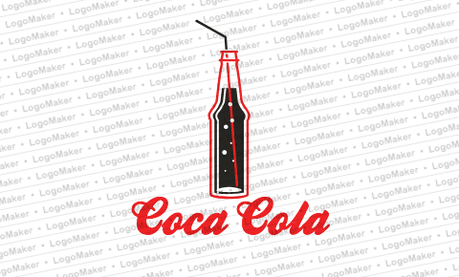

Reference:
Coca-Cola Company. (2019). Brand. Retrieved from https://www.coca-colacompany.com/packages/brands
Emily Goodhart. (2016). Giving Back. Retrieved on December 6th, 2016 from https://www.coca-colacompany.com/stories/delivering-more-than-beverages-how-coke-s-distribution-network-helped-two-schools-make-dreams-come-true
Business Wire. (2019). Be More Than One Flavor™”: Fanta® Inspires Self-Expression with New Summer Campaign. Retrieved from https://www.businesswire.com/news/home/20170727005635/en/%E2%80%9CBe-Flavor%E2%84%A2%E2%80%9D-Fanta%C2%AE-Inspires-Self-Expression-New-Summer
Richard Feloni. (2016). 7 strategies Coca-Cola used to become one of the world's most recognizable brands. Retrieved from https://www.businessinsider.com/strategies-coca-cola-used-to-become-an-iconic-brand-2016-2
LogoMaker, (2019). Retrieved from https://secure.logomaker.com/home-return

