By
Jennifer Maloney and

Jennifer Maloney
The Wall Street Journal
- Biography
- @maloneyfiles
- Google+
- Jennifer.Maloney@wsj.com
Saabira Chaudhuri

Saabira Chaudhuri
The Wall Street Journal
- Biography
- @saabirac
- Google+
- Saabira.Chaudhuri@wsj.com
April 23, 2017 1:31 p.m. ET
137 COMMENTS
Your browser does not support HTML5 video.

Your browser does not support the audio tag.
Why Big Tobacco Didn’t Fail

Revenues for U.S. tobacco companies hit $117 billion in 2016, up from $78 billion in 2001. How the industry succeeded despite lawsuits, rising taxes and declining smoking rates. Illustration: Heather Seidel/The Wall Street Journal
Your browser does not support HTML5 video.

Your browser does not support the audio tag.
Why Big Tobacco Didn’t Fail

Revenues for U.S. tobacco companies hit $117 billion in 2016, up from $78 billion in 2001. How the industry succeeded despite lawsuits, rising taxes and declining smoking rates. Illustration: Heather Seidel/The Wall Street Journal
TOBACCOVILLE, N.C.—It’s a great time to be a cigarette company again.
Far fewer Americans are smoking, and yet U.S. tobacco revenue is soaring, thanks to years of steady price hikes. Americans spent more at retail stores on cigarettes in 2016 than they did on soda and beer combined, according to independent market-research firm Euromonitor International. Consolidation and cost cutting are boosting profit. Big Tobacco shares are on a roll.
Two decades ago, such a boom didn’t seem possible. The industry faced a future of increasing regulation and declining sales, as older smokers quit and fewer young people picked up the habit. States were suing for billions of dollars. Bankruptcies for some players seemed just around the corner.
Things didn’t turn out so badly, though. Costs from an avalanche of legal settlements and regulatory requirements have been heavy, but they haven’t put any big players out of business. Cigarette makers found they could more than make up for falling volumes with higher prices.
“We came out of a challenging period,” said Marty Barrington, chief executive of Marlboro maker Altria Group Inc., in an interview.
The number of cigarettes sold in the U.S. fell by 37% from 2001 to 2016, according to Euromonitor. Over the same period, though, companies raised prices, boosting cigarette revenue by 32%, to an estimated $93.4 billion last year. An average pack in the U.S. cost an estimated $6.42 in 2016, up from $3.73 in 2001, according to TMA, an industry trade group.
Smoking-Hot Returns
Although the number of cigarettes purchased each year has been dropping, tobacco companies have been making more money. The rising price of a pack is a big factor in the tobacco companies’ growing profits, even though state and federal taxes eat a hefty portion of the sales price.
Cigarettes sold in the U.S.*
Total U.S. tobacco profit pool
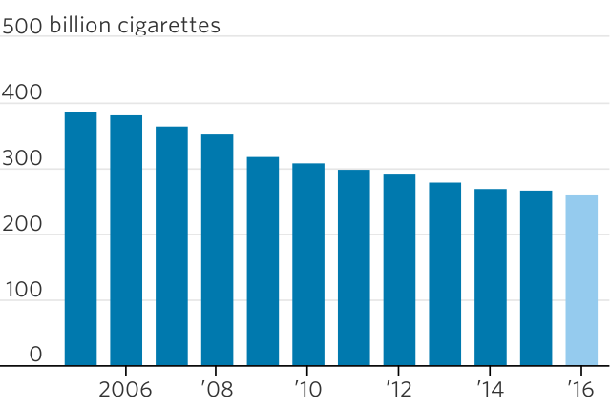
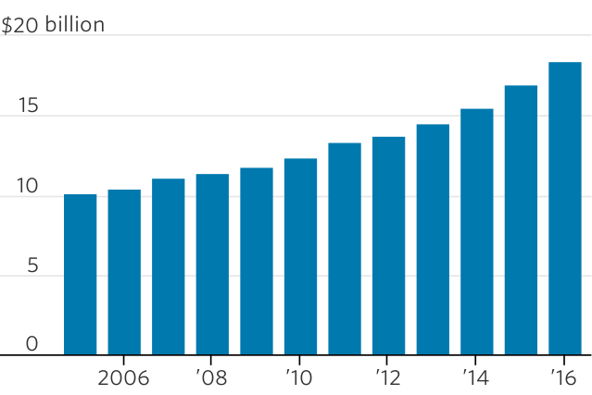
Average price of a pack of Marlboros
Taxes as a percentage of retail price†
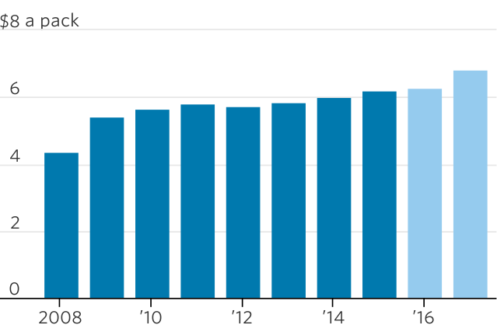
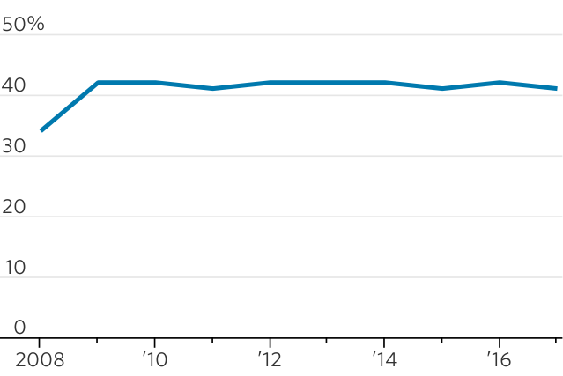
*2016 is an estimate †For a pack of Marlboros Note: 2016 and 2017 data are estimates for average price and taxes for a pack of Marlboros.
Sources: Euromonitor International (cigarettes sold); Company reports and Bank of America Merrill Lynch Global Research estimates (profit pool); Wells Fargo (price per pack, taxes)
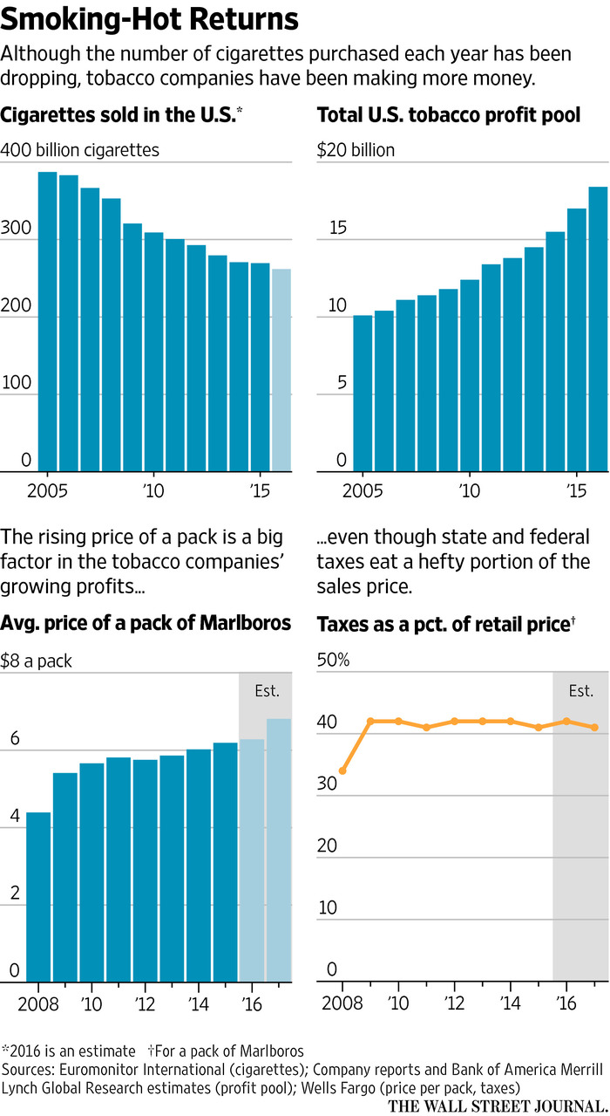
A flurry of consolidation has winnowed the U.S. tobacco market from seven big players to two: Altria and Newport maker Reynolds American Inc., which together sell eight out of every 10 cigarettes in the country. As companies combined, they squeezed out costs and increased pricing power, along with profits.
The operating profits of U.S. tobacco manufacturers have grown 77% since 2006 to $18.4 billion in 2016, according to Bank of America Merrill Lynch Global Research. Industry executives and analysts now figure the country generates more tobacco profits than any other market in the world outside China, where a state-run monopoly controls sales and prices.
Johnny Cagigas oversees the machines that spit out as many as 10,000 “sticks” a minute at Reynolds American’s plant here. He started out in the industry 20 years ago, and remembers the pressure and worries over an uncertain future.
When he tried to fill positions in the late 1990s at a Brown & Williamson factory in Macon, Ga., he says job candidates would ask, “Do you think they will shut you down?” Many refused offers.
“In a blessed way, I started at the right time, because now I’m getting to ride a wave that people were used to back in the ’60s and ’70s,” he says in his office, nestled inside a complex where overhead conveyor belts push along neatly stacked Newports. Robots squirt orange liquid into e-cigarette cartridges. “Uncertainty doesn’t faze us a whole lot now,” he says.
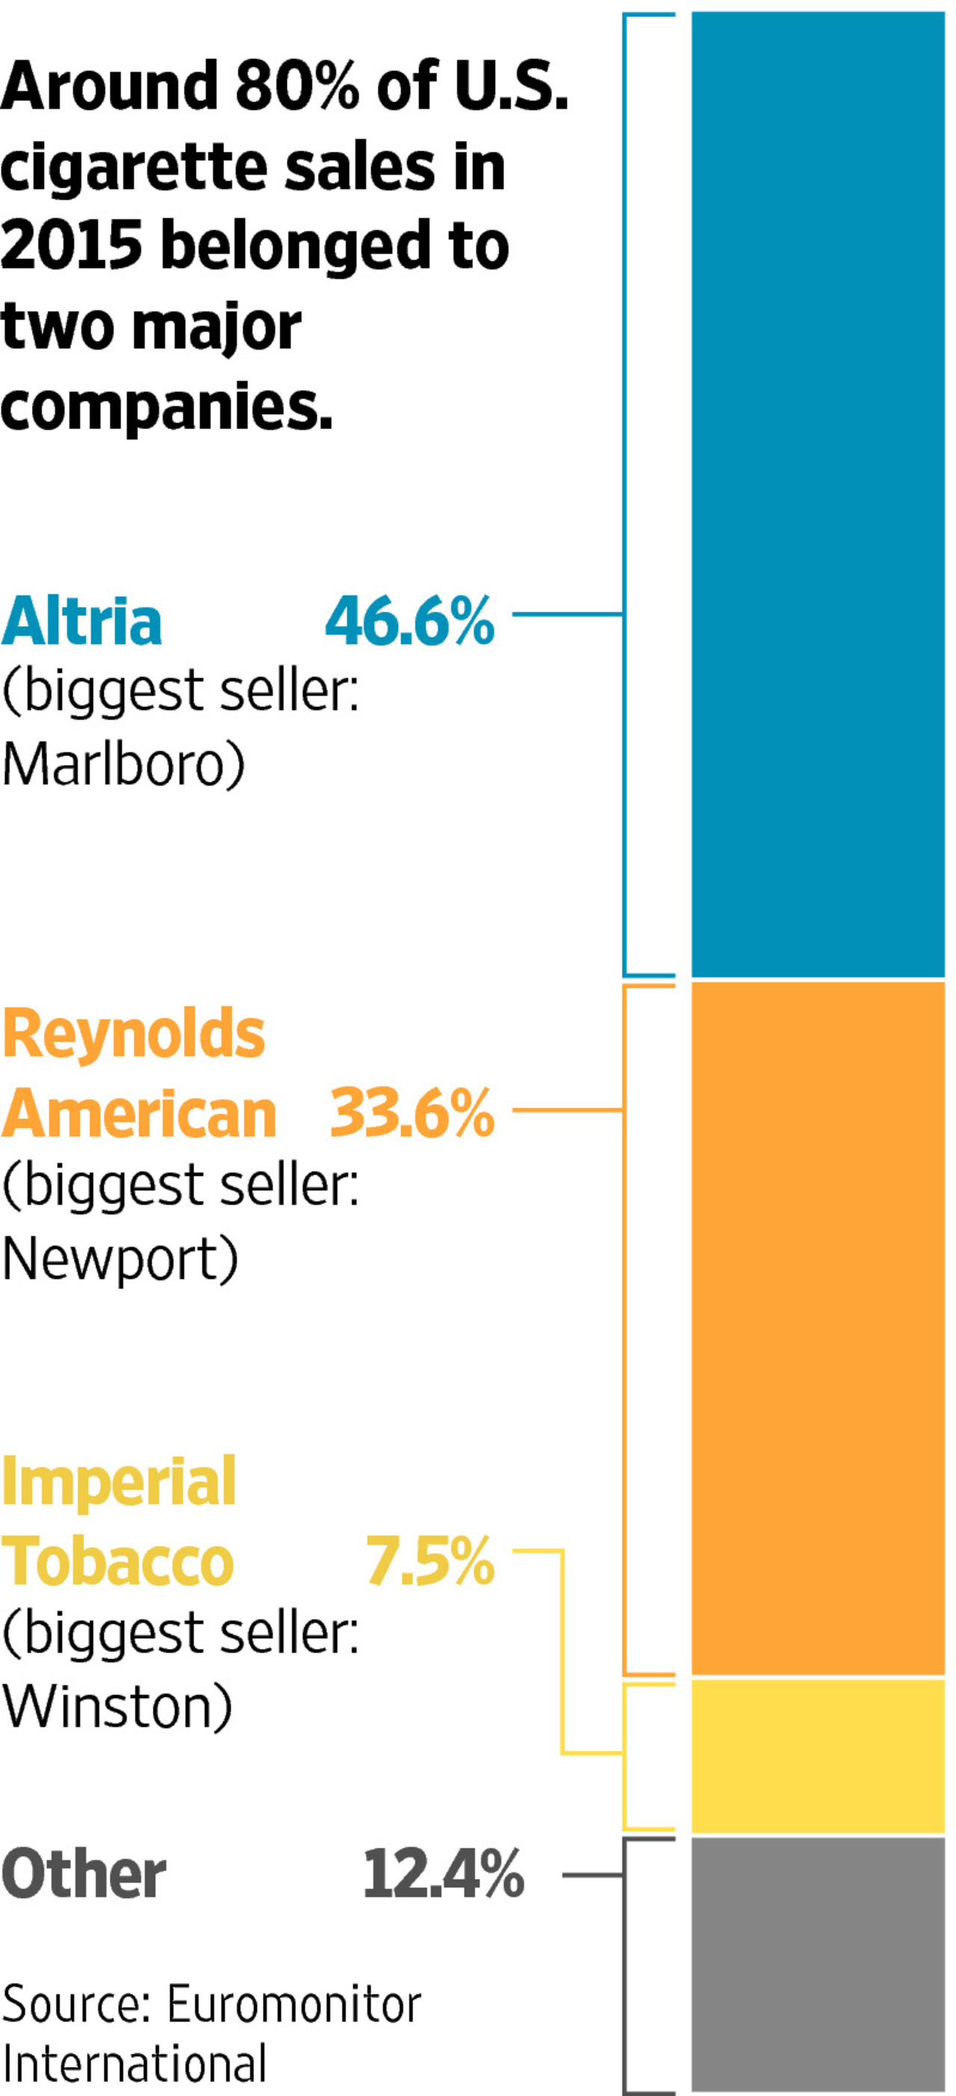
Investors are also cheering. In 2000, U.S. tobacco companies’ price-to-earnings ratios were about a third of their consumer-staples peers’. Today, they’re roughly 10% higher, according to Morgan Stanley. The S&P 500 Tobacco Index fell 22% between 1998 and 2002. Over the past decade, it’s up 178%, outperforming the broader S&P 500, which climbed 58%.
The industry sells 5.5 trillion cigarettes each year to the world’s one billion smokers. In many ways, the U.S. has become attractive again as opportunities around the rest of the globe wane.
Taxes are often lower in the U.S. than elsewhere in the developed world, according to World Health Organization data. About 42% of the average U.S. pack price is tax, according to TMA. In Britain, meanwhile, taxes make up 82% of the average pack, which sells for about $10.90, or about $4 more than the average U.S. price, according to Britain’s Tobacco Manufacturers’ Association.
Thanks partly to the First Amendment, U.S. tobacco makers also aren’t constricted by some of the more stringent branding and health-warning rules introduced elsewhere. In Britain and Australia, cigarettes are sold in drab, greenish-brown packs with a large health warning and a graphic photo illustrating smoking’s risks, from diseased lungs to blindness.
Some Middle Eastern and African markets are growing, thanks to rising populations and income. But in much of the rest of the emerging world, smoking is on the decline, with less opportunity than in the U.S. to boost prices to make up the difference.
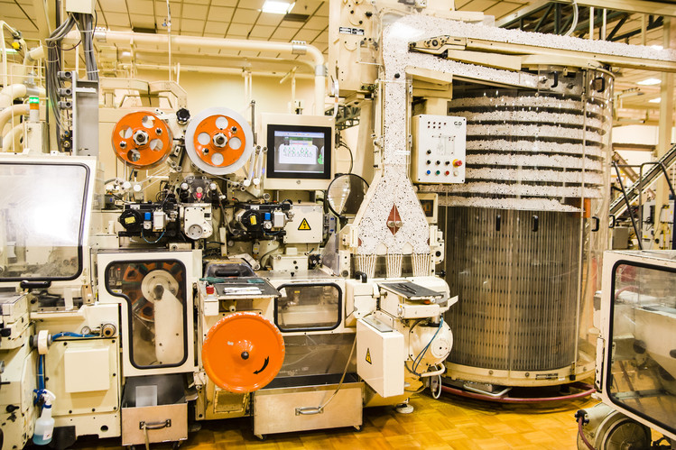
The RJ Reynolds Tobaccoville manufacturing facility. Photo: RAI Services Company
China is by far the world’s biggest market, where state-owned China National Tobacco Corp. sells 44% of the country’s cigarettes. In 2015, volumes fell there for the first time in two decades after big tax increases. Russia, the world’s second-biggest market, restricted advertising and banned smoking in public places in 2013. Those moves cut volumes sharply.
While all that makes the U.S. relatively more attractive, it also underscores the existential threat still hanging over the industry. No one expects volume declines anywhere to reverse, and price hikes can make up for that for only so long.
Tighter regulation and higher taxes remain big threats both in the U.S. and abroad. On April 1, California raised cigarette taxes by $2 a pack. And last week, New York Mayor Bill de Blasio threw his support behind proposals to raise the minimum price per pack to $13 from $10.50 and, through attrition, slash the number of retailers licensed to sell tobacco products.
A U.S. law passed in 2009 leaves open the possibility that the Food and Drug Administration could one day ban menthol cigarettes—a major revenue driver for Newport owner Reynolds—based on the agency’s 2013 finding that they likely pose a greater health risk than regular cigarettes. The law also gives the FDA the authority to mandate the reduction of nicotine levels in cigarettes to near zero.
Faced with these headwinds, tobacco executives know today’s boom won’t last forever, and are investing heavily to develop products they say are safer.
Altria and Reynolds both have diversified into smokeless tobacco—a market still growing by volume. Reynolds sells nicotine gum, while Altria owns a wine business in Washington state and has a 10% stake in Anheuser-Busch InBev NV, the world’s largest brewer.
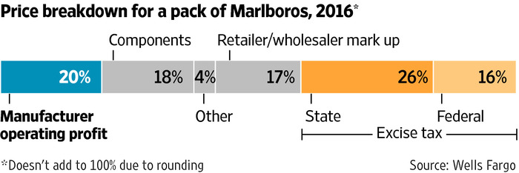
Philip Morris International Inc., spun off by Altria in 2008 to pursue non-U.S. business, has spent $3 billion developing next-generation products, including a device, called IQOS, that delivers nicotine by heating sticks of tobacco instead of burning them. Philip Morris says its internal studies have shown that by avoiding combustion, the product prevents or reduces the release of many harmful compounds. The company has asked the FDA for authorization to market IQOS as less harmful than cigarettes through a partnership here with Altria.
British American Tobacco PLC, which makes Dunhill and Pall Mall, has spent $1 billion over the past five years developing so-called next-generation products, including its vapor brand Vype and its own heat-not-burn product.
For now, though, revenue from those products remains a tiny slice of overall sales. Until they start to catch on more broadly, tobacco executives must rely on traditional cigarettes for years to come.
“The focus really is, how do we sustain our revenues from combustible products, which fuel the innovation for next-generation products?” said David O’Reilly, BAT’s head of research and development, in a recent interview.
Back in 2004, London-based BAT was retreating from the U.S. It merged its Brown & Williamson unit with Reynolds to create Reynolds American, keeping a 42% stake. Now, BAT is doubling down again on the U.S. Earlier this year, it agreed to pay $49.4 billion for the other 58%.
Since that megadeal, analysts have been atwitter about the prospect that Altria might get back together with Philip Morris International. A combination would create a $300 billion-plus behemoth.
A Philip Morris spokeswoman said the company has “no further plans beyond” its existing cooperation with Altria on alternative products. Altria declined to comment.
“Many of the reasons BAT and Philip Morris cited for leaving have become more manageable,” said David Taylor, U.S. head of Imperial Brands PLC, another U.K.-based global player, in an interview. In 2015, Imperial bought four American cigarette brands, and an e-cigarette brand, boosting its market share here to 9.5% from about 3%.
Newport and Camel cigarettes are stacked on a shelf inside a tobacco store in New York. Photo: Lucas Jackson/REUTERS
Altria and Reynolds, meanwhile, have been cutting costs for years. Reynolds consolidated its cigarette manufacturing here in Tobaccoville after its 2004 merger with Brown & Williamson. In 2015, Reynolds bought Lorillard, at the time America’s No. 3 tobacco company, for $25 billion.
As part of those deals, Reynolds claims more than $1 billion in cost savings. Altria says it cut $2 billion in costs between 2007 and 2013.
Today’s boom is all the more remarkable considering the depth of the crisis Big Tobacco found itself in more than two decades ago. Back then, it was slashing prices to fend off cheaper competitors. In April 1993, Altria-predecessor Philip Morris Cos. cut the price of Marlboro by roughly 20%. Stock prices plunged across the industry.
A year later, the FDA said for the first time it was considering regulating tobacco. The following week, ABC aired an explosive investigation concluding that companies manipulated nicotine content to hook consumers.
At a congressional hearing in April 1994, the top executives of seven tobacco companies testified under oath that they didn’t believe nicotine was addictive. A flood of news reports followed, with leaked internal documents showing nicotine’s addictive qualities were widely known inside the industry.
In 1997, the then-chief executives of Philip Morris and RJR Nabisco Holdings Corp., the owner at the time of RJ Reynolds Tobacco Co., sat down with four attorneys general, a public-health advocate and a slew of attorneys in an Arlington, Va., hotel conference room to begin talks over settling the mounting legal woes. States were seeking billions in compensation for costs associated with treating smoking-related illnesses. They also wanted new marketing restrictions and money for youth-smoking prevention programs.
The industry reached a deal with 46 states, five U.S. territories and the District of Columbia. Companies agreed to make annual payments indefinitely, calculated using a complex formula that accounts for volume and inflation. At the time, both sides estimated that those payments would amount to a jaw-dropping $206 billion over the first 25 years. The four remaining states settled separately.
“There was the sense that the industry may be teetering at the time on the edge of distress if not bankruptcy,” recalls Phil Angelides, a former board member for the California Public Employees’ Retirement System, who as California state treasurer in 2000 spearheaded a tobacco divestment drive by the pension fund. “The industry was on its knees.”
But the settlement also drew a line under the biggest of the industry’s legal woes. States gave up future legal claims, reducing uncertainty. The industry’s payments toward the master settlement have amounted to $119.5 billion to date, according to data from the National Association of Attorneys General.
New cigarettes at the Philip Morris USA Manufacturing Center in Richmond, Va. Photo: Altria Group Inc.
Stiffer regulation also didn’t hurt as badly as some feared. In 2000, Philip Morris came out in favor of federal oversight. The company took part in negotiations on legislation, passed in 2009, giving the FDA regulatory control of tobacco products. Last year, the agency said it would assume the same authority over e-cigarettes.
Industry executives and analysts say the oversight ended up creating a high barrier to entry for new players. Former Rep. Henry Waxman, a Democrat from California who sponsored the legislation, said its goal wasn’t to hobble the industry but to reduce smoking.
The adult smoking rate in the U.S. fell to 15% in 2015, from 25% in 1995. The rate among high-school students dropped to 11% from 35%, according to the U.S. Centers for Disease Control and Prevention.
“We were trying to lower the noise around tobacco issues,” Altria’s Mr. Barrington said. “We were trying to create a level playing field for manufacturers to compete.”
Firms also found they could easily pass on the costs to smokers. Altria figures the settlements with all 50 states equate to about 69 cents of the price of each pack.
“They took very little of an earnings hit,” said Richard Daynard, chairman of the Tobacco Products Liability Project at Northeastern University School of Law in Boston. The group was created in 1984 to use litigation to tackle tobacco-led public health issues.
Gary Fisketjon, an editor at publisher Alfred A. Knopf, remembers when a pack of unfiltered Camels cost a dollar. Now they go for $14 or more at Manhattan convenience stores. Mr. Fisketjon, 62, splits his time between New York and Nashville and stocks up on cigarettes in Tennessee, where they’re cheaper.
Colleagues on smoke breaks often complain about the rising price of cigarettes, he says. “It’s like, ‘I can’t even afford to do this anymore, it’s so ridiculously expensive.’ But I say, ‘Well, here you are.’”
Write to Jennifer Maloney at jennifer.maloney@wsj.com and Saabira Chaudhuri at saabira.chaudhuri@wsj.com
Appeared in the Apr. 24, 2017, print edition as 'tobacco’s surprise rebound.'

  - Save Article
  - Save to Profile
  - Remove Saved Article
  - View Saved Articles

  - Text Size
  - Regular
  - Medium
  - Large

  - Google+
Recommended Videos

Photographer Illustrates a 'Disappearing Landscape'

Desktop PCs Are Making a Comeback

Look Who's Coming With Dinner

Samsung Galaxy S8 Review: The Smartphone Evolves

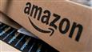
Beware Fake Amazon Deals: Hackers Hit Sellers
Most Popular Articles

French Presidential Runoff Heralds New Political Era

Once-Flush Startups Struggle to Stay Alive

This Vermont High School Is Having a Very Vermont Problem

Disapproval of Trump Grows in Latest Poll

Three Hard Lessons the Internet Is Teaching Traditional Stores
WSJ MEMBER MESSAGE
The Face of Real News
WATCH NOW

SHOW COMMENTS HIDE COMMENTS (137)
Failed to load comments
Show More Archives
What to Read Next...

video
Why Big Tobacco Didn’t Fail

u.s. news
Group of Addiction Experts, Insurance Executives Unites to Combat Opioid Abuse

europe news
French Presidential Runoff Heralds New Political Era

politics and policy
Disapproval of President Donald Trump Grows in Latest WSJ/NBC News Poll

washington wire
Capital Journal Daybreak: Trump’s Approval Rating Falls, More

Independent of The Wall Street Journal newsroom
markets
Dow industrials set to open 200 points higher on relief over French vote

Independent of The Wall Street Journal newsroom

A Rare New Mansion in Chicago’s Historic Gold Coast

Advertisement

