Money Doesn’t Buy Happiness. Well, on Second Thought…
If money can’t buy you love, can it still buy you happiness? A now famous 1974 study seemed to indicate that the answer was no. U.S. economist Richard Easterlin, then at the University of Pennsylvania, studied comparative data on moderately wealthy and very wealthy counties and concluded that although rich people are happier than poorer people, rich countries and not happier than poorer ones, and they do not grow happier as they grow increasingly rich. The explanation for this apparent paradox, said Easterlin, was that only relative income – your income compared to that of your peers and neighbors – matters to happiness, not absolute income.
Now, however, two Wharton professors, Betsey Stevenson and Justin Wolfers, say that the Easterlin paradox, as it has come to be called, does not exist. Based on new research, they say that the truth isn’t paradoxical at all, but is in fact very simple: “1. Rich people are happier than poor people. 2. Richer countries are happier than poorer countries. 3. As countries get richer, they tend to get happier.”
Pouring out that Easterlin had little data to work with 35 years ago, Stevenson and Wolfers draw their conclusions from data about more countries, including poor ones, over longer periods of time. Public opinion surveys and other studies show that life satisfaction is highest in richer countries. In the United States, for instance, 9 in 10 Gallup Survey respondents in households making more than $250,000 a year called themselves “very happy,” compared to only 4 in 10 with incomes below $30,000. “On balance,” Stevenson and Wolfers conclude, “GDP ad happiness have tended to move together.” The bottom line, they say, is that absolute income matters.
What do these new findings mean in practice? A pair of British economists suggest that government’s policy goals should focus less on growing GDP and more on improving measures that directly affect happiness.
Easterlin would probably agree. He now concedes that people in wealthy countries do report more happiness than those in poorer countries. But he still doubts that money alone is the reason. Comparing Denmark and Zimbabwe, for instance, he says. “The Danes have social welfare policies directed toward some of the most salient concerns of families – their health, care for the aged, child care. If you ask why the Danes are happier, an alternative hypothesis is they have a set of public policies that deal more immediately with people’s fundamental concerns.”
And the tiny Himalayan kingdom of Bhutan has, in fact, replaced GDP with a measure it calls “gross national happiness.”

Critical Thinking Questions
- What do you think is the role of money as a determinant of a person’s satisfaction at work and with life in general? Should organizations worry about this issue? Explain.
- As discussed in this chapter, firms vary widely on the extent to which emphasize money as an incentive. Do you think an emphasis on financial incentives is good or bad? Explain.

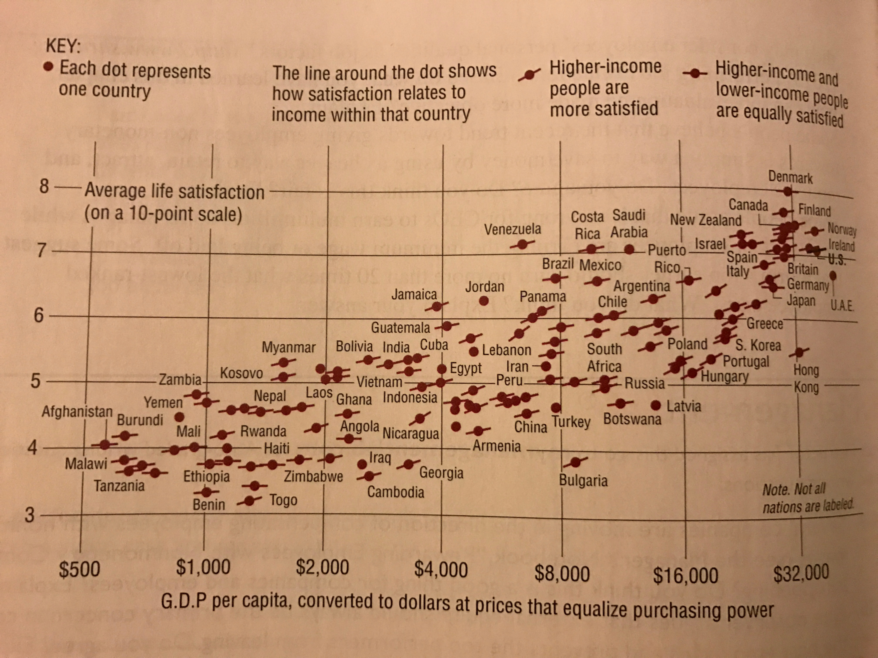

- For the past 90 years or so, job evaluation as a compensation tool has been designed to assess the value of each job rather than to evaluate the person doing the job, prompting a relatively flat pay schedule for all incumbents in a particular position. Some HR experts believe that the emerging trend is for pay inequality to become “normal.” Employers are using variable pay to lavish financial resources on their most prized employees, creating a king of corporate star system. “How do you communicate to a workforce that isn’t created equally? How do you treat a workforce in which everyone has a different deal?” asks Jay Schuster of Los Angeles – based compensation consultants Schuster-Zingheim & Associates, Inc. If you were asked these questions, how would you answer them? Given the issues just discussed in this case study, what effect do you think this trend toward greater pay equality will have on employees’ satisfaction with their pay, their job, and life in general? Explain.

