- In an answer of at least two well-developed paragraphs, provide a definition of the law of demand and explain how it can be used to determine prices. Provide an example of your own to illustrate this concept.

- In an answer of at least two well-developed paragraphs, provide a definition of the law of supply, and describe the factors that will cause a shift in the supply of a product. Provide an example of your own that illustrates how these factors affect supply.

- In an answer of at least two well-developed paragraphs, define the terms shortage and surplus and explain how each impact the prices of goods in the marketplace.

- In an answer of at least two well-developed paragraphs, explain how supply and demand work together to reach the equilibrium price in the marketplace.

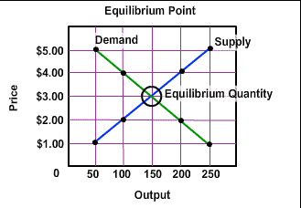

a. What is the equilibrium price?
b. How do you know this is the equilibrium price?
c. If consumers demand a quantity of 100 at $4.00 per item and suppliers supply 200 of the item at $4.00, is a shortage or a surplus created?
d. If consumers demand a quantity of 200 at $2.00 per item and suppliers supply 100 of the item at $2.00, is a shortage or a surplus created?
e. Why don't suppliers want to supply more of the good at $2.00 per item?
f. Why do suppliers want to supply more of the good at higher prices?
g. Why don't consumers demand as much of the item at higher prices?

