Milestone Four: Database Data Model
Southern New Hampshire University
Principles of Database Design
IT-650
Prof. Bindu George
October 18, 2017

Milestone Four: Database Data Model
Data Modeling for the Finance Department at Grandfield College
The study will work with the finance department at Grandfield College to develop and illustrate a compressive enterprise data model.
Data Model
It organizes elements of data and ensure that they relate to one another with entities in the real world. For every database to be created there is a need that a data model is created listing all operation and rules for a reliable system. Formally the basic inputs in data modelling are entities, operations, attributes, relations and Tables. The study will review all the requirements in the Finance department. (Blaha, 2017)
Administration
- Able to view available students list.
- Able to search available student list.
- Able to update student list.
- Able to make requests for student details.
- Able to track student fee status.
- Able to track student fee balance.
- Able to clear a student after his/her full cause.
- Able to classify students by cause and tag the respective fee payment.
Student
- Able to make requests for the fee balance
- Able to make requests for the fee structure.

Lecturers and Other Staff Members
- Able to view list of approve students to take a course.
Entities and Attributes and The Relations That Exist Between Them.
Entities
- Students.
- Administration.
- Staff.
Attributes
- Key for student accounts.
- Key for student details.
- Key for student list.
Relations.
- Administration to students-one to many relationship.
- Administration to staff-one to many relationship.
- Staff to students-many to many relationship.
- Student to student-one to one relationship.

Table
- Student account table.
Illustration of key entities
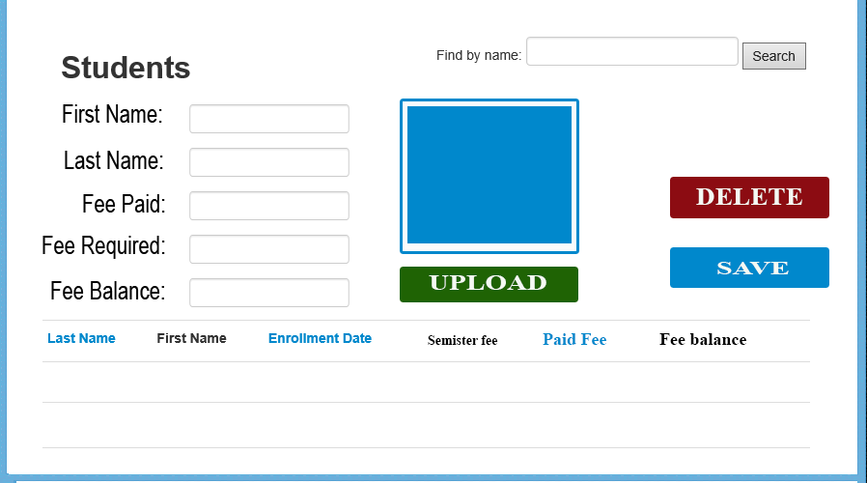
The diagram to illustrate the different operations in a data model (Kendle, 2017).
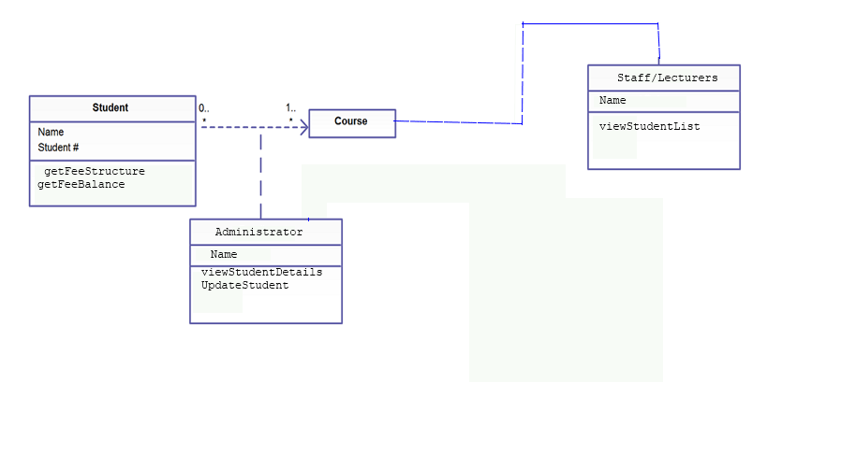
A Class Diagram with Enterprise Architect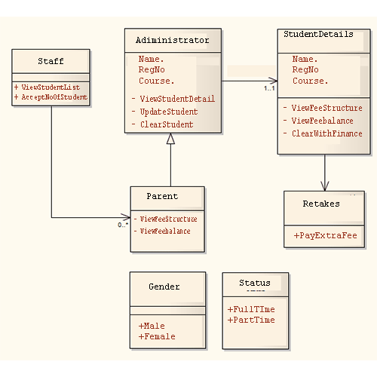
After coming up with a proper data model, the next step is to implement it in a database management system to enable users to manage a large amount of data within an application. With the proper DBMS in place, institutions such as Grandfield college will achieve efficiency in handling multiple data types, some of which is easily manageable, such as student records, fee structure information, and courses, while, some systems are much more complex to meet its user’s needs (Aveda, 2015, para. 2).

Some of known DBMS according to (Panwar, 2011) include:
- Relational databases management system
- Hierarchical databases management system
- Network databases management system
- Object-oriented databases management system

References
Blaha, M. (2017). Enterprise Data Modeling. Dataversity: http://www.dataversity.net/last-blog-data-modeling-sql-uml
Kendle, N. (2017). The Enterprise Data Model. TDAN.com: http://tdan.com/the-enterprise-data-model/5205
L., Reese, E. and Stupay, R. (2017). Learn about class diagrams @OpenClassrooms. OpenClassrooms: https://openclassrooms.com/courses/design-a-database-with-uml-1/primary-keys
Panwar, A. (2011). Types of Database Management Systems. Retrieved from http://www.c-sharpcorner.com/UploadFile/65fc13/types-of-database-management-systems/

