Business 1.0

Individual Written Brief #1 (IWB#1)

assignment
For your first written brief (IWB#1), you will research opportunities and threats facing a real company and create a two-page business memo detailing your recommendations, data researched, and analysis. The key to a successful business memo is that the data drives the recommendations.
The audience is the CEO of your company. Keep in mind that CEOs are not looking for opinions or a list of readily available facts they can find on their own or may already know. Instead, they seek recommendations. These are assertive statements that represent your proposal of what should be done and why – and they are always based on solid data and analysis.
Thus, your memo is the product of good research enhanced by your own critical thinking and analysis, in order to yield strong recommendations supported by data.
The memo will be two pages maximum, using 12-point font . One additional page should list your citations (using APA citation style), for a total length of three pages for this assignment.
Below are the key steps to complete for the assignment. See Annex 1 for complete deliverable timetable.

Step 1 – IDentify ONE (U.S.) Publicly traded CompanY
Your first step is to identify one company you would like to analyze. Your choice must be a publicly traded company on the New York Stock Exchange or NASDAQ Exchange.
First, think about industries - not actual companies but the larger industry - that you are personally interested in. Maybe it is sports, entertainment, fashion, chemical engineering, technology, construction, or real estate.
Then go to the IBISWorld database in the AU online database collection (accessible through AU Portal Academics Library Website Research Databases and letter “I”). Enter the industry name you are interested in the search box. For example, we entered Automotive in the screenshot below. It includes reports on different industries within the automotive sector.
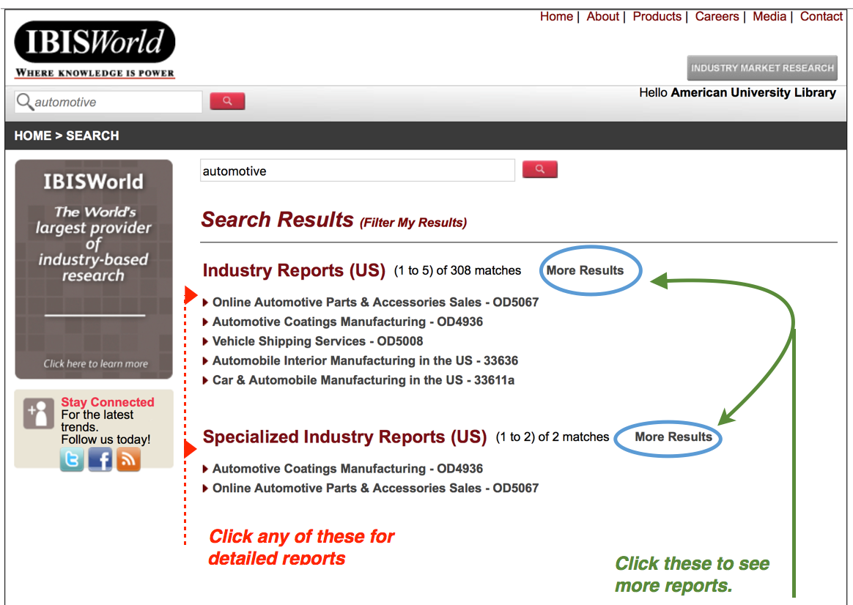

- Click on more results (see image above) and then on the report that is closest to the industry you want to study. As indicated in the illustration and caption above, click on the various tabs to get a better perspective of the market. Then click on the Major Companies tab and pick a company. The company you select must be headquartered in the U.S. and must be a publicly traded company on either the New York Stock Exchange or the NASDAQ Exchange.
- Note: You can also just “browse” through IBISWorld industry reports- there are hundreds of them – to find an industry that might excite you.
- Once you have identified one company, you must send an email to your TA with a short, two-sentence justification on why you would like to analyze this particular company. The email must be written in a “professional” business structure (See the Toolkit #2 for how to write a professional business email). Your TA will respond with either a yes or no for your company selected (if no, you will need to identify a different one).

Step 2: Conduct Research
Excellent business memos require strong and credible research. For this memo, your job is to identify third-party researched data from databases to support your recommendations.
Research the potential opportunities and threats that face your company. Opportunities are external items and actions that can have a favorable/positive impact on a company. Threats are external items and actions that can a detrimental/negative impact on a business.
For more information on Opportunities and Threats see Toolkit #4.
Where do I go to find information on my company?
You should proceed with more detailed research using a number of databases, including:
- IBISWorld
KSB 100 Research Portal: Short Cut!
You may find also these databases through the KSB 100 Portal set up specifically for our class:
http://subjectguides.library.american.edu/ksb100

Hint! Watch the short video on Research Overview on this page.

Note: we will have a session with the Kogod Business Librarian, Amanda Click
- Hoovers or Merchants
- Factiva
- eMarketer
- Statistica
- Lexis Nexis
- General Google Searches

You can find these databases through AU online database collection (accessible through AU Portal Academics Library Website Research Databases and letter “I, H, M, F, or S” (for each of the databases above). Or use the shortcut provided in the box to the right.
Your goal with the research is to find 3 – 4 different data points for each recommendation that you plan to make to the CEO of your company. Now we need to turn the data collected into something meaningful – recommendations.
While you research, be sure to capture your sources and begin to create your References page using APA format. (NOTE: THIS IS DIFFERENT FROM MLA FORMAT). For more information on APA Citations Guidelines: http://subjectguides.library.american.edu/apa4biz
Step 3: Turn your Research into your iwb#1 DRAFT memo

Recommendations, Data, and Analysis Sections of Memo
For the IWB#1 Memo, you will need to develop three recommendations. These recommendations will come from the data you find in your research. Each recommendation will need 3 – 4 different data points to support your recommendation.
So, for example, let’s say you come up with data points that indicate small outlet stores in rural America offer sales growth (an opportunity for our company). Here are the data points:
- Adding outlet stores in small urban locations instead of relying on large retailers can increase sales. (Hoover’s, 2016).
- The target age group for Company ABC products is ages 24 to 45 who are parents buying products for themselves or their kids. (IBIS World, 2016).
- Company ABC is expected to have a decline in sales to drop by 3% if they continue to rely on large department stores (Schzr, 2016).

Important! From these data points, you can now develop a recommendation:
Recommendation #1: Company ABC has an Opportunity to Increase Sales Growth by Opening More Outlet Stores in the Small Urban Cities of the United States
So, to repeat, the data you research serves as the foundation to create your recommendation.
Finally, as part of IWB #1, you will need to provide an analysis of the data, in your own words.
Adding more outlet stores in small urban areas in states such as North Dakota, South Dakota, and Idaho can generate more profit and as the same time allow customers to buy products at a reasonable price. Opening door-to-door outlet stores can make products look more appealing. Also, there is little competition in these areas for our products.
So one complete opportunity recommendation, research, and analysis for IWB#1 is below:
Recommendation #1: Company ABC has an Opportunity to Increase Sales Growth with 24 – 45 Year Olds by Opening More Outlet Stores in the Small Urban Cities.
- Adding outlet stores in small urban locations instead of relying on large retailers can increase sales. (Hoover’s, 2016).
- The target age group for Company ABC products is ages 24 to 45 because most people this age are parents who are buying products for themselves or their kids. (IBIS World, 2016).
- Company ABC is expected to have a decline in sales to drop by 3% if they continue to rely on large department stores (Schzr, 2016).

Adding more outlet stores in small urban areas in states such as North Dakota, South Dakota, and Idaho can generate more profit and allow customers to buy products at a reasonable price. Opening door-to-door outlet stores can make products look more appealing. Also, there is little competition in these areas for our products.

Next Action Steps for your Primary Recommendation Section of Memo
Your three recommendations should be ranked in order, with the most important one listed first.
For your first (most important) recommendation only: if the CEO were to give you the go-ahead to implement the primary recommendation, what would be three critical next steps the company would need to take over the next six months to address that recommendation?
For each of the three steps, provide what actions need to be done, when, and by whom.

APA Reference List (one page)

The actual template to use for IWB#1 is located in Annex 2.

Step 4 final IWB#1 Memo for GRADE

Once you have received your feedback, you will submit one final memo for your grade.

Annex 1: Timeline of Deliverables and activities

Aug. 31(CL 2): IWB#1 Assignment assigned/presented in Class 02. Assignment documents posted in Blackboard under “Assignments.” Begin preliminary research to identify your company
Sept. 3: Email your specific TAs with your one company requests by 9:00 pm. TA’s to respond by COB Sept. 4 to approve the company you requested.
Sept. 11(CL 4): Exercises on business research, writing, and APA citation. Your Toolkit also provides you information on research, data, and citations. Amanda Click, Interim Business Librarian. Email: aclick@american.edu
Sept. 14 (CL 5): IWB#1 DRAFT due by 1:00 am via Blackboard through “Submit Assignment”. Submit in MS Word only (not in PDF or Pages or we will be unable to offer feedback). Late submissions will be marked with a lower score.
Sept. 18 (CL 6): The Kogod Center for Business Communications (KCBC) will be in class for peer review exercise. They will also return drafts with comments so you can revise.
Sept. 21: (CL 7): IWB#1 FINAL MEMO for Grade due by 1:00 am via Blackboard through “Submit Assignment”. Submit in PDF. Late submissions will be marked with a lower score.

ANNEX 2: IWB#1 Memo Template – Use It!
To: CEO (name him/her), Company Name
MEMO Template Structure:
- 2-page memo + 1 page APA References
- Use 1.15 or 1.5 line spacing, 12-point Calibri or Helvetica font with 1-inch margins

From: Your Name and Section Number
Date: 9/ZZ/17
Re: (Choose a dynamic subject line that grabs the CEO)
------------------------------------------------------------

One – two sentences that state your purpose of the memo.

- Recommendations
Primary Recommendation (#1)
1 sentence introduction

Data Points: Provide 3 - 4 researched data points (with citation) to generate your recommendation (USE BULLET POINTS)

Analysis: Provide two – three sentences on the reason for your recommendation and how it will impact the company (in your own words)

Why is this the most important recommendation?

Recommendation #2
1 sentence introduction

Data Points: Provide 3 - 4 researched data points (with citation) to generate your recommendation (USE BULLET POINTS)

Analysis: Provide two – three sentences on the reason for your recommendation and how it will impact the company (in your own words)

Recommendation #3
1 sentence introduction

Data Points: Provide 3 - 4 researched data points (with citation) to generate your recommendation (USE BULLET POINTS)

Analysis: Provide two – three sentences on the reason for your recommendation and how it will impact the company (in your own words)

- Next Action Steps for your Primary Recommendation
For your Primary Recommendation only: if the CEO were to give you the go-ahead to implement it, what would be three critical next steps the company would need to take over the next six months to address the primary recommendation?
For each step, provide what needs to be done and by whom. (List as Step 1, Step 2, Step 3)
APA References Page (one separate page with the headline « References »)
ANNEX 3: Hints to Preparing the Business Memo
- Be sure your name and section number are on the first page and that you state the name of the company in the heading. Be sure to use the name of the actual CEO to whom you are addressing the memo (and put in the company name).
- Your audience is the CEO of the company. The CEO has limited time and is looking for recommendations supported by real nuggets of information on the key issues that CEOs value, solid analysis, and persuasive writing that can help position the company more strongly for 2016 and beyond.
- Be professional in structure and tone. Make sure your document design for the memo is “skimmable.” This means that your subject line is specific; subheadings and any bullets you use are clear, detailed, and re-enforce your major points. Concise sentences with vivid verbs, bullet points, and short block-style paragraphs (don’t indent the first line), are all tools to use in effectively structuring your memo.

Pitfalls to Avoid
- Avoid picking a company in an industry where there is very little research available in your initial IBISWorld search.
- Avoid companies that are exceptionally large and diverse and compete in so many markets that it is difficult to determine what markets the research is referring to.
- In your writing, do not just not “play back” what others have said. Instead, focus on synthesizing your research with your own ideas to develop your own unique point of view. This combination of your thinking based on solid research is what we mean by forming effective recommendations expressed IN YOUR OWN WORDS. That synthesis and innovation is what the CEO looks for in the best hires.
- Do not tell the CEO what he or she already knows: “It is important that our customers like our products” or “We want to increase our profitability” are examples of this type of non-critical thinking.
Do not copy or just repeat blocks of data from other sources. What we want to know are aspects YOU determine through research and analysis. Write the memo with essential details, such as who, what, when, where, why, and how:
- what we should do differently
- how we should do it,
- why YOU feel it is important,
- what impact you think it will have
- when we should take action, and where it should take place.

Ways to Improve Recommendation Headings – Get Specific!

Let’s say you found the follow data points in your research:
- The Southeast Asian market is expected to grow by 6% a year from 2017 – 2021 (ABC SOURCE, 2017)
- The Lao market is expected to grow by 10% a year from 2017 – 2021 (DEF SOURCE, 2016)
- Labor costs in Lao to remain low/competitive until 2025 (GHI SOURCE 2016)

Sooo…..how do you create your recommendation heading?
1. Start out by sketching the main topic and focus of your data captured.
Example (TOO BROAD): An opportunity exists to improve our international market share by expanding into Southeast Asia.

2. Develop that main topic into a one-sentence recommendation.
Example (BETTER, BUT NOT SPECIFIC ENOUGH): Expansion into the growing Southeast Asian market can help us improve our global market share against competitors who have not yet addressed this market.

3. Revise and expand by using more specific details.
Example (VERY SPECIFIC): (Name of Company) has an opportunity to expand our market share by 20% into Lao by June 2018 giving us a starting point for moving further into the growing Southeast Asian market for our line of ZZZ products.

What you come up with in number three above is what you would use for a recommendation heading (notice again how we go from broad in number 1 to very specific in number 3).

An industry is a group of manufacturers or businesses that produce a particular kind of goods or services (vocabulary.com)
“Just Google It” is a phrase you have grown up with. The challenge with “just google it” is the data you get back may be suspect, incomplete, or just flat wrong (Fake news anyone?). Be very careful in data collected by google searches – only use reputable sources. For example, data found from a trade association or customer survey company is likely acceptable. A blogger who has 25 followers is not.

