Corporate Profile Part 1: Buyer Profile

For this paper, you will research and construct a corporate profile for a publicly-traded company which operates in cyberspace and therefore has a need for cybersecurity products and services. A list of approved companies appears at the end of this assignment description. If you wish to use a company not on the approved list you must first obtain the approval of your instructor.

Research

- Review the company’s website to learn about the products and services which it sells.
- Retrieve and review the Hoovers profile for the company. The company profile web pages are interactive and have expanding menus / options (see figure below). You may find it helpful to use the “Print Quick Report” menu item under My Tools. http://ezproxy.umuc.edu/login?url=http://www.mergentonline.com/Hoovers
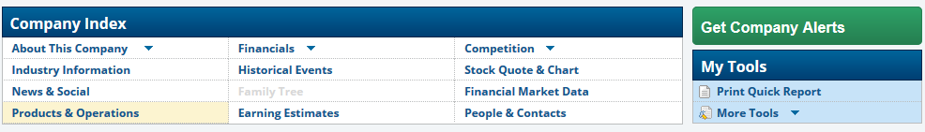
- Download and review a copy of the company’s most recent Annual Report to Investors from its Form 10-K filing with the United States Securities and Exchange Commission. (Note: the company is the author of its Form 10-K. Do not list the SEC as the author.)
- Identify 3 or more additional sources of information about the company and how it operates in cyberspace. These can be news articles, data breach reports, etc.
- Using the information obtained from your sources, identify the types of information and business operations which drive this company’s need for cybersecurity products and services. (What needs to be protected?)
- Using the course readings and other materials, develop a “Buying Forecast” for likely purchases by this company for cybersecurity related products and services.

Write

- An introduction section which identifies the company being discussed and includes a brief overview of the company including when it was founded and significant events in its history.
- An overview of the company’s operations which summarizes information obtained from its annual report, the Hoovers profile for the company, and other sources which you found in your research. This information should include: headquarters location, key personnel, primary types of business activities and locations, major products or services sold by the company, major competitors, stock information (including ticker symbol or NASDAQ code), recent financial performance, and additional relevant information from the business profiles.
- A separate section in which you describe this company’s needs or requirements for cybersecurity. What information and/or business operations need to be protected?
- A separate “Buying Forecast” section in which you discuss the company’s likely future purchases for cybersecurity products and services. In this section, you should identify and discuss three or more categories of cybersecurity products or services which this company is likely to purchase.

Your three to five page Buyer Profile is to be prepared using basic APA formatting (including title page and reference list) and submitted as an MS Word attachment to the Corporate Profile Part 1 entry in your assignments folder. See the sample paper and paper template provided in Course Resources > APA Resources for formatting examples. Consult the grading rubric for specific content and formatting requirements for this assignment.

Table 1. List of Approved Companies for Corporate Profile Project

Company Name | Corporate Website / Investor Relations | Form 10-K from SEC Edgar Database
Amazon | http://www.amazon.com  http://phx.corporate-ir.net/phoenix.zhtml?c=97664&p=irol-irhome | http://www.sec.gov/Archives/edgar/data/1018724/000101872415000006/amzn-20141231x10k.htm
Apple | http://www.apple.com/about/  http://investor.apple.com/ | http://www.sec.gov/Archives/edgar/data/320193/000119312514383437/d783162d10k.htm
eBay | http://www.ebayinc.com/  http://investor.ebayinc.com/ | http://www.sec.gov/Archives/edgar/data/1065088/000106508815000054/ebay201410-k.htm
Facebook | https://www.facebook.com/facebook  http://investor.fb.com/ | http://www.sec.gov/Archives/edgar/data/1326801/000132680115000006/fb-12312014x10k.htm
Google | https://www.google.com/intl/en/about/company/  https://investor.google.com/ | http://www.sec.gov/Archives/edgar/data/1288776/000128877615000008/goog2014123110-k.htm
Microsoft | http://www.microsoft.com  http://www.microsoft.com/investor/default.aspx | http://www.sec.gov/Archives/edgar/data/789019/000119312514289961/d722626d10k.htm
Oracle Corp. | http://www.oracle.com/us/corporate/index.html  http://investor.oracle.com/overview/highlights/default.aspx | http://www.sec.gov/Archives/edgar/data/1341439/000119312515235239/d920711d10k.htm
Priceline | http://www.pricelinegroup.com/  http://ir.pricelinegroup.com/index.cfm | http://www.sec.gov/Archives/edgar/data/1075531/000107553115000007/pcln-20141231_10k.htm
Salesforce | https://www.salesforce.com/company/  http://investor.salesforce.com/about-us/investor/overview/default.aspx | http://www.sec.gov/Archives/edgar/data/1108524/000110852415000008/crm-2015131x10k.htm
Twitter | https://about.twitter.com/company  https://investor.twitterinc.com/ | http://www.sec.gov/Archives/edgar/data/1418091/000156459015001159/twtr-10k_20141231.htm
Yahoo | https://info.yahoo.com/  https://investor.yahoo.net/index.cfm | http://www.sec.gov/Archives/edgar/data/1011006/000119312515066560/d826131d10k.htm

