Problems and Exercises

- Chapter 5, Problems/Exercises, Questions 1 and 3 (middle of page 148)
1. One of the potential problems mentioned in this chapter with gathering information requirements by observing potential system users is that people may change their behavior when observed. What could you do to overcome this potentially confounding factor in accurately determining information requirements?
3. Suppose you were asked to lead a JAD session. List ten guidelines you would follow in playing the proper role of a JAD session leader.

- Chapter 6, Problems/Exercises, Questions 8 and 9 (bottom of page 179).
8. Consider the DFD in Figure 6-20. List three errors (rule violations) on this DFD.

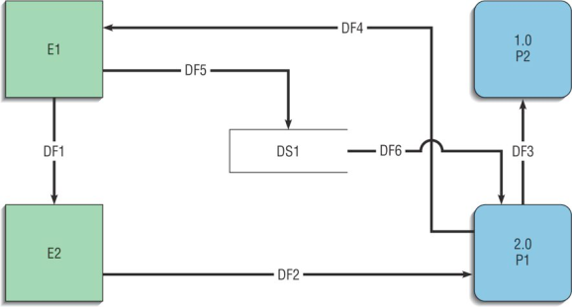

9. Consider the three DFDs in Figure 6-21. List three errors (rule violations) on these DFDs.

