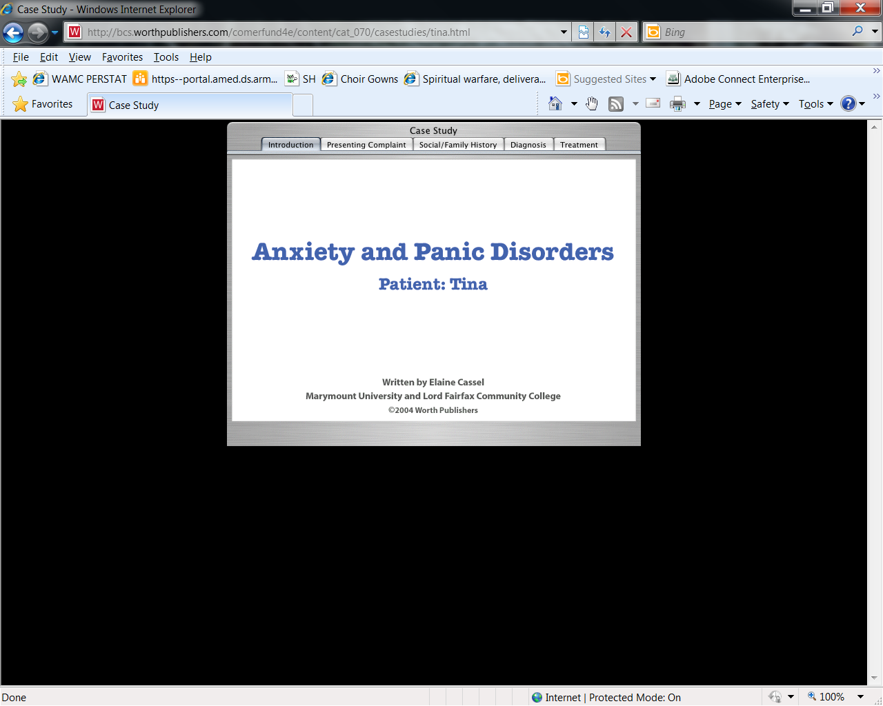

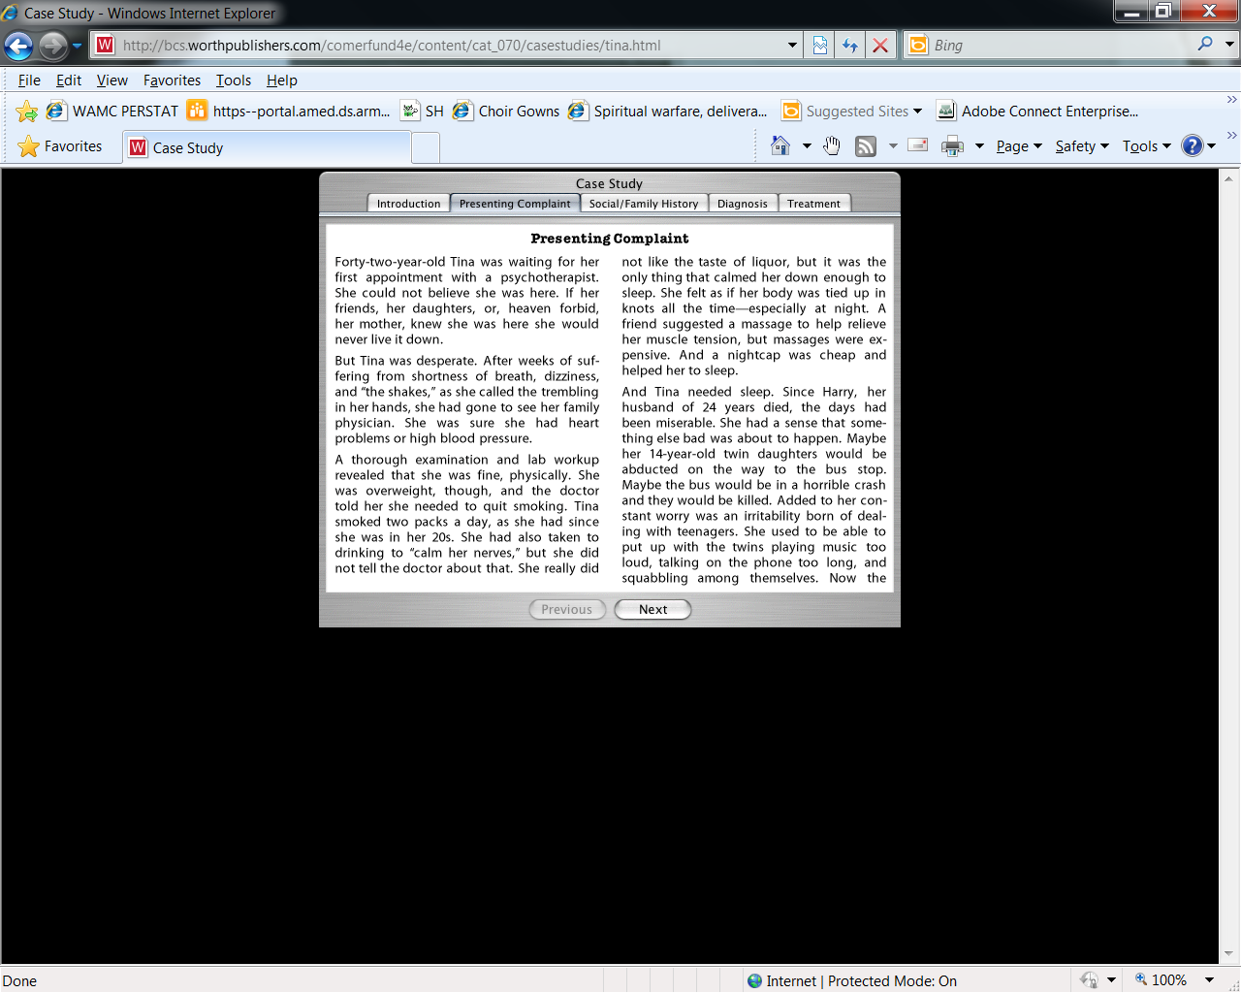

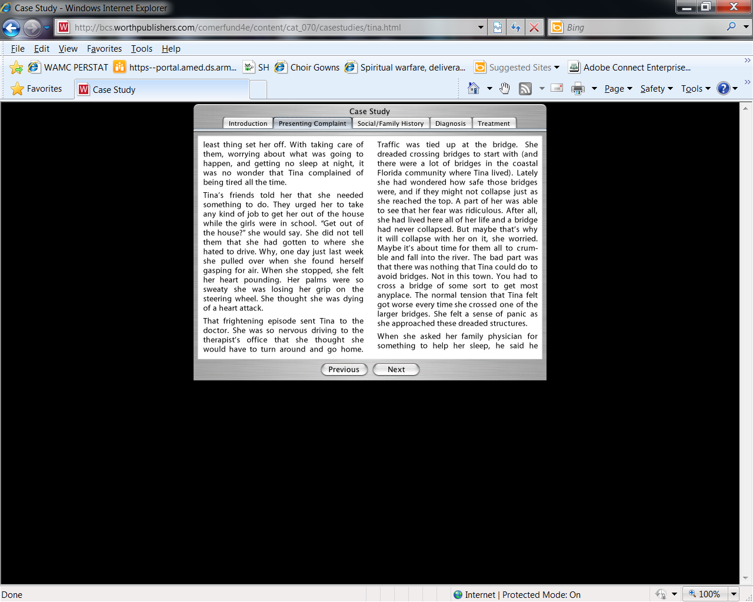
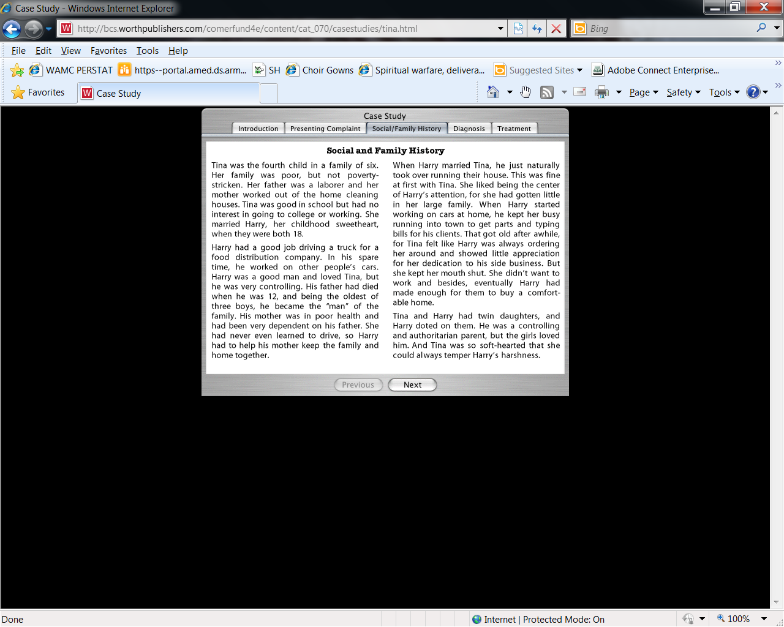
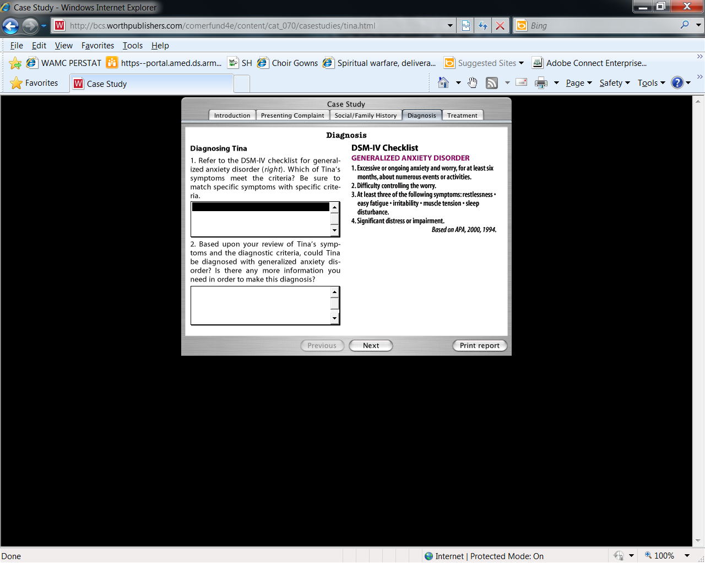
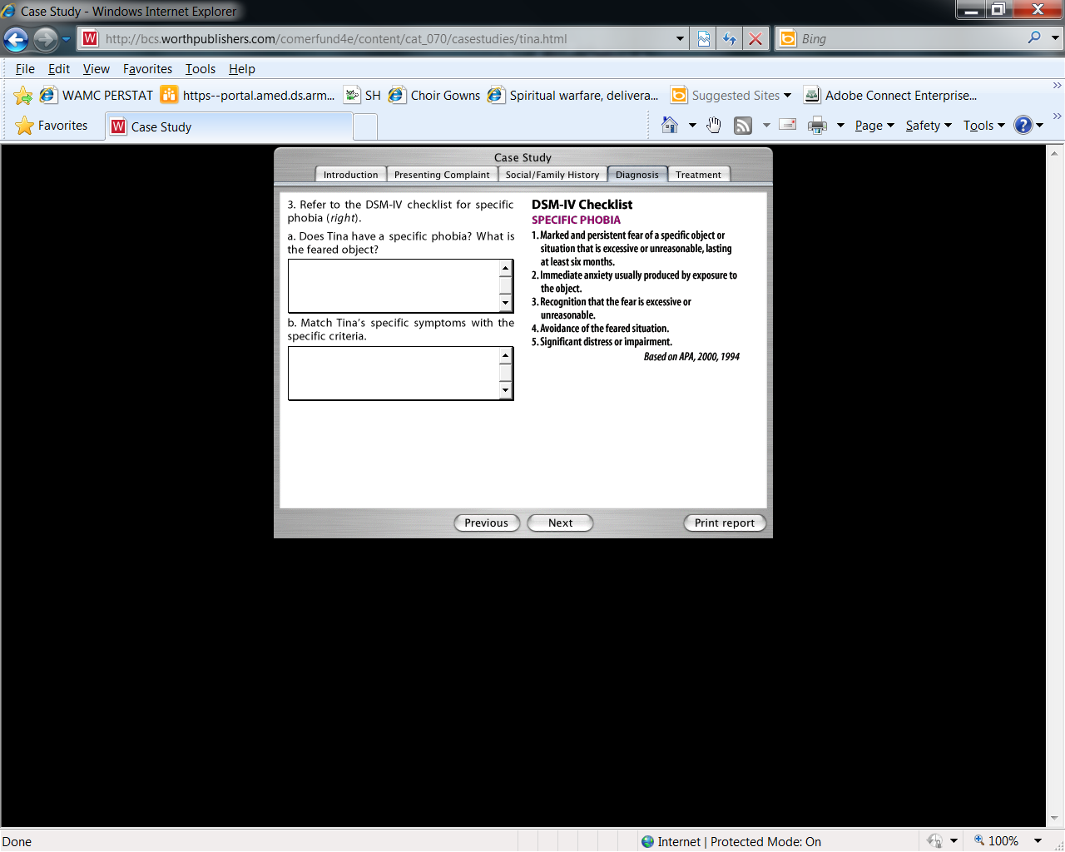
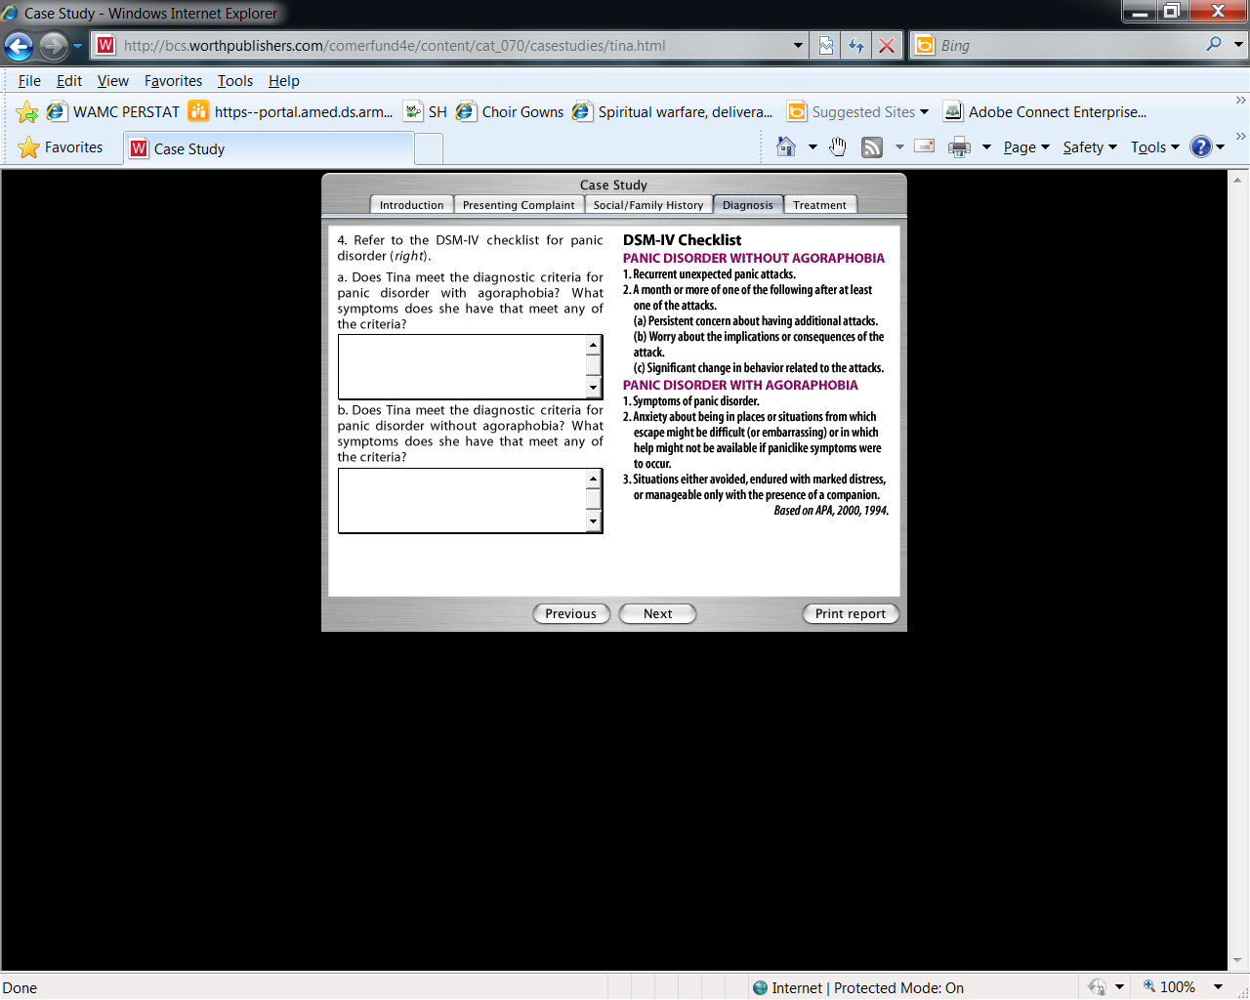
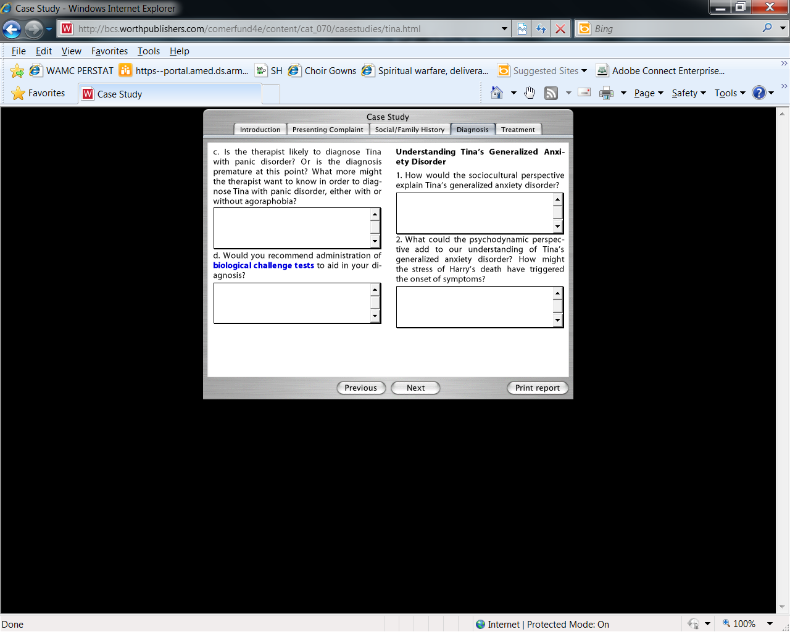
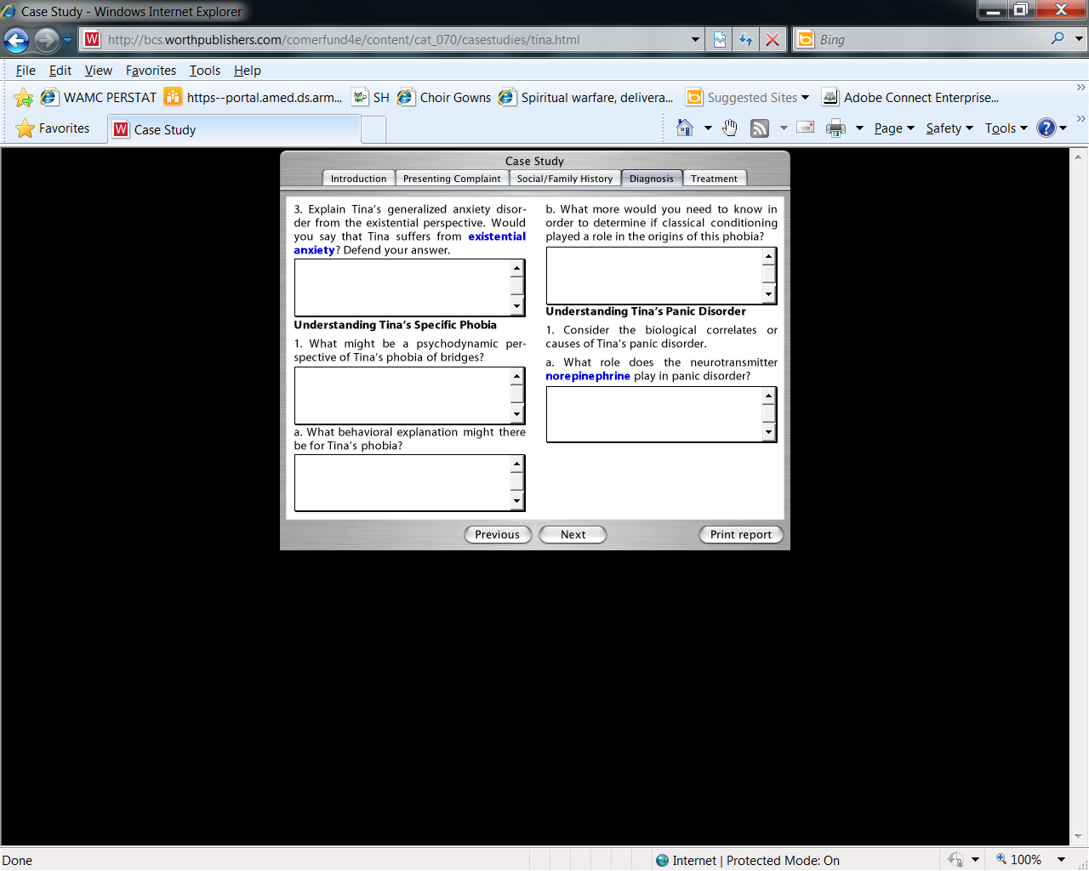
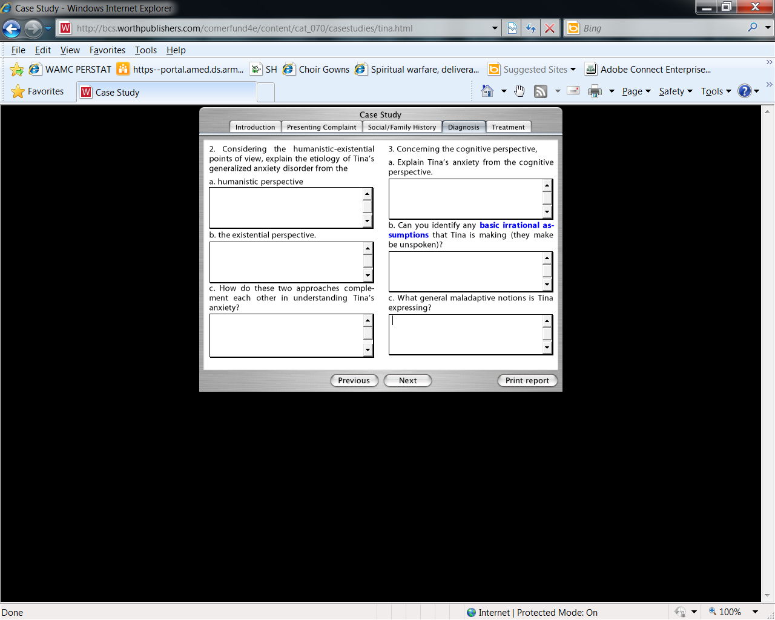
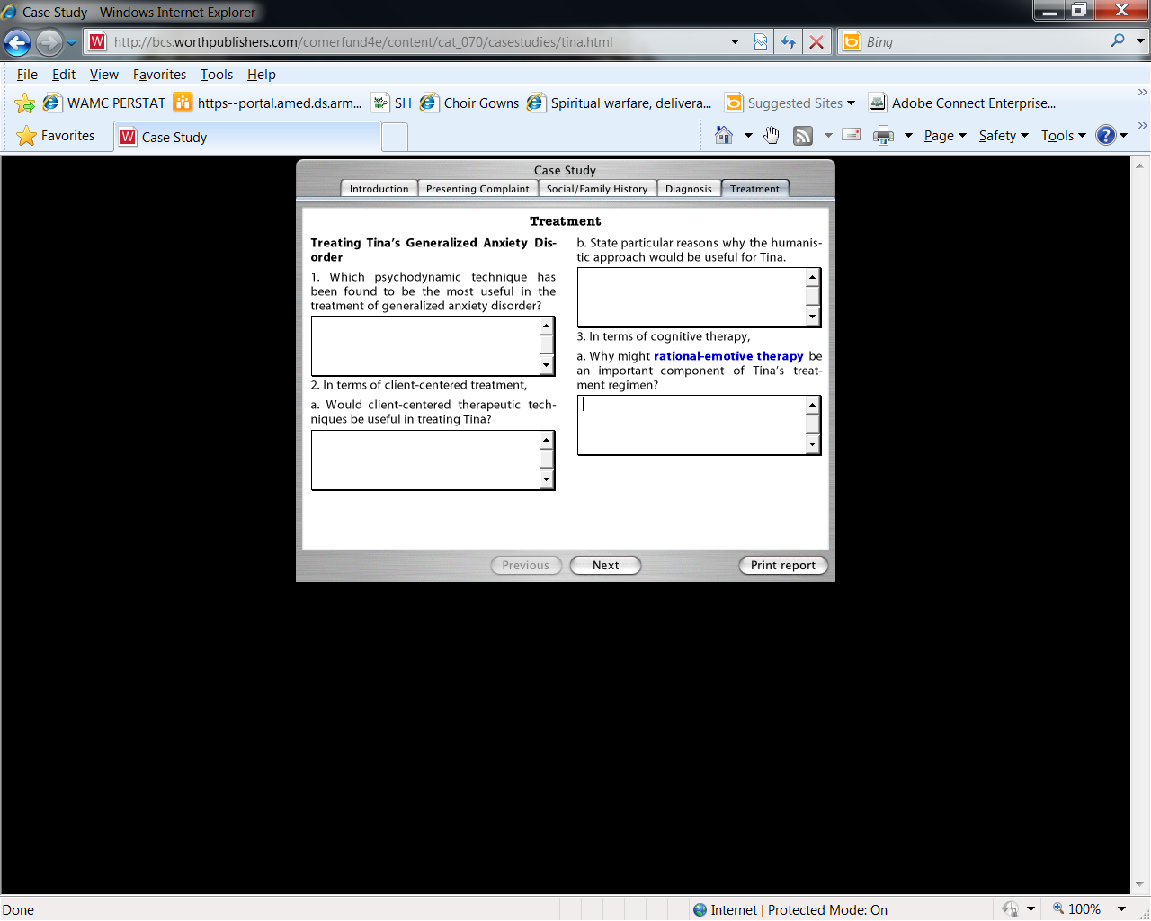
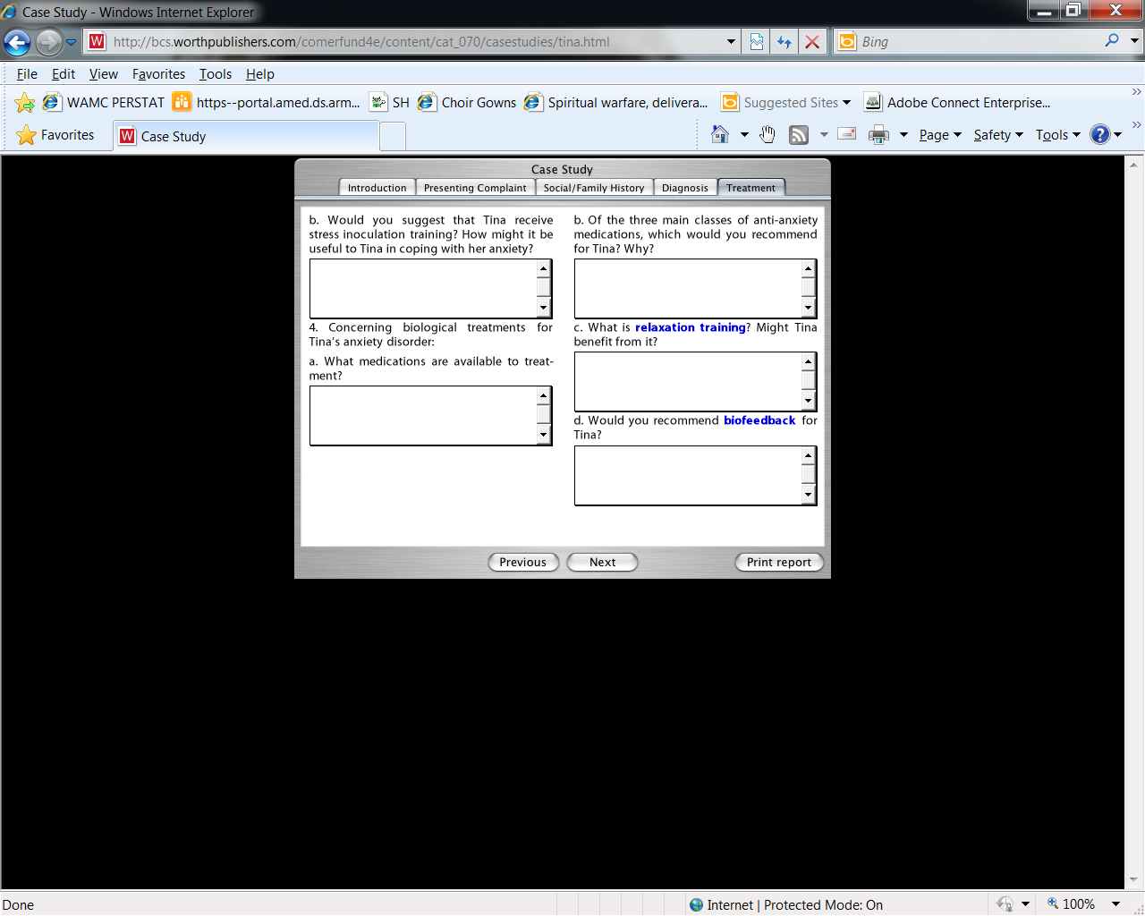
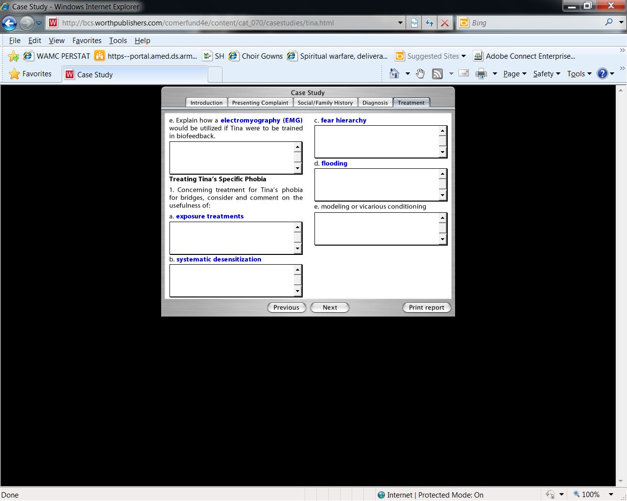
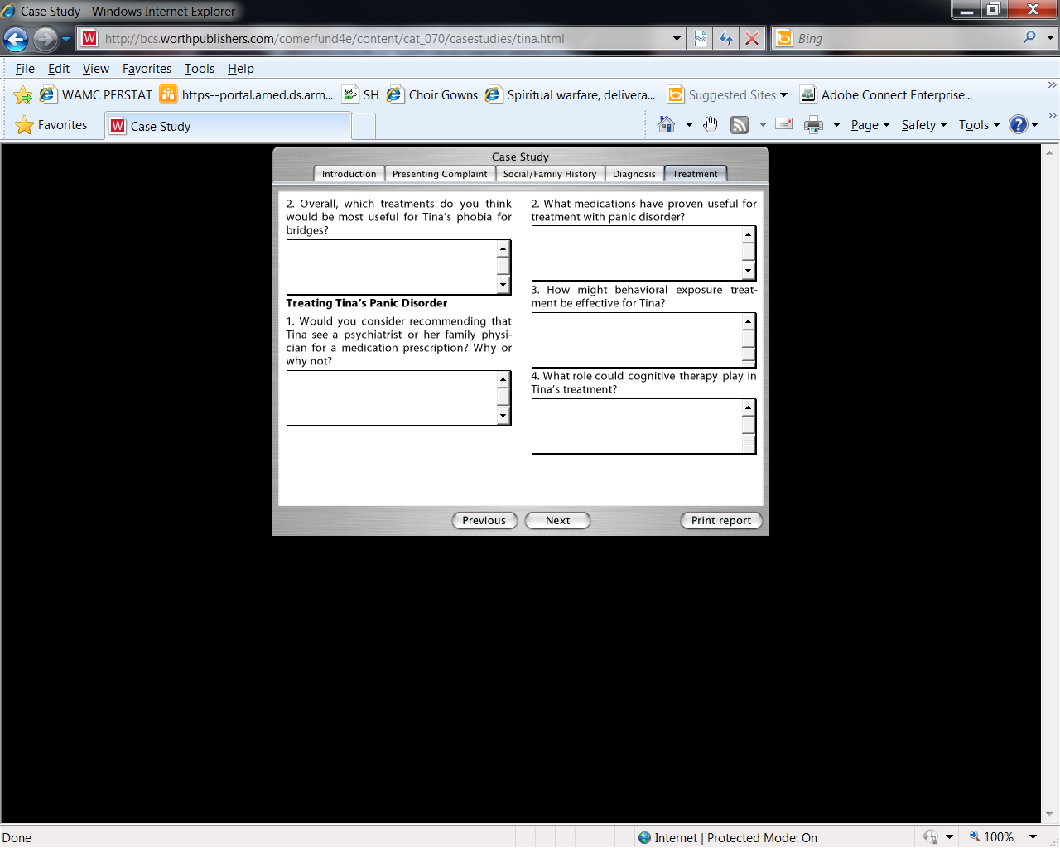

You will complete a total of three (3) Case Study assignments. For each assignment, read through the case study and complete the provided answer sheet of questions, utilizing information from the Comer textbook to formulate appropriate answers. Submit the completed document as an attachment via the assignment submission link.
Grading will be based on the accuracy and quality of answers, the demonstration of higher-level critical thinking skills, and appropriate quantity/content of the answers. Your answers should do the following:
Be in complete sentences.
Demonstrate focus and clarity of thought.
Display grammar, spelling, and sentence structure appropriate for college-level work.
Access the case study above, navigating through it using the tabs at the top of the page and using the Previous/Next buttons on the bottom. (The animations on this page require the Flash plug-in, version 6.0 or later. This page works best in the Internet Explorer browser.) Thoroughly read the case study, making sure to read the Presenting Complaint and Social/Family History tabs. See also the DSM Criteria listed in the Diagnosis tab (Generalized Anxiety Disorder, Specific Phobia, and Panic Disorder). Use the information from the case study and your textbook to answer the 22 questions on the Case Study: Anxiety Answer Sheet. Do not use the question and answer blocks provided in the case study. Answer all the questions in the document and submit your finished document for grading through the assignment submission link below

Case Study: Anxiety Answer Sheet
Diagnosing Tina
Student Name:

Diagnosing Generalized Anxiety Disorder:
1a. Refer to the DSM-IV checklist for generalized anxiety disorder. Which of Tina's symptoms meet any of the criteria? (Be sure to match specific symptoms with specific criteria.)
1b. Based upon your review of Tina's symptoms and the diagnostic criteria, could Tina be diagnosed with generalized anxiety disorder or not (and if not, why not)?

Diagnosing Specific Phobia:
2a. Refer to the DSM-IV checklist for specific phobia. Which of Tina’s symptoms meet any of the criteria? (Be sure to match specific symptoms with specific criteria.)
2b. Does Tina have a specific phobia and if yes, what is the feared object?

Diagnosing Panic Disorder:
3a. Refer to the DSM-IV checklist for panic disorder with agoraphobia and the checklist for panic disorder without agoraphobia. Which of Tina’s symptoms meet any of the criteria? (Be sure to match any specific symptoms with specific criteria.)
3b. Does Tina meet the diagnostic criteria for panic disorder with agoraphobia or panic disorder without agoraphobia or neither? Explain why you believe your choice is the most appropriate diagnosis.

Understanding Tina’s Disorders:
1. How would the Socio-Cultural Perspective explain Tina's GAD?
2. Explain Tina's GAD from the Existential Perspective.
3. Explain Tina’s GAD from the Cognitive Perspective (please identify any basic irrational assumptions that Tina is making, even if they may be unspoken).
4. Explain Tina’s Phobia from a Behavioral Perspective (please use classical conditioning as a possible example).
5. Explain Tina’s Phobia from a Psychodynamic Perspective.
6. Considering the biological correlates or causes of Tina's panic disorder, what role does the neurotransmitter norepinephrine play in her panic disorder?
7. What does Tina's locus ceruleus have to do with her panic disorder?
8. What role might GABA play in her symptoms?

Treating Tina
1. Which Psychodynamic technique has been found to be the most useful in the treatment of GAD?
2. Explain why a humanistic approach would be helpful in treating Tina's GAD.
3. How might you use Rational-Emotive Therapy to treat Tina’s GAD?
4. How would Systematic Desensitization be used to treat Tina’s phobia of bridges?
5. What medications have proven useful for treatment with panic disorder?
6. What role could cognitive therapy play in Tina's treatment for panic disorder?
7. Considering that Tina may be treated for comorbid disorders, how do you see the treatments for the various disorders complementing each other?
8. Is there any reason to think that any of the treatments would be contraindicated when utilized together? Explain why/how or why/how not.

