Business Plan

Getting Organized Inc.

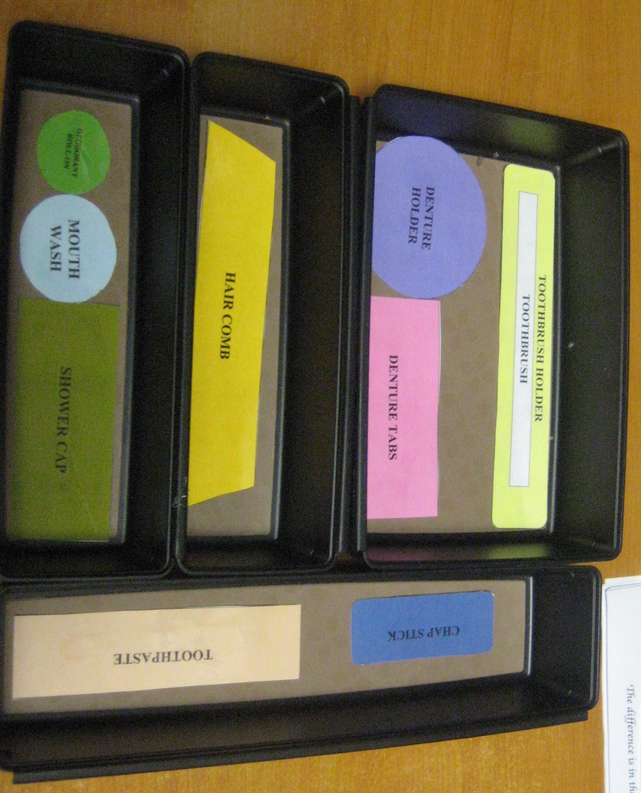

Thursday, September 19, 2013

President/CEO currently hold the company’s stock

This document is confidential.

Table of Contents

Table of Contents 2
Executive Summary 3
Vision/Mission Statement and Goals 4
A. Vision Statement 4
B. Goals and Objectives 4
C. Keys to Success 4
Company Summary 5
A. Company Background 5
B. Resources, Facilities and Equipment 5
C. Marketing Methods 5
D. Management and Organization 5
E. Ownership Structure 5
G. Internal Analysis 6
Products and/or Services 7
Market Assessment 8
A. External Analysis 8
B. Customers 8
C. Strategic Alternatives 8
Strategic Implementation 9
Financial Plan 11
A. Financial Projections 11
B. Contingency Plan 11
Monitoring Error! Bookmark not defined.

Executive Summary

Getting Organized Inc was founded in 2013 and is a growing manufacturer of organizing products. Our principal offices are located in Boston, Massachusetts.

Business/Product or Service
Getting Organized Inc makes innovative products, to help organize your life. The product line consists currently of draw organizers for hygienic items.

The Company produces/provides the following products/services:

Color coded/shape drawer organizer

Presently, our draw organizer is in the introductory stage. It competes primarily based on price and customer needs. Our future plans include developing additional organizing product lines in the near future.

The Market
We define our market as home organization units. The total market size was approximately $7.7 billion last year, and is expected to grow by 4% by 2017. We currently hold 1.5% of this market and believe we can capture 12% of it by 2020. Some of our most notable customers include Cambridge Health Alliance and Jackson Memorial Hospital.

Competition
We compete directly with Quill and Rubbermaid and alternatives to our product include Quill Model # 106861-QL and Rubbermaid Black Plastic Deep Drawer Organizer 1313028. Our product is unique/superior because the product is innovative and appeals to consumers. We have a competitive advantage because of our established brand name and low cost producer status. We do not anticipate new companies to enter this market.

Risk/Opportunity
The greatest risks associated with our business today are the product is launched without influencers to promote its efficacy, the product design is unique but confuses consumers, who don’t understand how the product works, and new competitor replicates the design and feel for our product. We feel we can overcome these risks because of our experienced management team. Our biggest recognized opportunities include establishing an online presence, patenting our products and selling our products to exclusive vendors.

Management Team
The management team is led by Chief Executive Officer who founded the company in 2013 / joined the company after working as a Consultant at The Boston Consultant Group, Inc. His team handled the turnaround of ABC Insurance and helped saved two thousand jobs, during the great recession of 2008. He received his M.B.A. from the Cambridge College in 2004

The Vice President of Sales and Marketing is, [Add relevant work experience and education]

The [title of position] is [], [Add relevant work experience and education]

The [title of position] is [ ], [Add relevant work experience and education]

Operations
We have [manufacturing facilities / offices / branches] located in [location, location, location]. We currently perform [u] in house, while outsourcing [v]. Our total full time staff is [15 people] and our products are distributed by [method or distributor]

Capital Requirements
We are seeking $300,000 which will enable us to [describe what you will accomplish with the funds] by [describe how the funds will be spent]. We expect to provide an exit within [x] years by [a dividend of excess profits, recapitalization, sale of company, or public offering].

Financial Snapshot
In [the most recent quarter/month], our company had sales of [x], and net income of [y], compared to sales of [u] and net income of [v] in [the previous quarter/month].
Last Year This Year Next Year Year Two
Sales:
Cash:
Assets:
Book Value:

Previous capital raises for equity included [$x] in [month/year] from [name] for [y% for the company], [and…]

Vision/Mission Statement and Goals

A. Vision Statement
The vision/mission statements are clear summaries of where the business is headed. It describes what the business produces, who products are produced for, and unique business characteristics. It will reflect the values of the management team and the type of business culture you are trying to create.

B. Goals and Objectives
What do you want your business to achieve? Be specific in terms of financial performance, resource commitments (time and money) and risk.
When will various milestones be achieved?

C. Keys to Success
What do you need, or must happen, for you to succeed?

Company Summary
The material in this section is an introduction to the firm.

A. Company Background
What does your business do?
Who were the founders of the business?
What were the important milestones in the development of the business?

B. Resources, Facilities and Equipment
With what do you produce your products or services?
What are the land, equipment, human and financial resources?
Who provides them?
How are resource providers rewarded?

C. Marketing Methods
What is your annual sales volume in dollars and units?
Explain how you work with others to improve returns. This may include a strategic alliance with suppliers or customers that you can leverage.
Do you use forward contracting, options, or futures? If so, how?
How much does it cost to produce and deliver your products and services?
How is contracting used?

D. Management and Organization
Who is currently on the management team?
How have management responsibilities been divided among the management team?
What are the lines of authority?
Who acts as the president/CEO? spokesperson? Chief Financial Officer?
Who determines employees’ salaries and conducts performance reviews?
What is the educational background of the management team members?
What is the management team’s reputation in the community?
What special skills and abilities does the management team have?
What additional skills does the management team need?
Who are the key people and personnel that make your business run?
Who do you go to for advice and support?
Do management and employees have avenues for personal development?
Sketch a diagram of lines of authority for your operation.

E. Ownership Structure
Who are the primary stakeholders in your business?
Describe the legal form of your company, such as partnership, proprietorship, or corporation.
Do you need special permits to operate, or a record for inspections? If you do, please describe them.

F. Social Responsibility
What environmental practices do you follow?
What procedures do you use for handling chemicals?
What noise/dust/timing/odor policies do you have?
What will be the roles of management and employees in community organizations?
What will be your involvement at the local/state/national level in commodity organizations?
What training and new employee orientation practices will you offer to insure proper handling of hazardous materials and safe operation of equipment?

G. Internal Analysis
What are the strengths and weaknesses of your firm?
What are the relative strengths of each enterprise or business unit within the firm?
What are the core competencies (things you are doing better than others) of your firm?
What things can you build on? Think only about the things that you can control.
Suggested areas to consider:
- knowledge and work
- financial position
- productivity
- family
- lifestyle
- location
- resources
What enterprise or business unit should be exited?
What enterprise or business unit shows promise?

Products and/or Services

Describe the products and services you plan to sell.
How is your product or service unique?
Are you producing a commodity or a differentiated product?
How does your product or service compare to other products in
Quality? Price? Location?
What experience do you have with this product/service?

Market Assessment

A. Examining the General Market
How is the market characterized?
Are there clear segments in the market? Describe them.
What important customer need(s) is the market not currently fulfilling?
What is the growth potential for each segment of the market?
What opportunities and threats does your firm face?
What does an analysis using the Five Forces model suggest about your industry? Who is your competition (in light of the Five Forces)?
What trends, relevant to your business, do you see?
What are the drivers of change?
What political and legal issues do you face, such as zoning, environmental laws, inspections, etc?

B. Customer Analysis
Who will be your customers?
What do you sell to each of the customers?
How does your product/service solve a key customer problem?
How difficult is it to retain a customer?
How much does it cost to support a customer?

C. Industry Analysis

D. Strategic Alternatives

Strategic Implementation

A. Production
How will you produce your product?
What value will you create and capture with your product?
What is your competitive advantage?
What technology will you use, i.e. reduced tillage, GPS systems, etc.?
What processes will you use to produce products?
What growth options will you use to develop the business unit?
- Enterprise Expansion
- Replicate
- Integrate
- Network
What is the anticipated timeline?

B. Resource Needs
In order to effectively organize your business you need to insure the resources are available. Assess those needs here.

- Human
What skills are needed?
How will human resources be acquired?

- Financial
What level of financial resources will be needed?

- Physical
What type, quantity and quality of physical resources will be required?

C. Sourcing/Procurement Strategy
On what do you base a decision to buy products or services? Price? Quality? Convenience? Extra service? A combination?
By what venue will you find suppliers — local dealer, Internet, direct from manufacturer, etc.?

D. Marketing Strategy
What is your sales plan?
What advertising and promotion will be used to increase sales/awareness?
Where will you sell products/services?
Will you use the open market or contracts?
Do you have a preferred market outlet?
Are you a qualified supplier for a specific processor or buyer?
How will you price the product?

- Hedging, forward pricing, options
How will you use these to mitigate your risk?

- Contracting
Will you use production or marketing contracting to reduce risk?

- Insurance
How will you use crop, liability and other insurance?

E. Performance Standards
What performance standards will be used to monitor this enterprise or business unit?
What are acceptable performance standards?
What yield or output levels could you attain?
What efficiency levels will you reach?
What procedures will be used to monitor performance?
Who is responsible for monitoring performance?
What industry benchmarks will be used to assess performance?

Financial Plan

A. Financial Projections
How will you fund the business?
What is your desired debt and equity position?
Who will provide capital debt funds?
What role will leasing play in your financial strategy?
Will you use outside investors for equity capital?
How will you manage the financial risks your business faces?
What operating procedures, such as developing cash flow budgets or spending limits, will you have to ensure adequate money for debt repayment?
What are the important assumptions that underlie your projections? These assumptions may be associated with both external or internal factors.
What financial aspects of your business (equity, asset growth, ROA, ROE, etc.) will you monitor?
What procedures will be used for monitoring overall business performance?
What level of performance will your business shoot for? These should be targets for next year and in five years. They should be financial performance standards used to monitor the overall business.
What yield and output levels could you attain? What efficiency levels will you reach?

B. Contingency Plan
What will you do if you can’t follow through with your primary plan?
How are you preparing for an emergency in your business?
How will the business function if something happens to one of the key members of the management team?

A SWOT analysis determines a company's position by examining 4 factors
- Strengths
- Weaknesses
- Opportunities
- Threats
Strengths and weaknesses are said to be internal, that is, controlled by the company. Opportunities and Threats are outside the company's control and are therefore said to be external influences.
Strengths

Most people are willing to try a new product. If they are impressed, they will trust the company and build a loyalty to it.

It is the only product of its kind; therefore, it would have a large target audience

As my company is new, it has no reputation. This could be seen as a weakness, but I prefer to see it as strength, because although it has no goodwill, it also has no bad will against it. Goodwill can be built over time.

My distribution costs would be kept to a minimum, as my channel would be very small.

My Company ® Wholesalers ® Retailers ® Consumers.

Decisions can be made quickly as there will be a small management team. This means increased efficiency within the firm.
Weaknesses

My product is untried and untested, so I have no idea how successful my product will be or if there will be any real demand for it.

I will have to employ a distributor as I am a small firm and cannot afford to supply my own distribution. This will still cost a lot of money

I won’t be able to take advantage of any economies of scale, as my company won’t be big enough

I have no expert knowledge in any aspect of marketing. But to employ someone who does will cost extra money

I will not have patents; this will make it easy for competitors to duplicate the product.
Opportunities

There is a gap in the market for this product. No one has invented this yet, therefore, it may have the opportunity to monopolies this segment of the market.

There may be unsatisfied needs within the market. This will be identified through research.
Threats
A competitor may come up with an idea the same or similar, which would threaten my main selling point, originality.

Inflation rates, the strength of the pound and employment rates affect the public's disposable income. If this is low, my product will not sell as much as if it was high and the public had more to spend on luxury goods.

Technology may advance, leaving my product out of date. This would lessen its appeal greatly, as the public usually wants the most recent technology.

