Chapter 12 questions 5 & 7
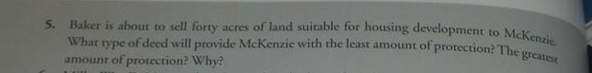
Chapter 13 questions 2 & 8
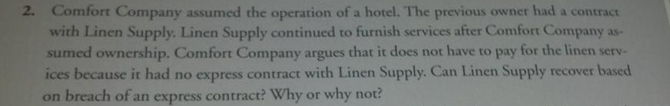
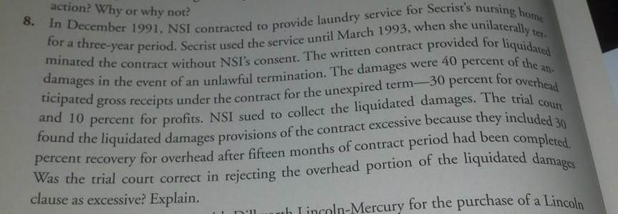
Chapter 14 questions 6 & 7
