Read *Resolving Ethical Business Challenges* found in the textbook on pages 148-149 and write an analysis that addresses each of the following:

1. What are the legal and ethical risks associated with the decision about hiring truck drivers at Zyedgo? = 3 points
2. Do you think Peter is too emotionally attached to the Martin case to make an objective decision? Explain your answer. = 3 points
3. Assume that Peter were to espouse an Egoist approach to moral moral philosophy what would he do in each of these cases (the drivers; Gwen; and the Martins/insurance payments)?  Be sure to clearly explain how the principles of Egoism would be applied. = 6 points
4. Now assume Peter were to approach these issues from a Christian Worldview.  List any Biblical scriptures/principles that may be used to guide his decisions. = 3 points

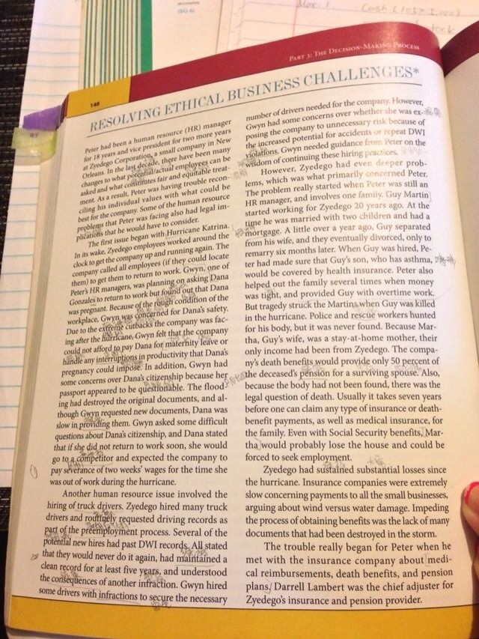

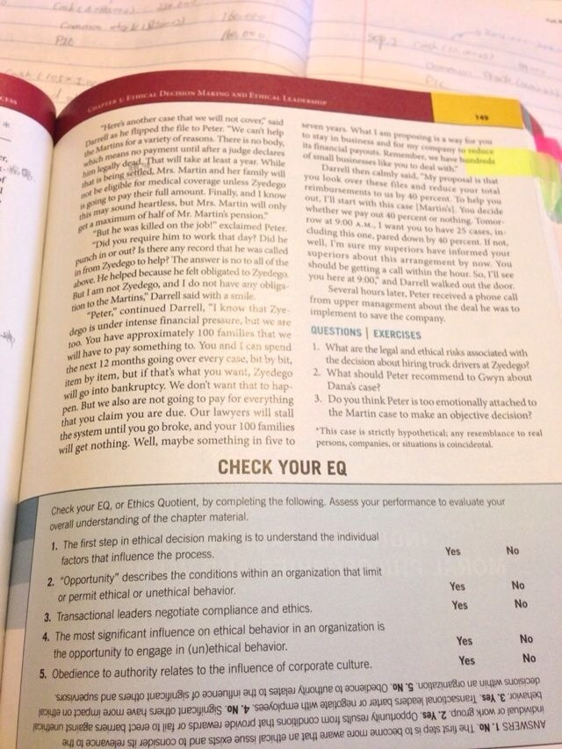

please answer those questions directly and clearly.