Remember that this essay's purpose is not just to summarize a poem: you are looking to offer an explanation for a poem, what you see as the poem's meaning and how you think an element or several elements of poetry are being used to contribute to that meaning. Before you begin drafting, you may find it helpful to track how/when diction, tone, imagery, and figurative language are used in your poem. However, don't identify elements of poetry for the sake of identifying them: identify them only when you believe their use is helping to convey what you see as the poem's meaning. You may find that the best way to organize your essay is to begin your argument where the poem begins and continue to work your way through the poem as it progresses. Your essay will need a thesis: this is, typically, a concise statement that appears in the introduction and names what you see as the poem's meaning, as well as the element or elements your essay will explore. Continue to flesh out your argument throughout the body of your essay, working your way through the poem. Select quotations from the poem to illustrate your claims.

Sample Explication Essay: Introduction

The explication essay we will be using as a sample is based on the Dylan Thomas poem "Do Not Go Gentle into That Good Night."

Essay source: Abcarian, Richard and Marvin Klotz. Literature: The Human Experience. Shorter 9th ed. Boston: Bedford/St. Martin's, 2007. Print.
Please use this essay as a model for your own.
Let us begin by looking at the introduction:
Notice the following: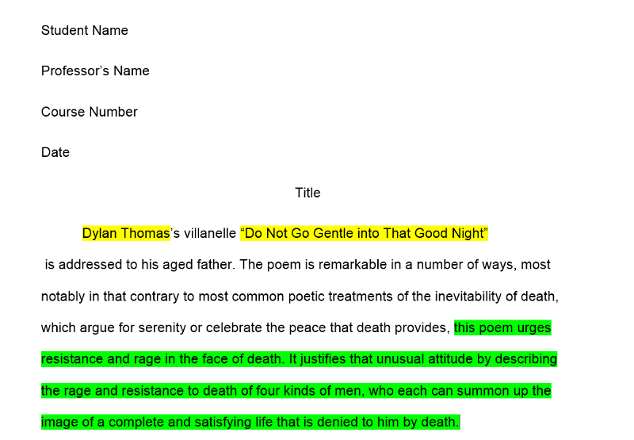

- the introduction needs to formally introduce poet and poem: the poem's name is given in full, first and last; if the poet is named again later in essay, the convention is to use last name only. The poem's title is placed inside quotations marks
- the thesis should identify what the essay will argue is poem's meaning; here it is "this poem urges resistance and rage in the face of death." Notice this is expressed as a complete sentence, not a single word/subject (not just "death" -- remember that in a previous lesson we discussed the difference between theme and subject). Notice also this is a universal argument. Although the introduction identifies that the poem is addressed to Thomas's father, the meaning of the poem is not solely for him. Finally, notice that the thesis also alludes to how imagery will be discussed as an element of poetry that conveys the poem's meaning ("it justifies that unusual attitude by describing the rage and resistance to death of four kinds of men, who each can summon up the image of a complete and satisfying life that is denied to him by death."
- we may find the thesis at the very end of the introduction paragraph, as in our sample paragraph above; it is also possible though that the thesis is the very first sentence in the introduction paragraph and that the paragraph immediately begins to explicate

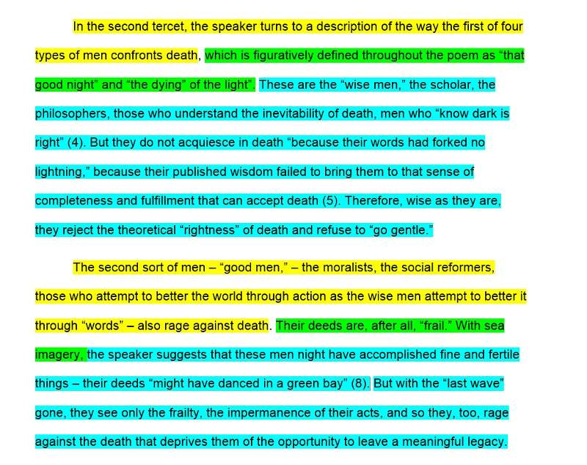

Notice the following :

- each body paragraph has a focus. The line highlighted in yellow -- the topic sentence -- identifies for the reader what the paragraph is about. In essays, body paragraphs need focus: each paragraph should address only one thing a time. In this essay, each paragraph focuses on where we are in the poem or on one of the four types of men discussed in the poem. For your essay, you will need to find a logical method for focusing your paragraphs; it may be that each paragraph looks at one stanza or one section of the poem, for example. How many paragraphs should your essay have? There is no magic number - but it should follow some logic. It will depend on how you choose to organize your essay. Our sample essay happens to contain six paragraphs (which mirrors the number of stanzas in the poem).

- the sections highlighted in green identify elements of poetry -- notice how they make reference to figurative language and imagery

- the sections highlighted in blue offer explanations and evidence: these are the portions of the body paragraphs that are the most developed. These sections are where your essay needs to work hardest: explain the connection between the element of literature and what you claimed (in your thesis) was the poem's message. Discuss how form contributes to meaning.

- However, for this particular essay, you should not be using any sources other than the one poem. As such, your Work Cited page should only contain one entry (for the poem itself) and be relatively painless to compose.
- . In brief, "in an explication essay, you examine a work in much detail. Line by line, stanza by stanza...you explain each part as fully as you can and show how the author's techniques produce your response. An explication is essentially a demonstration of your thorough understanding of a work" (Literature: The Human Experience 47).
- For this particular essay, you will want to focus on the poetic techniques of diction, tone, image, and/or figurative language, which we will also cover in this unit.
- Your essay should adhere to MLA formatting. It needs to quote directly from your chosen text for support, but it should not use any secondary research.
- Remember that the explication essay should not just summarize the poem.
- It needs to look at the different elements of poetry used and offer a detailed explanation of the poem that also addresses the poem's overall effect and meaning.

