A patient information system for mental healthcare:
A patient information system to support mental healthcare, (the Mentcare system), is a medical information system that maintains information about patients suffering from mental health problems and the treatments that they have received. Most mental health patients do not require dedicated hospital treatment but need to attend specialist clinics regularly where they can meet a doctor who has detailed knowledge of their problems. To make it easier for patients to attend, these clinics are not just run in hospitals. They may also be held in local medical practices or community centers.
The Mentcare system (see below):
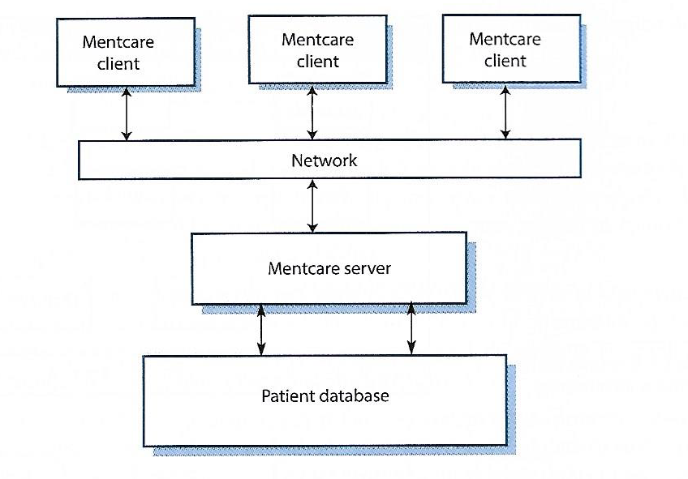
This is a system that is intended for use in clinics. It makes use of a centralized database of patient information but has also been designed to run on a laptop, so that it may be accessed and used from sites that do not have secure network connectivity When the local systems have secure network access, they use patient information in the database, but they can download and use local copies of patient records when they are disconnected. The system is not a complete medical records system and does not maintain information about other medical conditions – however, it may interact and exchange data with other clinical systems.
The system has two purposes:
- To generate management information that allows health service managers to assess performance against local and government targets.
- To provide medical staff with timely information to support the treatment of patients.
Patients who suffer from mental health problems are sometimes irrational and disorganized so they may miss appointments, deliberately or accidentally lose prescriptions and medication, forget instructions and make unreasonable demands on medical staff. They may drop in on clinics unexpectedly. In a minority of cases, they are a danger to themselves or to other people. They may regularly change address or may be homeless on a long-term or short-term basis. Where patients are dangerous, they may need to be “sectioned” or confined to a secure hospital for treatment and observation.
Users of the system include clinical staff such as doctors, nurses and health visitors. Nonmedical users include receptionists who make appointments, maintain records, and other administrative staff.
The system is used to record information about patients (name, address, age, next of kin, etc.) Consultations (date, doctor seen, subjective impressions of the patient), conditions, and treatment. Reports are generated at regular intervals for medical staff and health authority managers. Typically, reports for medical staff focus on information about individual patients, whereas management reports are anonymized and are concerned with conditions, cost of treatment, etc.
Key features of the system:
- Individual care management. Clinicians can create records for patients, edit the information in the system, view patient history, and so on. The system supports data summaries so that doctors who have not previously met a patient can quickly learn about the key problems and treatments that have been applied.
- Patient monitoring. The system regularly monitors the records of patients that are involved in treatment and issues warnings if potential problems are detected. Therefore, if a patient has not seen a doctor for some time, a warning may be issued. One of the most essential elements of monitoring in the system is to keep track of patients who have been sectioned and to ensure legally required checks are carried out correspondingly.
- Administrative reporting. The system generates monthly management reports showing the number of patients treated at each clinic, the number of patients who have entered and left the care system, the number of patients sectioned and the number of drugs prescribed and their costs, etc.
Two different laws affect the system: the laws on data protection that govern the confidentiality of personal information and mental health laws that govern the compulsory detection of patients deemed to be a danger to themselves or others. Mental health is unique in this respect as it is the only medical specialty that can recommend the detention of patients against their will. This is subject to strict legislative safeguards. One aim of the Mentcare system is to ensure that staff always act in accordance with the law and their decisions are recorded for judicial review if necessary.
As with all medical systems, privacy is a critical system requirement. It is essential that patient information is confidential and is never disclosed to anyone apart from authorized medical staff and the patient themselves. The Mentcare system is also a safety-critical system, meaning that some mental illnesses cause patients to become suicidal or a danger to themselves or others; when possible the system will warn medical staff about potentially suicidal or dangerous patients.
The overall design of the system must consider privacy and safety requirements. The system must also be available when needed – otherwise safety may be comprised and it may be impossible to prescribe the correct medications. There is a potential conflict – privacy is easiest to maintain when there is only a single copy of system data, however, to ensure availability in the event of server failure or when disconnected from a network, multiple copies of the data should be maintained.

