English 1102
T3/2019
Essay 3
Requirements: Minimum 750 words
Draft Due in Canvas: 2.10
Revision Due: 3.10

Assignment: Write an essay that defends a thesis you developed through a close critical reading/analysis of one (or two depending on topic) literary works listed below and supported by at least one secondary source drawn from such academic databases as the MLA International Bibliography, JSTOR, and Project MUSE. You will access these databases through the Troy Library website, not general web searches. This essay relies mainly on textual support from the primary text, but includes at least one secondary source that supports/sustains the student’s argument. Do not confuse “critical analysis” with “plot summary”; the goal is to develop, sustain, and advance a thesis based on a critique of the primary text but supported in part by at least one secondary source.

Choice of two topics—write on only one:

Topic 1:
Analyze one soliloquy in Shakespeare’s Othello so that you can show how the speech’s imagery helps us to understand what Iago or Othello is thinking and doing at that point of the play. Use the discussion boards to ask questions—there is an entire section in the discussion boards for the speeches. You are analyzing the speech to give a sense of HOW Iago and Othello explain their thoughts—you do not want to merely summarize the speech. As with Essays 1 and 2, this is thesis driven—you are not given a thesis here as in Essay 1, but must invent one as in Essay 2. So, the thesis should say something about how the speech reveals Iago or Othello’s character and what they are thinking at this point in the play.

You will want to go through the speech and examine how each line builds up the speech—go through it line by line (not to summarize though), to show how it all comes together through the specific imagery in the speech.

The soliloquies are:
Iago: Act 1, Scene 3, Lines 367-88 (1.3.367-88)
Iago: 2.1.269-95
Iago: 2.3.299-325
Iago: 3.3.336-345
Iago: 4.1.93-103
Othello: 5.2.1-22

You will want to formulate a clear thesis (a statement about what you believe the speech says or does most strikingly, in your opinion) and develop your argument showing how it achieves this by drawing evidence from such elements as simile, metaphor, vocabulary/diction, symbol, rhyme, etc. Use the elements discussed in the Backpack Literature chapters and in our discussions as your guide.

Your goal is in no way here to summarize the speech. Rather, go through each line very carefully, explaining how each image adds to the speech’s overall impact and progress—each of Iago’s speeches shows us how his thinking is developing and how his plan comes together. Othello’s speech shows us the result of Iago’s work on him—Othello is possessed by the idea that Desdemona has not only been unfaithful to him, but will bewitch and cheat on other men.

Topic 2:

In an argument using either of the following pairs of speeches, compare and contrast the ideas expressed by either Troy or Rose (but not both) in Fences. In this essay, you will want to really dig into how Troy and Rose express themselves, what they have wanted out of life, and what they have wanted from each other. You do not want to compare Troy’s speeches to Rose’s—rather, look at how the characters develop and change between the two speeches each gives. In other words, as with the first choice, your goal here is to go through the speeches very carefully, showing how the language shows us who these characters are.

- Troy’s speech at the end of Act 1 Scene 3 on page 1053 that begins, ‘I don’t want him to be like me…’ down through ‘I can’t give nothing else,’ and Troy describing his father in Act 1 Scene 4 in the long set of speeches that begins, ‘Sometimes I wish I hadn’t known my daddy…’ on page 1058 ending with ‘the matter of a few years’ on p 1060.

B. Rose’s speech in 2.1 that begins on page 1068 with: ‘I done tried to be everything a wife should be. Everything a wife could be’ through to ‘don’t even know nobody’s giving!’ on 1070, and her speech in 2.5 on page 1084 beginning with ‘You can’t be nobody buy who you are…’ to ‘the best of what’s in me.’

You will want to formulate a clear thesis (a statement about what you believe the speeches say or do most strikingly, in your opinion, to develop the common themes) and develop your argument showing how they achieve this by drawing evidence from such elements as simile, metaphor, vocabulary/diction, symbol, rhyme, etc. Use the elements discussed in the Backpack Literature chapters and in our discussions as your guide.

You MUST USE direct quotes to support a thesis in a tight, focused argument; a good rule of thumb is one quote per paragraph. Each speech has strong elements to choose to analyze, and I will certainly be happy to talk to each of you about possible quotes. I look forward to reading your essays.

There is one required outside source. This source cannot be from just any author or website—any use of a site like SparkNotes, Shmoop, eNotes, etc. will not fulfill the requirement and should be avoided. These are not university level sources. Instead, you must use the MLA International Bibliography of JSTOR Arts and Sciences—databases you must access through the Troy Library: http://trojan.troy.edu/library/

When you access that link, you should see this screen:
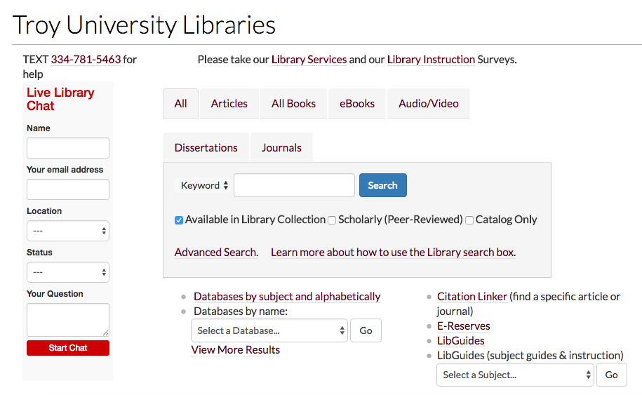

In your browser (not the image above), click on ‘Databases by name:’ and then type ‘MLA International Bibliography,’ ‘JSTOR,’ Project MUSE.’ It is useful to go through all three to find good sources.

If you are off-campus/off-site, you will be prompted to enter your Troy email address and password for access to the databases. Do so. You will then be in the MLA Bibliography through EBSCHOhost (or JSTOR or Project MUSE).

When you search here, simplicity is best. Start wide--just the author’s name and/or the title of the play. Here, I might start with ‘Shakespeare Othello' or ‘Wilson Fences’ and be sure to select 'Linked Full Text' articles from all sources. Since most of us are not able to get to main campus and the library, we want to search only for 'full-text' articles so we can read and download them remotely.

You will need to read several articles to find one that fits your argument. Do not simply ‘drop’ a quote or two from your article into the essay—as in 1101, all outside sources must be logically incorporated into your essay with an attributive phrase and analysis that ties the quote to your thesis.

Here's what that search screen should look like:

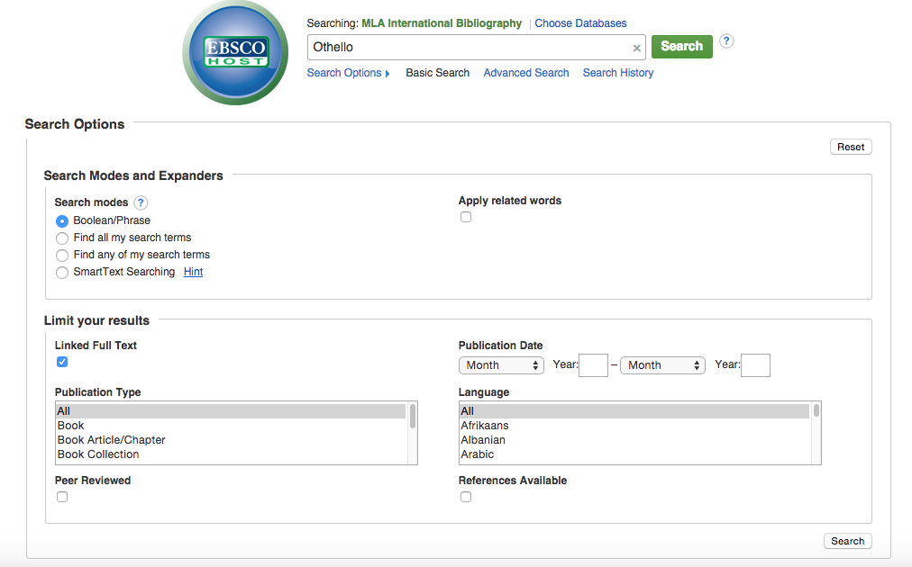

Quality research takes time. It is not easy, and results rarely fall into one's lap. One needs to understand that diligence and reading a lot of material that might not directly help one's research project is a part of the job.

Please email me with questions/ideas/problems. I am here to help!

Basic Guidelines:

- Double space your essay; include your name, the course number and section at the top of the first page
- Avoid the use of the second person as it is conversational and too direct. Use the first person to describe your own thoughts, but better to use the third person.
- Introduce your poems and authors by full title and his/her full name early in the paper. Thereafter, only use his/her last name.
- Do not focus on the writing process.
- Be sure that you do not simply summarize or paraphrase the speech or speeches. Assume the reader knows the play you are talking about; your job is to help the reader see below the surface and understand the speech or the speeches better.
- Write in the present tense, but do use tenses to show chronology in the speech itself as needed.
- Always use direct quotes to support your claim, and thoroughly explain what each quote means and why it is important to your thesis. A good rule of thumb is one quote per paragraph.
- Examine how Shakespeare and Wilson use language—including similes, metaphors, and other comparisons, symbols, rhymes that link concepts, archaic meanings of words and their etymologies—use the OED through the links at the Troy library website (you pay for the subscription as part of your tuition—use it), etc.

What you’ll be graded upon:

15% Introduction: You establish a context for the significance of your thesis in regards to the literary work as a whole. How does your argument contribute to understanding the author’s major literary/thematic concerns? What can other readers learn from your analysis? How does your analysis/critique fit in with other critical responses of the author/literary work?

15% Thesis: You state your main point (or argument) in 1-2 sentences. The thesis is the culmination of your introduction.

30% Organization. Your essay should follow that of typical literary critiques:
Since your focus must be on analyzing some literary motif, theme, or a combination of literary elements (such as symbolism, character, setting, etc.), your essay must contain well-structured supporting paragraphs that contain a topic sentence, quotes from the primary text, at least one quote from a secondary source, an explanation/discussion of the significance of the quotes you use in relation to your thesis, and a concluding sentence or two that situates the entire paragraph in relation to the thesis. Your thesis will focus on some kind of critical analysis of the primary text, so your supporting paragraphs should contain quotes from the text that illustrate your thesis/argument; in addition, you should include at least one quote from secondary source to support your argument. Your supporting paragraphs should be organized around each of the quotes you use, explaining the significance of the quotes and why (or how) they illustrate your main point, but you also need to make sure that your paragraphs contain strong transitions and at least six (or more) sentences.

10% Conclusion: Regardless of the argument you make, you want a conclusion that avoids summarizing what you’ve just said, and please avoid writing, “In conclusion.…” Your aim in a conclusion is to place the discussion in a larger context. For example, how might your critical analysis of a literary character relate to the other characters in a work? How might your thesis be applied to other aspects of the text, say for example, setting or symbolism?

15% Grammar and mechanics: Your paper avoids basic grammar mistakes, such as dropped apostrophes in possessives, subject/verb disagreement, arbitrary tense switches, etc. The paper demonstrates a commitment to proofreading by avoiding easy-to-catch typos and word mistakes (effect for affect, for example). The paper adheres to MLA formatting style for in-text and bibliographic citations.

15% Presentation: Your paper meets the minimum length criteria of 750 words, is typed with a title and your name on it. You follow your individual professor’s instructions for formatting (margins, placement of the name, etc).

