3-2 Jennings text, p. 295, Consider
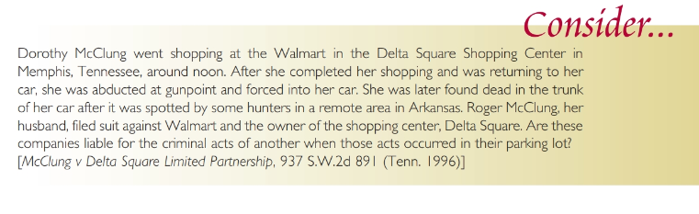
3-3 Jennings text, p. 302, Consider
