4.01: Crime Story

Unit Introduction: Trace Evidence 2
When asked to describe trace evidence from a crime scene, most people will think of fingerprints, blood, hair, or DNA. However, there is much more. Lessons in this unit will address other types of evidence, such as toolmarks, glass, soil, impressions, footprints, tire tracks, and poisons.
You will begin by looking at a crime involving such evidence. Then you will learn how forensic scientists study each type of evidence. You will apply what you have learned to the initial crime to determine what happened.

Lesson Introduction: Finding Brittany
A teenager has been abducted from her home. The daughter of a wealthy physician, she is possibly being held for ransom. The police need to find where her abductors are holding her.
As head of a forensic laboratory, you have been asked by the police to examine the trace evidence in hopes that your team can determine exactly what happened at the crime scene and where the captors may be holding the victim.

What's the Story?: At the Crime Scene
Teenager is missing.
At 10:30 p.m., police responded to an emergency call from a home in Ladue, a suburb of St. Louis, Missouri. When officers arrived, there was no one on the premises. The house showed signs of breaking and entering. Officers secured the area and called investigators.
Open the Crime Story Introduction document to find out what happened next in the case.
Finding Brittany: A Crime Story: Introduction (DOCX)
Officers find evidence.
Crime scene investigators methodically searched the scene and collected evidence for forensic analysis.
Open the Crime Story Evidence document to learn more about what evidence was collected at the crime scene.
Finding Brittany: A Crime Story: At the Crime Scene (DOCX)

Explore: Analyzing the Evidence
Read the evidence from the crime scenes.
Police are sending most of the evidence to the laboratory for analysis.
They intend to fully cooperate with the laboratory in the hopes that your investigations can reconstruct the crime and possibly lead them to where Brittany Evans is being held.
Take a few minutes to review the evidence from the crime scenes.
Finding Brittany A Crime Story - Evidence (DOCX)
You must investigate an abduction.
The 16-year-old daughter of a wealthy doctor has been abducted, possibly for ransom. Police have given you, the head of a forensic laboratory, evidence in the form of sketches, glass samples, soil samples, toolmark casts, footprint impressions, tire track impressions, blood samples, hair samples, fabric samples, and a used syringe.
You must analyze the evidence to reconstruct the crime. Police hope that your analyses can lead them to where the victim, Brittany Evans, is being held. Your analyses should lead to broad, accurate conclusions and may not lead to a very specific address.
You will continue to analyze evidence, record your observations, and refine your conclusions as you go along.

4.02: Toolmarks

Lesson Introduction: Toolmarks
In many crimes, especially burglaries, criminals use tools like pry bars, screwdrivers, or knives. When a tool contacts a surface, it leaves a mark.
In this lesson, you will learn about the various types of toolmarks and how to collect toolmark evidence. You will also see how toolmark examiners analyze the evidence to identify the types of tools used in crimes.

What's the Story?: Lindbergh Kidnapping
Lindbergh Kidnapping: Introduction
Charles Lindbergh was a famous aviator. In 1927, he became the first person to fly across the Atlantic Ocean. He was an American hero.
On March 1, 1932, Lindbergh’s 20-month-old son, Charles Augustus Lindbergh, Jr., was kidnapped from his home in Hopewell, NJ. A subsequent search of the home revealed a crude wooden ladder, a chisel, muddy footprints, and a ransom note.
The New Jersey State Police launched a massive investigation. Over the next two months, Charles and his wife, Anne, negotiated with the kidnapper through lawyers and friends.
The family paid $50,000 ransom to a man with a German accent who said that the boy would be found safe aboard a boat on Martha’s Vineyard, MA.
In May, the child’s body was found in woods near the Lindbergh’s home. He was killed, probably at the time of the kidnapping, by a blow to the head. In the subsequent investigation, the ladder and the toolmarks on it would become key evidence in solving the crime.

Learn: Collecting Toolmark Evidence
What are toolmarks?
When you use any tool, such as a hammer, screwdriver, pliers, or saw, the tool leaves a mark on the surface of the object. Likewise, the surface may leave a mark on the tool.
For example, a file will leave scratch marks on a piece of wood. If you look at the file, you will see wood shavings in the grooves or perhaps even some wear on the grooves.
The impression, scratch, or abrasion that occurs when a tool comes in contact with an object is called a toolmark.
Criminals often use tools to commit crimes.
Toolmarks are often evidence at a crime scene. Toolmark evidence is most common in burglaries, robberies, and break-ins.
Tools leave two types of marks: class marks and individual marks. Class marks identify the type of tool. For example, the marks left by pry bars differ from marks left by other tools. So investigators can identify the type of tool used in a crime based on the mark it left.
The specific pry bar used in a crime also leaves individual marks—marks that are unique to the tool. If a tool is found with a suspect's belongings, the individual marks may help link the suspect to the crime.
Toolmarks are usually one of three types.
Toolmarks usually fall into one of three categories.
- Indentation – impressions that a hard tool makes into a softer material
- Striation or abrasion – scratches made when the surface of the tool slides across the surface of the object
- Cutting marks – marks along the edge of a surface that has been cut
Specific tools typically make certain kinds of marks. For example, a screwdriver usually makes a striation. However, a screwdriver sometimes makes an indentation or a cutting mark. Forensic examiners consider all possibilities when working with toolmarks.
Photographs document toolmark evidence.
How do investigators collect toolmark evidence? At a crime scene where toolmarks are present, investigators photograph the toolmarks to document the evidence.
- Investigators will insert a ruler or scale in the photograph to document the size of the toolmark.
- Investigators will take photos at various distances, including from close up.
- To highlight details of the toolmark, the photographer will use lighting from an angle (known as oblique lighting). It produces shadows that show the marks better.
- If the toolmark is on a very dark surface, the investigator may burn some magnesium ribbon on it. The smoke forms a white powder (magnesium oxide) that highlights the toolmark.
Toolmark examiners use casts to duplicate the mark's shape.
When necessary, the investigator may remove the surface containing a toolmark, like the portion of a doorframe containing an indentation.
Toolmarks can be further documented by making casts or molds of them. Investigators can create them by using various resins, putties, or waxes, like dental wax or silicone.
To view a video demonstration of a toolmark cast, visit the Crime Scene Investigator Network:
Casting Toolmark Impressions with Mikrosil
When you have finished, go to the next screen to try your hand at making a simple toolmark cast.

Learn: Analyzing Toolmarks
Tools can be compared to the marks they make.
Suppose you found a screwdriver in a burglary suspect’s car. You think it might have been used in the crime. How could you tell for sure?
You could make a test mark using the suspected screwdriver and compare it to a toolmark photograph or cast from the crime scene. You would look for matching lines in the striations of the toolmark and the test mark.
You could also make a cast of the suspected tool. Then you could compare the cast of the toolmark to the cast of the tool to see if they match.
Investigators would never match the tool itself directly with the cast or mark so as not to contaminate the evidence, either the tool or toolmark.
Test marks and toolmarks must be compared carefully.
The comparison microscope allows an examiner to compare crime-scene toolmarks side-by-side with test marks. The microscope reveals the fine details in the toolmark, including any individual marks. An individual mark can link a suspect's tool to a crime.

Explore: Do It--Toolmark Casts
Make a Toolmark Cast.
Follow these steps to create a set of toolmarks. Then use a modeling material, such as clay, soft bubble gum, or Silly Putty®, to create a cast of the toolmarks.
Study the casts and your tool. Look for nicks or other imperfections that might be specific to your tool.

Do it :Reach your own conclusions using real-life samples.
Concept: Gathering Trace Evidence
Experiment: Make a Toolmark Cast
Materials: Screwdriver; hammer; piece of wood; modeling material such as Silly Putty®, clay, or soft bubble gum
1. Place the screwdriver point on the block of wood.
2. Tap the screwdriver with the hammer to make an impression in the wood.
3. Repeat Step 2 several times to make toolmarks that are close together.
4. Spread the modeling material over the marks and gently press down. Press down uniformly to cover the marks.
5. Gently peel back the modeling material. You should see the mold of the toolmark inside.

What's the Story?: Lindbergh Kidnapping Resolution

Toolmark evidence in the Lindbergh case
The crude ladder was one focus of the Lindbergh kidnapping investigation. Forest Service expert Arthur Koehler was asked to examine the ladder. Koehler was able to tell the type of wood used to make it.
From milling marks (which are a kind of toolmark), Koehler identified where the lumber was cut.
When other evidence revealed a suspect, Bruno Hauptmann, Koehler examined the floorboards in Hauptmann's attic and determined that the wood in the floorboards matched the wood used to make the ladder.
Finally, Koehler compared toolmarks made from a carpenter's plane found in Hauptmann's house with the plane marks found on the ladder used in the crime and the marks matched.
This evidence, along with other evidence, helped convict Bruno Hauptmann in the kidnapping and murder. Hauptmann was later executed.

Learn: Toolmarks As Evidence
Toolmark evidence has been questioned in court.
In Ramirez v. State of Florida (2000), toolmark evidence from a knife was key in convicting Joseph Ramirez for the 1983 murder of a 27-year-old woman. Toolmark examiners testified that a knife found in Ramirez’s car was the murder weapon, to the exclusion of all others. This testimony was challenged in two appeals stating that the knife-blade toolmark evidence lacked rigorous scientific testing. Ramirez lost the appeals, but questions about toolmark evidence remain.
Scientists at Ames Laboratory (U.S. Department of Energy) are using a laser scanning profilometer to document toolmarks. They are creating a toolmark database and developing software to compare toolmarks with greater than 99.9% reproducibility.
Explore career possibilities in forensic toolmark examination.
The science of forensic toolmark examination is complex. New techniques and information give crime examiners a chance to grow professionally.
Here is a link to a site visited by toolmark forensic scientists.
Association of Firearm and Tool Mark Examiners

Review: Toolmarks
Toolmark evidence is important in solving crimes.
Criminals often use various tools. Because tools make toolmarks when they come in contact with objects, they leave toolmarks at crime scenes.
Toolmarks can be classified as indentations, striations (abrasions), or cutting marks. Various tools make distinct types of toolmarks.
Forensic scientists collect tool evidence by photography and by casting. The toolmark evidence is compared to test marks from known tools with a comparison microscope. Toolmark evidence is used to identify either the type or the specific tools used in a crime. Toolmark evidence from a ladder was a key factor in solving the Lindbergh kidnapping case.

4.03: Glass

Lesson Introduction: Glass
Forensic scientists must collect and analyze glass evidence. In this lesson, you will learn how glass evidence is characterized by physical properties such as density, color, fluorescence, refractive index, chemical composition, and fracturing patterns. These characteristics can be used to identify glass and exclude suspects.

What's the Story?: The Baby Food Case
Baby food contaminated with glass.
From February to March 1986, there were more than 500 complaints to the Food and Drug Administration (FDA) that jars of baby food contained glass shards. The baby foods were manufactured by H.J. Heinz, Beech-Nut, and mostly by Gerber. Heinz and Beech-Nut issued recalls of their products, but Gerber did not. Gerber maintained that there was nothing wrong with its manufacturing process and that the glass fragments found in the baby food jars were foreign and placed there by someone else. The FDA investigated the claims by analyzing the glass.
Glass fragments are found in many crimes (for example, burglaries, hit-and-run accidents, and so forth). Forensic scientists must be able to collect, characterize, and identify glass evidence.

Learn: Collecting Glass Evidence
Glass evidence is carefully collected.
According to Locard’s principle, when glass is broken at a crime scene, some glass may be transferred to the perpetrator. Therefore, a suspect’s clothing might have tiny glass fragments caught within it.
At a crime scene, clothing gets bagged separately in paper bags. Bloodstained or wet clothing must first be dried before packaging. Large, visible glass fragments are collected and placed in sealed paper bags, plastic bags, or plastic containers to prevent the shards from tearing the bag. The samples are not stored in glass containers. All containers are marked. Often, comparison samples are also taken.
If a large piece of glass, such as that of a windshield, must be examined for direction of impact, then the outside and inside surfaces should be marked. Samples are sent to forensic labs for analysis and comparison.

Glass is made from sand.
The main ingredient in glass is silica (SiO₂), which occurs in nature as sand. At temperatures greater than 3000°F, sand melts and becomes a liquid. If the liquid cools under the right conditions, the smooth, amorphous solid known as glass forms.
Glass made entirely from silica is expensive. To lower costs and improve properties, glass manufacturers add certain metal oxides. For example,
- Na₂CO₃ lowers the melting point.
- CaO makes glass less water soluble.
- MgO and Al₂O₃ improve durability.
- B₂O₃ improves the ability to withstand thermal shock.
Glass manufacturers vary the amounts of metal oxides to make different types of glass:
- Soda-lime silica: Most of the glass we use in everyday life is soda-lime silica. It is made from sand (SiO₂), limestone (CaCO₃), and sodium carbonate (Na₂O₃). Small amounts of MgO and Al₂O₃ are added.
- Borosilicate: Cookware and laboratory glassware are often borosilicate glass. Manufacturers add B₂O₃ to improve thermal properties. Laboratory grade Pyrex® is borosilicate glass.
- Aluminosilicate: High-performance glasses, for example, space-vehicle windows, are often aluminosilicate glass. Manufacturers add 20% Al₂O₃ to improve durability.

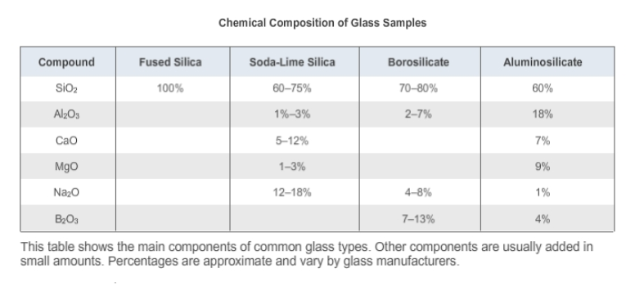
Manufacturing techniques affect glass properties.
Glass manufacturers also control the properties of glass during manufacturing. For example, a particular technique used to heat and cool glass, regardless of the chemical composition of the glass, affects its strength and the way the glass fractures when broken.
Different techniques are used in the production of glass:
- Annealed glass
- Heat-resistant glass
- Tempered glass
- Laminated glass

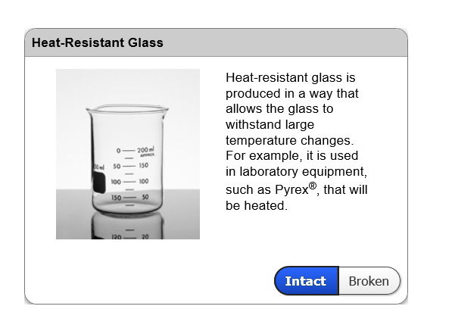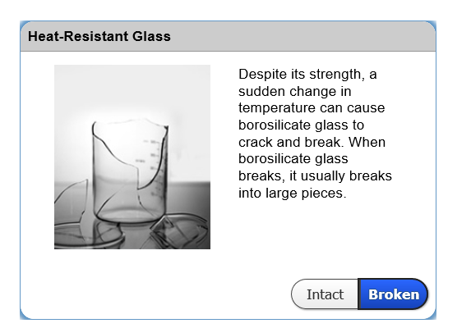
Melting and cooling occur in making glass.
Let's look at just one example of how glass is made. This diagram shows the process for annealed, monolithic glass.
Monolithic glass is a single sheet of glass. It is made by combining a mixture of SiO₂ and other components, melting the mixture, and combining the mixture with denser molten tin. The molten glass floats on the tin and flattens. Once flat, the glass is cooled, without crystallizing, by annealing. The glass is then washed, dried, and cut into sheets.
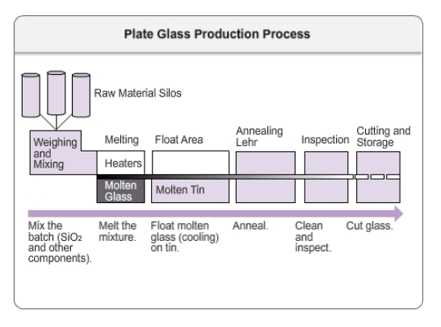
Use these properties to identify glass type.
Various types of glass have different properties.
- physical properties – color, thickness, density
- optical properties– fluorescence, refractive index
- element composition
Forensic scientists must compare the various properties of the glass evidence with those of the known glass samples to see whether they match.
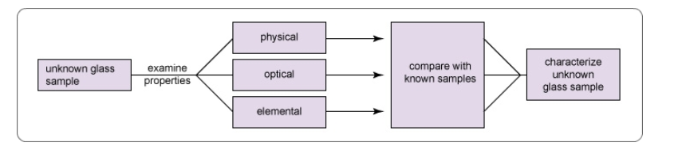
Find glass density with flotation method.
Forensic scientists use the flotation method to measure density (d). In a surrounding liquid, an object will either float (d_{object} < d_{liquid}), sink (d_{objec t}> d_{liquid}), or be suspended (d_{objec t}= d_{liquid}). If you know the density of the liquid in which a glass fragment is suspended, you know the density of the glass.
In practice, scientists place a few pieces of a known sample in a mixture of bromoform (CHBr₃) and bromobenzene (C₆H₅Br). Then they add small amounts of CHBr₃ or C₆H₅Br to the mixture until the glass particles are suspended (CHBr₃/C₆H₅Br ratio tells them the density).
Next, they add some of the unknown glass evidence fragments of the same size. If both the evidence fragments and known samples are suspended, then they have the same density.
Compare fluorescent spectra to match glass.
When viewed with ultraviolet light, many objects, including glass, will fluoresce . In this process, the glass absorbs the short wavelengths of ultraviolet light and emits light of a longer wavelength, such as red, green, or yellow. The exact wavelengths of emitted light depend on the type of glass.
Scientist can compare the fluorescent spectrum of glass evidence fragments with that of known samples. If the spectra match, then the evidence and known samples must be of the same type of glass.
Refractive index differs from glass to glass.
Glass fragments can be compared by refractive index (RI), a measure of how much the glass bends light passing through it.
Glass fragments are placed in a drop of silicone oil on the hot stage of a microscope. A camera and computer record the image of the fragment. A bright halo called a Becke line surrounds the fragment. As the temperature of the stage and oil increases, the RI of the oil changes and the Becke line moves relative to the edge. When the RI of the oil matches that of the glass, the glass image and the Becke line disappear. The computer notes this temperature and calculates the glass’s RI.
The FBI maintains an RI database.
If the RI of a suspect glass fragment is different from a piece of evidence glass, the suspect glass can be ruled out. What if the RI is similar?
Refractive index is not individual evidence. Two pieces of glass from different sources can have the same refractive index. However, forensic scientists are able to determine the likelihood that two pieces of glass come from the same source by submitting the RI to an FBI database.
The FBI has collected the refractive indices of glass samples submitted to it for analysis over the years. The result is a database that shows the frequency of a particular refractive index in the samples the FBI has analyzed.

Forensic scientists use the frequency from the database to estimate the probability that two samples with the same refractive index come from the same source. Although an RI value is not individual, there is a wide distribution of RI values in the FBI database, so a value can be fairly distinctive: Some refractive indices in the database occur in as few as 1 in 2000 glass samples.
On the next screen, you can see an example of an FBI database for refractive index.
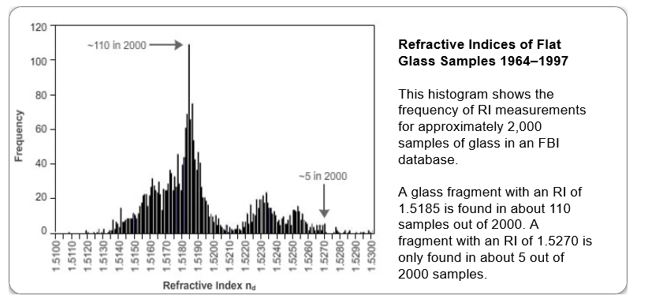
Instruments are used for elemental analysis.
The following instruments are used to determine the elements in a glass sample:
- Electron probe microanalysis hits the sample with an electron beam in an electron microscope. When atoms in the sample absorb the electrons, they re-emit the energy as X rays. The energies of the emitted X rays indicate what elements are present.
- X-ray fluorescence works in a similar manner, but it hits the sample with an X-ray beam.
- Laser ablation mass spectrometry hits the sample with a laser beam and the liberated atoms are sent through a mass spectrometer to determine their identity.
- Laser-induced breakdown spectroscopy vaporizes the sample to high-energy plasma where the elements emit specific wavelengths of light.
FDA investigation cleared baby food maker.
The FDA examined the glass in 240 opened jars of Gerber baby food. The FDA's key findings were as follows:
- In 70% of the jars, the types of glass found in the jars were different from the clear flint glass used to package the baby food.
- Using elemental analysis, scientists identified glass shards in the baby food as window glass, light bulb glass, glass tumblers, and other types of glass not used in the baby food packaging.
- In only a few instances did large pieces of clear flint glass get stuck in jars during the manufacturing process.
The FDA concluded that the glass in the baby jars did not come from the manufacturing process and must have been placed in them after opening. So Gerber did not need to recall the products.

Glass fractures in two types of patterns.
When forces are applied to glass by an impact from a bullet or a stone, the glass breaks in two types of cracks— concentric fractures and radial fractures . By examining these cracks, an examiner can develop an explanation of the nature of the impact or impacts that caused them.
Radial cracks form first on the opposite side of the glass from impact. Concentric circles form next on the same side of the impact.

Forensic scientists examine glass evidence.
Forensic scientists gather and analyze broken glass from crime scenes. They compare evidence glass fragments with those from known samples by a variety of techniques (flotation, microscopy, X-ray fluorescence, and laser-induced breakdown spectroscopy). They measure physical properties (density), optical properties (color, fluorescence, refractive index), and element composition. Using those findings, they can determine whether two samples of glass match.
Finally, they can tell the direction of force applied to the surface of glass by examining the cracks and stress marks created by the impact. These cracks can also reveal the sequence of impacts when more than one impact occurs.

