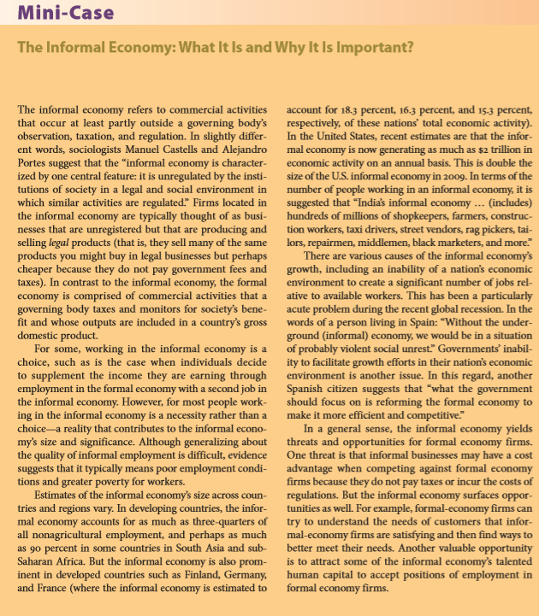

Read the Chapter 2 Mini-Case: The Informal Economy: What It Is and Why It is Important?
Respond the question: What threats does the informal economy present to firms operating in the formal economy? Use examples from your personal experience with the informal economy.
Word limit 300

