Ctenophores: Structure, Development and Affinities:

From: http://www.biologydiscussion.com/animals-2/marine-animals/ctenophores-structure-development-and-affinities/34344

Shape and Size of Ctenophores:
The name Ctenophora was coined by Eschscholtz in 1829 for a group of marine plankton animals commonly known as “Comb jellies” or “Sea walnuts”. Ctenophora refers to the locomotory comb-like plates on the body (Gr. Kestos – comb, phoros – bearing). About 80 species have been described. Some are abundant enough to be ecologically important
Shape:
Different members have variable shapes. A typical one like Pleurobrachia is somewhat spherical.
Size:
Moderate, usual range few millimeters to 20 cms.
Symmetry:
Biradial. Structures are tetramerously arranged in a radial fashion around the oral-aboral axis.
Colour:
Usually transparent, tentacles and combplates are tinged with white, orange or purple.

Structure of Ctenophores:
The spherical body can be divided into two hemispheres. The mouth lies at one end or oral pole and a sense organ at the opposite end or aboral pole.
(i) Combplates:
Eight equally spaced rows of paddle plates arranged on the sides of the body and are used in swimming. The comb rows are composed of a series of short ciliary plates or ctenes. The cilia are strong and propel the animal slowly through the water.

(ii) Tentacles:
Two in number, found nearer to the aboral end on opposite sides of the body. They are extremely long, solid and retractile. Tentacles emerge from deep ciliated epidermal blind pouch or tentacular sheath. Tentacle bears short lateral branches or pinnae. Nematocysts are absent, but tentacles possess peculiar adhesive cells called lasso cells or colloblasts which help in food capture.
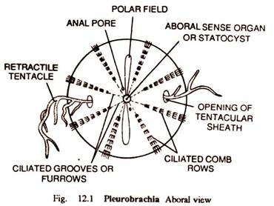

Sense Organs of Ctenophores:
Apical sensory organ is a deep seated statocyst at aboral pole. It is lined by tall, ciliated epithelial cells. Statocyst contain statolith and balancers. It is covered by a roof like a dome or bell, formed of fused cilia. The sensory organ serves as an organ of equilibrium.
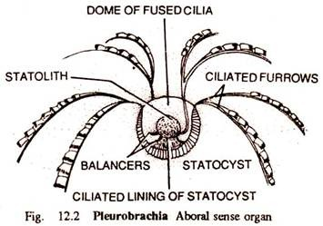

Body Wall of Ctenophores:
Composed of an outer epidermis and an inner gastrodermis separated by a thick gelatinous mesogloea. The epidermis is syncytial and contains many gland cells, sensory cells and pigment granules. Mesogloea contains amoebocytes, connective tissue fibres muscle fibres and some nerve cells.

Digestive System of Ctenophores:
Mouth slit-like situated in the centre of the lower end. It leads into a long tubular pharynx lined with epidermis. The pharynx opens into a small but wide stomach. It gives out a system of five gastrovascular canals which extend throughout jelly in a definite arrangement. The stomach and gastrovascular canals are lined with gastrodermis. Two anal canals open to the outside near the aboral sense organ, each by an anal pore.
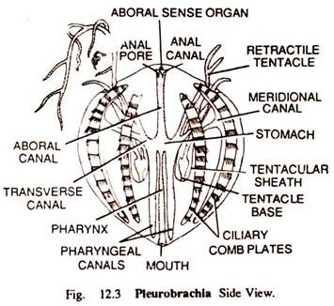
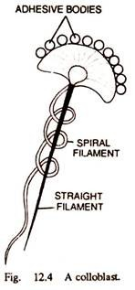
Ctenophores feed on small planktonic organisms and are voracious Food is captured by trapping in colloblast. Digestion is extracellular in pharynx and intracellular in gastrovascular canals.

Respiratory and Excretory System of Ctenophores:
There are no respiratory structures. Gaseous exchange takes place through general body surface.
Excretory System:
No definite excretory organs. Cell rosettes consisting of a double circlet of ciliated gastrodermal cells, surround openings leading from the gastrovascular canals to the mesogloea. They may be excretory or osmoregulatory.

Nervous System of Ctenophores:
There is no localized control centre. The epidermal nerve plexus is concentrated in a ring around the mouth, and at the base of the comb rows, where it forms the radial nerves. The nerves are not true nerves, but the condensation of the nerve net. The nervous system controls muscular movements and determines the. activity of cilia on the combrows.
The aboral sense organ is a statocyst or balance organ useful in maintaining normal orientation.

Reproductive System and Development of Ctenophores:
All are hermaphrodites. Reproduction is sexual only and asexual reproduction is totally absent. Gonads develop from endoderm in the form of bands in the meridional canals of the gastrovascular system.
Development:
Generally fertilization is external. Cleavage is total, determinate and unique in ctenophores called disymmetrical. Usually free swimming characteristic cydippid larva occurs which undergoes gradual metamorphosis. Some ctenophores exhibit a strange phenomenon called dissogeny in which both the larva and adult reproduce sexually. There is no alternation of generation.
Ctenophores have great powers of regeneration. Lost or wounded parts, even the statocyst, are replaced or repaired by regeneration.

Affinities of Ctenophores:
Many zoologists still keep ctenophores as Acnidaria, a subphylum of Colenterata.
The affinities of these animals can be studied under following heads:
1. Affinities with Cnidaria
2. Affinities with Platyhelminthes.
1. Affinities with Cnidaria:
Ctenophores resemble Cnidaria in:
1. Having a strong biradial symmetry and an oral-aboral axis.
2. Diploblastic body.
3. Medusa like body with a gelatinous mesenchymal mesogloea.
4. Absence of coelom.
5. Similar but more advanced endodermal gastrovascular cavity.
6. Diffused epidermal nerve plexus.
7. Presence of statocyst.
8. Absence of nephridia.
9. Absence of respiratory organs.
10. Endodermal gonads.
On the basis of above affinities with cnidaria, many zoologists treat them as a class of phylum Coelenterata.
(a) Affinities with Hydrozoa:
Ctenophores show following resemblances with Hydrozoa:
1. General body surface corresponds to exumbrellar surface of a medusa.
2. Stomodaeum corresponds to subumbrellar surface of medusa.
3. Simple gastrovascular cavity.
4. Thick, gelatinous mesogloea.
5. Two opposite tentacles in sheath.
(b) Affinities with Anthozoa:
1. Ciliated ectoderm of Anthozoa is forerunner of combplate.
2. A well-developed stomodaeum.
3. Endodermal gonads.
4. Release of gametes through mouth.
5. Biradial symmetry.
6. Gut in embryos four lobed.
7. Cellular mesogloea.
Differences from Cnidaria:
1. Presence of combplates.
2. No tentacles around mouth.
3. Presence of colloblasts.
4. An aboral sense organ.
5. Mesenchymal muscles.
6. Definite organization of digestive system.
7. Presence of anal pores.
8. Determinate cleavage.
9. Absence of a planula larva.
10. Presence of cydippid larva.
11. Complete absence of polymorphism.
12. Absence of alternation of generation and asexual reproduction.
2. Affinities with Platyhelminthes:
Two ctenophores viz. Coeloplana and Ctenoplana exhibit following resemblances with polyclad turbellarians.
1. Dorsollventrally flattened body.
2. Crawling mode of locomotion.
3. Ciliated epidermis.
4. Lobed gastrovascular cavity.

