The Search for the Urbilaterian Ancestor
It is doubtful that we will find a fossilized representative of the ancestral lineage that gave rise to both the deuterostomes and the protostomes. This hypothetical animal is sometimes called the Urbilaterian ancestor or the PDA (protostome-deuterostome ancestor). Since it is doubtful that such an animal would have had either a bony endoskeleton (a deuterostome chordate trait) or a hard exoskeleton (characteristic of protostomate ecdysozoans), it would not have fossilized well. However, we can undertake what Sean Carroll has called “paleontology without fossils.”

Homologous genes with ancestral functions
The immediate aim of “paleontology without fossils” is to find homologous genes that perform the same functions in both a deuterostome (usually a chick or a mouse) and a protostome (generally an arthropod, such as Drosophila). Many such genes have been found (Table 1), and their similarities of structure and function in protostomes and deuterostomes make it likely that these genes emerged in an animal that is ancestral to both groups.
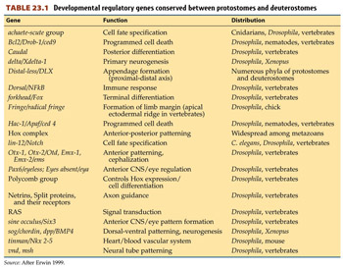
Table 1 (Click image to enlarge.)
The Pax6 protein, for example, plays a role in forming eyes in both vertebrates and invertebrates (see Chapter 2). Ectopic expression of Pax6 results in extra eyes in both Drosophila and Xenopus—representatives of the protostomes and deuterostomes, respectively (Chow et al. 1999). Moreover, the ectopic expression of a deuterostome (mouse) Pax6 gene in a fly larva induces ectopic fly eyes (see Figure 1), and the ectopic expression of the Drosophila Pax6 gene in Xenopus ectoderm induces eye development in the frog tadpole (Halder et al. 1995; Onuma et al. 2002). Therefore, it is a safe assumption that the samePax6 gene is involved in eye production in both deuterostomes and protostomes. Moreover, at least three other genes—sine oculis, eyes absent, and dachshund—are also used to form eyes in both Drosophila and vertebrates (Jean et al. 1998; Relaix and Buckingham 1999). Since it is extremely unlikely that deuterostomes and protostomes would have evolved Pax6 and its partners independently—and used them independently for the same function—it is likely that the PDA possessed a Pax6 gene and used it for generating eyes.
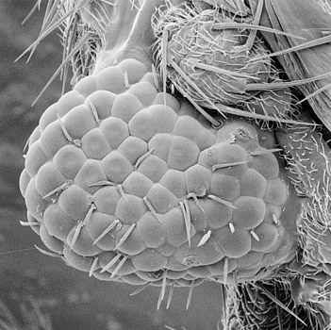
Figure 1 The Pax6 gene for eye development is an example of a gene ancestral to both protostomes and deuterostomes. The micrograph shows ommatidia emerging in the leg of a fruit fly (a protostome) in which mouse (deuterostome) Pax6 cDNA was expressed in the leg disc. (From Halder et al. 1995, courtesy of W. J. Gehring and G. Halder.) (Click image to enlarge.)
Another gene shared by deuterostomes and protostomes is the homeobox-containing gene tinman. The Tinman protein is expressed in the Drosophilasplanchnic mesoderm, eventually residing in the region of the cardiac mesoderm. Loss-of-function mutants of tinman lack a heart (hence its name). In mice, the homologous gene is Nkx2-5, and it too is originally expressed in the splanchnic mesoderm and continues to be expressed in those cells that form the heart tubes (see Chapter 12; Manak and Scott 1994). Thus, even though the hearts of vertebrates and of insects have little in common except their ability to pump fluids, they both appear to be predicated on the expression of the same gene, and it is therefore probable that the PDA had a circulatory system with a pump based on the expression of the ancestral Nkx2-5/tinman gene.
Another set of genes shared by deuterostomes and protostomes are those for the transcription factors involved in head formation (Finkelstein and Boncinelli 1994; Hirth and Reichert 1999). In Drosophila, the brain is composed of three segments, called neuromeres. These neuromeres are specified by three transcription factors. The genes encoding these factors are tailless (tll) andorthodenticle (otd), which are expressed predominantly in the anteriormost neuromere, and empty spiracles (ems), which is expressed in the posterior two neuromeres (Monaghan et al. 1995; Hirth et al. 1998). Loss-of-function mutations of otd eliminate the anteriormost neuromere of the developingDrosophila embryo, and loss-of-function mutations of ems eliminate the second and third neuromeres (Hirth et al. 1995). In frogs and mice, the homologues of these genes (Otx1, Otx2, Emx1, Emx2) are also expressed in the brain (Simeone et al. 1992), although the exact patterns of transcription are not identical (see Figure 8.30). When the Otx2 gene is experimentally knocked out (Acampora et al. 1995; Matsuo et al. 1995; Ang et al. 1996), the resulting mice have neural and mesodermal head deficiencies anterior to rhombomere 3. In humans, mutations of EMX2 lead to a rare condition known as schizencephaly, in which clefts rip through the entire cerebral cortex (Brunelli et al. 1996). Even though the Drosophila otd and ems genes are specified by the Bicoid and Hunchback gradients and the mammalian Otx and Emx genes are induced by the anterior dorsal mesoderm and endoderm, it appears that the same genes are used for determining the anterior brain regions. It is therefore likely that the ancestor of all bilaterian organisms had sensory organs based on Pax6, a heart based on tinman, and a head based on otd, ems, and tll. It also had something else: an anterior-posterior polarity based on the expression of Hox genes.

Anatomical similarities: Larval forms
Features held in common between protostomes and deuterostomes are thought to be derived from the PDA. In addition to the molecular similarities, there are also structural similarities between these two groups. The most basal forms of both deuterostomes and protostomes arise from ciliated larvae. These larvae might form in different ways—the protostomes using the blastopore region as their foregut and mouths, and the deuterostomes using the blastopore region as their anal hindgut—but recent molecular evidence suggests that even this morphological distinction may have underlying similarities. Arendt and colleagues (2001) have shown that the Brachyury (T) gene is expressed in the ventral foreguts of pluteus and hemichordate larvae of basal deuterostomes and in the trochophore larvae of annelid worms (Figure 2). Goosecoid and Otx are also found in the foregut regions of deuterostome and protostome larvae. Convergent evolution of these three genes would be unlikely (especially considering how specific their localizations are), suggesting that both protostomes and deuterostomes inherited a ciliated larval form from the PDA. Indeed, Arendt and colleagues (2001, 2004) have proposed that the Urbilaterian ancestor had a single blastoporal opening that extended along the surface of the embryo (like the blastopores of certain annelid embryos today), becoming a mouth in the protostomes and an anus in the deuterostomes.
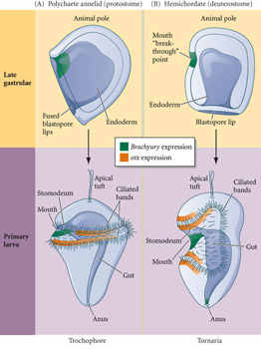
Figure 2 Late gastrula embryos (top) develop into ciliated larvae (bottom). (A) In the polychaete annelid worms (Protostomia), the lateral blastopore lips fuse along the later ventral midline. The blastopore gives rise to mouth and anus at opposite ends. In the trochophore larva produced by these embryos, the Brachyury gene (green) is expressed in the ventral portion of the stomodeum (i.e., the mouth) and in the proctodeum (anus), whileotx (gold) is expressed in two bands of cells along the ciliated bands. (B) In the hemichordates (a deuterostome lineage that includes the acorn worms), the tip of the gastrulation cavity touches the lateral body wall on the future ventral side, where the mouth later breaks through. The blastopore gives rise to the anus only. In the early tornaria larva produced by these embryos, Brachyury is expressed in the ventral portion of the stomodeum and in the proctodeum, and otx is expressed in two upper bands parallel to the pre-oral ciliated band and in two lower bands parallel to the post-oral ciliated band. (After Arendt et al. 2004.) (Click image to enlarge.)

Cnidarians and their larvae as Urbilaterian candidates
Current research has focused on cnidarians and their planula larvae as the possible bilaterian ancestor. The planula larva of cnidarians resembles the acoelomic flatworms of the taxon Acoelomorpha. These animals are now thought to represent the sister group to the protostomes and deuterostomes (Baguña et al. 2008). While not within either of these two large groups, they do exhibit bilateral symmetry. If this placement of taxa is correct, many ideas have to be reconsidered. First, according to this scheme, the Urbilaterian ancestor is a different organism than the PDA (Figure 3). Second, recent phylogenies have indicated that the Xenoturbella is probably the most basal deuterostome clade, and that the unsegmented Chaetognathans are sister group to all the lophotrochozoans. This would suggest that both protostomes and deuterostomes originated from simple, unsegmented, wormlike creatures with only one body opening and a non-centralized nervous system at its base (Hejnol and Martindale 2008). The direct-developing acoel flatworms and the planula larvae of cnidarians may represent this type of organization. This would argue for a much simpler Urbilaterian that pre-dated the PDA. This Urbilaterian would be an unsegmented wormlike organism without feet and heart and with a decentralized nervous system. Its gut would have one opening, not two. The big difference between the cnidarians and the bilaterians would be the position of the site of gastrulation in relation to the egg. In bilaterians, gastrulation occurs ventrally (in what would normally become endoderm), while in cnidarians it occurs at the animal pole. In acoel flatworms, gastrulation takes place vegetally, in the macromeres that become the endomesoderm (Henry et al. 2000).
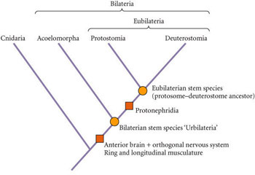
Figure 3 Phylogenetic position of the Acoelomorpha, based on molecular and morphological evidence from several recent sources. In this model, the position of the “Urbilaterian”—the stem species of the Bilateria—is distinct from that of the eubilaterian stem species (“protostome-deuterostome ancestor,” or PDA). Synapomorphies are indicated by filled squares. (After Hejnol and Martidale 2008.) (Click image to enlarge.)
This would mean that the genes corresponding to heart or eye development arose only later. Genes specifying “mesoderm” appear to exist in cnidarians that lack mesoderm (Martindale et al. 2004), and the Pax6 gene appears to have evolved after the eyes of cnidarian medusae (Matus et al. 2007). The presence and expression of Hox clusters in cnidarians (Ryan et al. 2007; Hejnol and Martindale 2009), and the discovery that the Bmp4/dpp homologue in cnidarians is expressed on only one side of the blastopore (indicating bilateral symmetry; Hayward et al. 2002; Finnerty et al. 2004), indicates that cnidarians and bilaterians probably follow the same developmental rules, originating from an ancestor 570–700 million years ago.

Our new phylogenies and new abilities to determine gene expression patterns are enabling us to return to one of those old questions that Roux had promised we would come back to solve. One of the biggest of these questions concerned the origin of bilateral symmetry. There were several hypotheses (see Martidale and Hejnol 2009), but one of them, the acoeloid-planuloid hypothesis (von Graff 1891), predicted that the cnidarian planula larvae underwent a heterochronic change to give rise to the ancestor of acoel bilateral flatworms. The combination of molecular and anatomical investigations offers us provocative clues as to what the proverbial Urbilatarian ancestor might have been and may provide evidence for the ways that some of the most crucial features of the animal kingdom evolved.

