After being in operation for over a year, Marcus Kingo’s fast-growing waste collection business was facing a serious challenge. Information handling errors were pervasive and the business was losing customers. If he wanted to stay in business, Kingo needed to find an affordable IT system that met his operational requirements and allowed the business to grow.
Kingo entered the junk removal business in 2008. To reduce high fixed startup costs, he opted to create a simple, virtual business model “without bricks-and-mortar.” By offering professional services and competitive prices, a year later, his business was doing very well.
As the business grew, however, so did operational complexity, and inefficiency and errors became commonplace. Drivers relied on instructions delivered through an e-mail system, and when this information was incomplete or incorrect, customers suffered the consequences. Furthermore, the geographical dispersion of the business, which already operated in three Canadian cities, and the absence of face-to-face interaction with staff, often left Kingo without a good sense of the “pulse” of his business. He believed it was essential to design a system of information flow that improved the quality of day-to- day operations, and that allowed him to “manage the business by the numbers”.
INDUSTRY OVERVIEW1
Non-hazardous waste collection stood as part of the larger environmental and facilities services industry.2 The industry’s value chain included waste collection, transport, processing, recycling or disposal, and monitoring of waste material. According to Datamonitor, the industry had experienced a compound
1 This section was written based on primary and secondary sources. Secondary sources included:
Datamonitor. Industry Profile: Global Environmental & Facilities Services. Reference Code: 0199-1015. Copyright March 2010.
The 2009-2014 World Outlook for Waste Collection. Philip M. Parker, INSEAD, copyright 2008, www.icongrouponline.com.
2 As defined by NAICS, the industry excludes large-scale water treatment systems, which are classified in the water utilities sub-industry. Hazardous materials, such as chemicals or leftovers of some industrial processes, are also excluded from this industry.
Page 2 9B11E025
annual growth rate (CAGR) of 2.5 per cent (2005–2009). However, in 2009, the industry slowed down significantly, growing by only 0.6 per cent. For the coming five-year period, a CAGR of 3.9 per cent was predicted, which would result in an industry total value of $276.4 billion by 2014. These figures are presented in more detail in Exhibit 1.
Within the industry, solid waste management was the largest and most lucrative segment, accounting for 53.8 per cent of the industry’s total value. INSEAD’s Professor Philip Parker, in a study published by Icon Group International, forecasted latent demand3 for waste collection at US$129.0 billion. For the period between 2009 and 2014, on average, Canada was expected to represent 1.9 per cent of this demand, and the United States 20.6 per cent. Details by year and city for these two markets can be found in Exhibit 2 and Exhibit 3, respectively.
Globally, the environmental and facilities services industry was fragmented. A large number of small, local companies competed with a small number of large, global or national players. Within the waste management segment, the largest global competitors were Waste Management Inc. and Republic Services, which together accounted for 10.5 per cent of the global market share. The service was considered a commodity, so competition was based mainly on price.
Waste collection in Canada followed the same trends found in the larger global industry. Most businesses were tiny companies operating under the “one man, one truck” model. Companies that specialized in non- hazardous substances needed a licence from the Ministry of Environment to operate the business, permits from the Ministry of Transport to run commercial vehicles, and commercial insurance for the trucks. Other than the paperwork and some money, requirements were not hard to meet. Waste collection was generally perceived to be a “rough” business, characterized by unreliable customer service and a lack of professionalism. It was also considered to be a commodity service, and so as competitors increasingly entered the market, prices began to fall. Achieving operational efficiencies in this challenging environment was difficult enough for global companies that benefitted from significant scale economies, but was almost impossible for local companies.
Buyers of waste collection services ranged from large public authorities to individual households. Potential clients had several alternatives, some of them at no charge. For example, they could perform the services themselves; utilize municipal services; or sell, donate or pass on their unwanted items to others – through word of mouth to friends and family, by advertising on Internet sites like Kijiji, or by hauling unwanted items to the curb for passers-by. Due to this variety of options, clients tended to be highly sensitive to price. Customers who used junk removal services tended to be those who could not carry out the service on their own, or who preferred the convenience of the outsourcing option.
Kingo’s largest competitor was 1-800-Got-Junk, which was a relatively young franchise company operating both in Canada and internationally. Kingo was currently the sole proprietor of all 1-888-JUNK- VAN locations, but his goal was to use franchising to facilitate future growth. The value offered to customers by these two companies was quite similar: they both strived to be flexible about customer needs in terms of timing of the service; they were both committed to conveying a professional appearance, with uniformed drivers and a corporate look; and both companies were highly competitive in terms of pricing.
On the supply side, fuel was clearly an important raw material, and one for which prices and supply were highly unpredictable. Companies in the industry attempted to address this uncertainty primarily through
3 Latent demand is a measure of potential industry earnings under hypothesized market conditions. Usually, this measure is larger than actual industry revenue.
Page 3 9B11E025
efficient operation of their trucks. Entry barriers within the industry were about to increase, as new environmental regulations had raised the bar for more integrated environmental management services.
OVERVIEW OF THE COMPANY
One day in 2008, a friend of Kingo’s, who was a single-truck operator in the junk-removal industry, had called to see whether Kingo could help him out. The friend had become ill and was unable perform a couple of already-scheduled waste-removal jobs. As Kingo helped out his friend, he immediately spotted a business opportunity. That same year, he invested $500 in a truck and started his new household waste collection business, operating in the London, Ontario area.
Kingo had been an entrepreneur all his life, and from experience he knew that paying the rent and utility bills for an office location was a huge challenge for a small start-up. Thus, he was motivated to design a business model that required very low overhead. He decided that 1-888-JUNK-VAN would not have a physical office. Kingo and his employees would work from home, and all communication and information transmission would be electronic.
The virtual design worked brilliantly. By 2009, the business had quickly expanded to operate in two more cities — Kitchener was added in 2008, and Hamilton in 2009. The business now had five trucks, and sales had doubled during the 2008-2009 period, from $300,000 to $600,000. Kingo planned to further expand his business by opening franchises in new cities, while still maintaining a non-office-based model of work. But, before he could move forward with his plans for expansion, Kingo first needed to address some challenges regarding his operation.
In 2009, the company’s top priority was to become known to potential customers. In order to gain visibility in the local markets, 1-888-JUNK-VAN followed the strategy of “advertising in people’s faces.” Marketing was considered very important and used up about 20 per cent of the total budget. Kingo looked for strategic locations for parking the company’s trucks, like parking lots with good visibility in high traffic areas. The company also advertised on buses whenever possible. About 90 per cent of its marketing budget went towards coupons on print media, which served the dual purpose of attracting customers and promoting the company name. Kingo also used Google AdWords.
To increase market share, 1-888-JUNK-VAN attempted to deliver service as per the company slogan “yes, we do that.” The company endeavoured to offer highly competitive prices, while also meeting customers’ specific preferences. Other companies sometimes refused certain jobs, such as picking up leftovers from minor demolitions or jobs that necessitated the rental of additional equipment to remove the items. 1-888-JUNK-VAN attempted to build its reputation as a company that would pick up any (legal) item, while presenting a highly professional image (i.e., reliable service, uniformed drivers, etc.).
OPERATIONS AND THE ROLE OF INFORMATION TECHNOLOGY
The company employed two call centre operators, one data clerk, three drivers and three helpers, all under Kingo’s direct “virtual” supervision. Operations began with customers calling reception. All service orders, referred to internally as “jobs,” were received by cell phone. The call centre operators worked in six-hour shifts, from 8 a.m. to 2 p.m., and from 2 p.m. to 8 p.m. The operators inputted job information (customer contact details, time and date for the job) to a custom-built MS-Works® database. Exhibit 4 shows two screenshots of the database.
Page 4 9B11E025
The morning operator opened the database at the beginning of her shift, booked new jobs into the database, and then emailed the file to the evening operator at the end of her shift. The evening operator followed the same procedure, but every day at 8 p.m. she emailed the updated database to the data clerk. The evening operator also created and mailed work order spreadsheets for each driver in each location, which included job details for the following day.
Upon receipt of the information, the drivers planned their next day’s schedule in more detail, and informed their helpers. The following day, they performed the services as indicated in the spreadsheet, such as waste collection at customer sites, and waste disposal at dumps, recycling facilities, and charities. Dumps generally charged by weight, whereas recycling facilities had slightly different rules in different cities. For example, 1-888-JUNK-VAN got paid for disposing of large quantities of metals in some places, and for large quantities of paper and e-waste in other locations. Most of the time, the quantities were not large enough and the drivers had to leave the materials and pay by weight, even at recycling facilities. Dump tickets and recycling tickets were provided by each facility and were retained by the driver for customer billing purposes. With respect to donations, customers occasionally had specific requests about where they wanted their items to go, but usually it fell to the van drivers to decide where to take items, depending on their condition.
1-888-JUNK-VAN’s pricing scheme had two components: a flat rate of $50 that included the truck and two workers to load the junk, plus a variable rate of $0.21 per pound. At loading time, drivers provided customers with a weight estimate. Once the weight ticket was received from the dumps or recycling facilities, the customer would be contacted by telephone with the exact weight and billed accordingly. An average job weighed 800-900 pounds, and cost the customer approximately $230 plus tax. For items that were to be donated, the weight was estimated and a price was agreed upon with the customer at the time of pickup. Three payment methods were acceptable: cash, cheque and credit card. For cash and cheques, drivers returned to the customer’s site with the weight ticket, prepared the invoice manually, and received payment; payments were deposited daily to the company’s bank account. For credit card transactions, drivers scanned the weight ticket and e-mailed a copy of the invoice to the customer with the weight ticket attached. The main objective of weight-based pricing was to facilitate standardized billing, which could be replicated and franchised.
Each evening, drivers e-mailed the data clerk details regarding jobs performed, weights, invoices, payments received, and hours worked. The data clerk’s main task was to integrate the information into the central database, which he should have received from the evening call centre operator by 8 p.m. After integrating the information, the data clerk manually processed credit card payments, and then forwarded the updated database to the morning operator, and the cycle would repeat the next day.
Staff payroll was also processed using the Works database. All staff emailed daily work hours to the data clerk, who consolidated the information and sent it to Kingo, who in turn wrote the weekly pay cheques (see Exhibit 5). Drivers were paid on the basis of hours worked as well as productivity. Hourly wages ranged from $12 to $20, depending on the driver’s sales performance. Kingo sent all invoice and expense receipts to an accounting firm for bookkeeping purposes.
While this system had allowed 1-888-JUNK-VAN to grow initially, information errors and inefficiencies were now negatively impacting operations and increasing costs. For example, simple administrative tasks (e.g., contacting helpers, going back to the customer site to collect money) took up a lot of the drivers’ time. Even though some templates existed for drivers to send their information to the data clerk, they rarely used them, so drivers’ data consolidation was very time consuming. Customer service quality was
Page 5 9B11E025
suffering, which damaged the company’s reputation. Errors in customer contact information, forgotten emails, manual calculations and billing mistakes caused negative customer interactions.
Ironically, the most serious problems originated with the data clerk. On several occasions, the clerk accidentally sent the wrong version of the database to the morning operator, and as a result some jobs that were already booked no longer showed in the database and did not make their way onto the spreadsheets used by the drivers. The resulting angry calls from frustrated customers kept Kingo awake at night. And if that were not enough, fixing the database was extremely time-consuming — it could take Kingo and the data clerk an entire day to get the database cleaned up, and meanwhile no new reservations could be taken as there was only one live copy. Unfortunately, this scenario had occurred more than a few times, with increasing regularity as the business grew. Kingo was frustrated about suspending bookings in order to chase mistakes. The problem had to be fixed as soon as possible.
Kingo desperately wanted to preserve his virtual business model in order to facilitate business expansion through franchising. Putting out these fires was taking too much of his time, and distracting him from activities that would help the business grow. Inspired by the idea that people do not fail, only poor systems do, Kingo was eager to develop a better operational system for his business. He set out to find some information technology (IT) tools that would enable him to put his ideas into practice.
POSSIBLE INFORMATION TECHNOLOGY SOLUTIONS
Kingo started to explore possible solutions to his business problem. He knew the company needed a central database, and that internal information should no longer be transmitted by e-mail. The database should be accessible remotely since everybody would be working on it simultaneously from different locations. He also wanted e-mails to customers to be sent automatically from the system in order to avoid mistakes and the resulting delays.
He reflected further on his needs. The business was too small to justify hiring a dedicated IT worker, and since Kingo did not personally have an IT background, the solution had to be easy to implement and operate. Ease of use was also critical since his staff did not possess very high IT skills, yet they would have to rely heavily on the system on a daily basis. The solution also had to be flexible and robust enough to handle evolutionary changes in the market or the business. Vendor support was essential; Kingo wanted to have someone to rely on for as long as the company used the system. Finally, time was of the essence.
From Kingo’s preliminary research, five options were apparent.
Microsoft Access Database
Upgrading from MS-Works® to MS-Access® could be done within a relatively short time and on a small budget. Access could be installed locally on multiple computers, or it could also be installed on a centralized server to be accessed remotely through the Internet and a secure virtual private network (VPN). Local installations in several computers had an advantage in that Kingo could easily perform the installations himself. Licenses were priced at $179 per computer. Kingo believed he could find time during evenings or weekends to create the new database, and that it could be ready in a couple of weeks. However, this option would not allow for remote access, and so each instance of the database would have to be updated manually, every day.
Page 6 9B11E025
MS-Access could apparently be installed on a shared server so as to provide remote access to multiple users, but Kingo did not know how to implement this. Choosing this option would require him to delve into a significant amount of technical information, and he could not rule out the possibly of needing to hire some extra help in order to get it right. In this case, the number of required user licenses would depend on how many people would be working on the program concurrently. Kingo would also need to consider the costs of hosting the shared server, as well as any required professional development assistance.
Custom Application
Another alternative was to have someone build a completely customized application for the business. Kingo received several quotes for a web-based system, which would meet the requirements of a central database and provide remote access, and the system would also have some very basic functionality included. The initial build time was estimated to be four weeks, and the upfront price was about $2,000. However, this did not provide for any changes or adjustments that might be required. Maintenance was charged at about $60 per hour per developer, and there was no way to predict how much maintenance would be needed.
There were other questions related to this alternative. First, the quotes did not include data migration, so Kingo imagined he would end up paying some extra money for this service. Second, custom-made software simply could not be seen beforehand. He could tell the programmer what he needed and explain that he wanted a user-friendly solution, but until he actually saw the final product, he could not know whether his needs were being understood or whether the software would be easy to use. By that time, a certain amount of time and money would already have been invested. What if a lack of understanding led to higher costs and longer programming times? As for post-implementation support, Kingo learned that “with a custom application, support is billed by the hour.”
Google Docs
Kingo happened upon Google Docs while surfing the Internet, and he opened a free account to explore its possibilities. Basically, Google Docs offered online applications that could be used to create text documents, spreadsheets, slide-based presentations and forms. The forms application was particularly intriguing, as forms could be quickly created and shared with employees. Users could work simultaneously on the same file, in a collaborative system environment. It was also possible to set different user profiles, for example, one providing full access to files, another for editing forms, and a third limited to reading information. E-mail distribution was also supported (e.g., customers could be sent an e-mail with a link to a form, which they could then complete and return online).
From a non-functional perspective, Google Docs had some advantages. It was free for up to 10 user accounts, and for small businesses there was a fee of $5 per user per month, or $50 per user per year. It could be implemented quickly and it was easy to use. As with the MS-Access option, Kingo believed he could migrate to a Google Docs system in a matter of a couple of weeks.
However, with this option, all data would be input into an online spreadsheet, and could not be cross- referenced in the way it usually is in relational databases.4 This would result in all of the data showing in
4 In relational databases, tables can have “foreign keys,” which are fields whose records must match the data contained in a field belonging to a different table. Consider this example: a table containing customers’ information has a field called
Page 7
a single, very large form, which was not ideal (e.g., the call centre operators would see fields they did not need, such as those to be filled in by the drivers). Another downside was Google Docs’ lack of formal customer support; the only available assistance was through online blogs and forums. Kingo had heard some of his friends say they were afraid to rely on cloud computing.5 A common concern was that users did not own the tools and resources used to store sensitive company data, which raised some confidentiality issues, and made people wonder what would happen if Google decided to suspend or even cancel the service.
Platform as a Service
Another option called Platform as a Service (PaaS) was similar to Google Docs in that it was delivered on a cloud-computing infrastructure. PaaS was defined as the provision of computational resources — namely hardware, storage, network capacity and some basic software functionality — on demand and through the Internet. PaaS differentiated itself through the fact that users could utilize common applications, as well as build their own unique applications, using a shared computing platform that was provided and hosted by a third party.
The available information suggested PaaS was starting to be appreciated mainly by software developers, and Kingo was not sure he possessed the necessary IT skills to take advantage of the independence PaaS seemed to offer. To explore the option further, he restricted his search to PaaS providers operating in North America, and found a handful of them. Based on the information available online, different providers had slightly different offers. He contacted four providers. Two of them did not reply to Kingo’s request for a quote. One of the vendors offered an on-site trial, which Kingo accepted. During the trial, he watched as the sales representative easily built forms and connected tables. Kingo thought he could perform this task by himself.
Service package costs ranged from $300 to $600 per month, depending on how much storage space and how many user licenses and applications were needed. Implementation, including data migration, would take approximately three days. If customization was required, more time and money would be needed, as this option was charged extra on an hourly basis, at about $180. Before making up his mind, Kingo would also have to understand ‘how much’ of a platform he would want, or how much he was willing to pay. Fortunately, long-term contracts were not required; he could scale the service up or down at any point, or cancel the service with one month’s notice.
Enterprise Resource Planning (ERP) System
ERP systems were built around a central database. They were designed to be accessible remotely, and claimed to integrate business processes by covering every aspect of the business, from purchasing, sales, and customer service, to finance, human resources and e-commerce.
Several ERP packages were targeted at small and medium-sized enterprises. Before asking for quotes, Kingo tried to gather as much information as he could through online searches. The packages with the most available information were SAP Business One®, Microsoft Dynamics® and Sage ERP®. In spite of their focus on small firms, these options seemed very costly. An average “small firm” implementation
customer ID. If a second table containing invoicing information wants to relate the invoice information to a particular customer, customer ID is used as a foreign key to cross-reference these two tables.
5 “Cloud computing” is often defined as on-demand provision of computational resources and services.
Page 8
was expected to have 20 to 25 users, and the cost for licences would be about $2,500 per user per year. In terms of up-front implementation cost, IT blogs suggested that companies should budget one dollar for each dollar of software licences.
Kingo found it difficult to extrapolate these estimates to his business. First, it was likely that licence prices would be higher for companies with fewer users — in fact, he had read somewhere that a Business One “starting pack” consisting of four licences was priced at $12,000. Second, these estimates included modules that Kingo was not interested in purchasing (e.g., finance and manufacturing). Kingo was also uncertain as to how well an ERP system would fit with or could be adapted to his specific business needs. These systems appeared static, and focused mainly on production and finance modules, which were not top priorities for his company.
DECISION
So there sat Kingo, tired after a long night sitting in front of a computer helping fix the database, trying to sort out which solution would best serve his business. He did not have all the information he wanted about the possible solutions, and he knew his business would change over time. At the same time, he knew a solution was needed, urgently.
Page 9
Exhibit 1
GLOBAL ENVIRONMENTAL AND FACILITIES SERVICES INDUSTRY VALUE
Year | USD billion | % growth
2005 | 207.1 | -
2006 | 213.8 | 3.20%
2006 | 220.5 | 3.10%
2008 | 227.1 | 3.00%
2009 | 228.5 | 0.60%
2010* | 235.0 | 2.80%
2011* | 243.0 | 3.40%
2012* | 252.7 | 4.00%
2013* | 264.5 | 4.70%
2014* | 276.4 | 4.50%
* Estimated
Source: Datamonitor. Industry Profile: Global Environmental & Facilities Services. Reference Code: 0199-1015. Copyright March 2010.
Exhibit 2
ESTIMATED LATENT DEMAND FOR WASTE COLLECTION IN CANADA AND THE UNITED STATES – BY YEAR
Year | Global demand |  | Canada | % Global |  | U.S. | % Global
2004 | 108,539 |  | 2,239 | 2.1% |  | 24,634 | 22.7%
2005 | 112,317 |  | 2,295 | 2.0% |  | 25,176 | 22.4%
2006 | 116,258 |  | 2,352 | 2.0% |  | 25,730 | 22.1%
2007 | 120,370 |  | 2,410 | 2.0% |  | 26,296 | 21.9%
2008 | 124,641 |  | 2,470 | 2.0% |  | 26,875 | 21.6%
2009 | 128,985 |  | 2,531 | 2.0% |  | 27,466 | 21.3%
2010 | 133,494 |  | 2,593 | 1.9% |  | 28,070 | 21.0%
2011 | 138,193 |  | 2,656 | 1.9% |  | 28,688 | 20.8%
2012 | 143,093 |  | 2,721 | 1.9% |  | 29,319 | 20.5%
2013 | 148,204 |  | 2,788 | 1.9% |  | 29,964 | 20.2%
2014 | 153,535 |  | 2,856 | 1.9% |  | 30,623 | 20.0%
Source: Philip M. Parker, INSEAD, copyright 2008, www.icongrouponline.com
Page 10
Canada
Exhibit 3
ESTIMATED LATENT DEMAND FOR WASTE COLLECTION IN CANADA AND THE UNITED STATES – BY CITY, 2009. (IN USD MILLIONS)
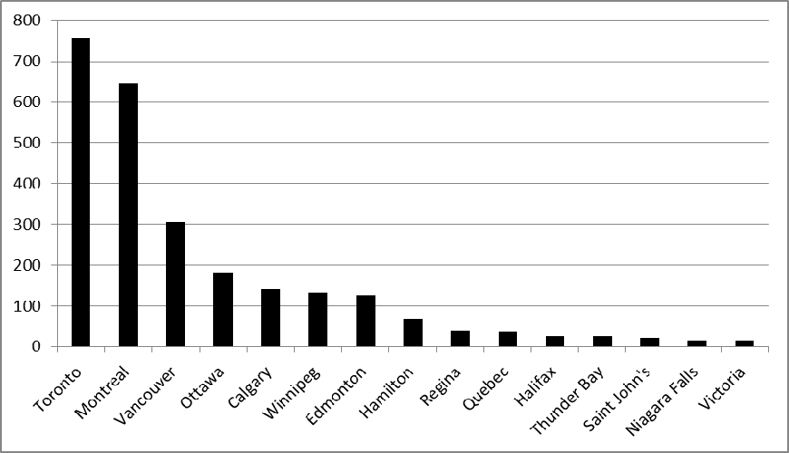
Source: Philip M. Parker, INSEAD, copyright 2008, www.icongrouponline.com
U.S.
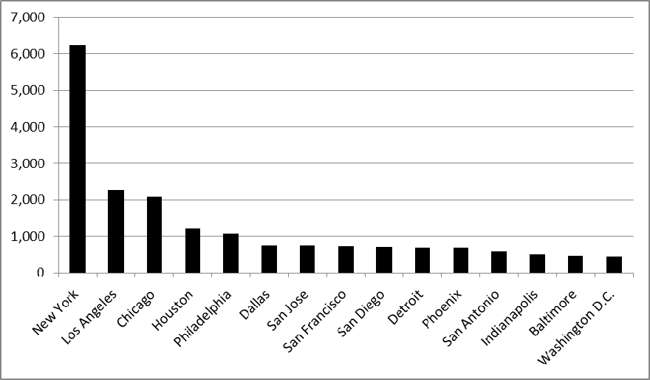
Source: Philip M. Parker, INSEAD, copyright 2008, www.icongrouponline.com
Page 11
Exhibit 4
SCREENSHOTS OF THE MICROSOFT WORKS DATABASE INDIVIDUAL RECORD VIEW
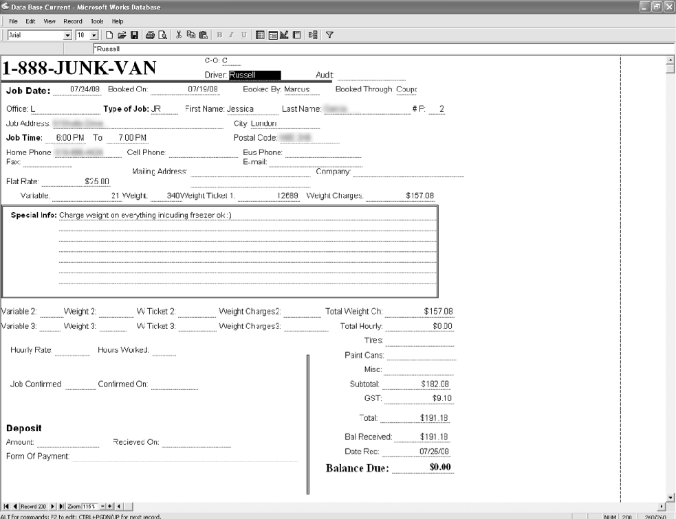
Page 12
Exhibit 4
SCREENSHOTS OF THE MICROSOFT WORKS DATABASE SUMMARY VIEW
Page 13
Exhibit 5
PAYROLL SHEETS – EXAMPLE 1
Page 14
Exhibit 5
PAYROLL SHEETS – EXAMPLE 2
Page 15
Exhibit 6
GOOGLE DOCS SCREENSHOT
