RUNNING HEAD: The Evolution of the Photography Camera

Impact Analysis:
The Evolution of the Photography Camera
Archie K, Crystal Sams, DeShunna Patterson, Lotus Loum, Patrick Williams
Learning Team A
CMGT 557
Tammy Borunda

SWOT Analysis
“SWOT analysis is a straightforward model that analyzes an organization’s strengths, weaknesses, opportunities and threats to create the foundation of a marketing strategy (Using SWOT Analysis to Develop a Marketing Strategy, 2015).
- Strengths
  - The technical skills the end user maintains.
  - Cost of maintenance of new cameras
  - Familiarization of the older technology
- Weakness
  - the aging technology which has to be upgraded
  - technology approaches end of life cycle
  - cost of maintaining older cameras
  - newer technology training
- Opportunities
  - maintain a competitive edge on the competition
  - greater quality and resolution
  - high stakeholder profit margin
- Threats
  - Not keeping up with the latest technology
  - Not being able to offer higher quality of service
  - Stakeholder profit margin will not grow with older technology
If we continue to maintain the older cameras we will have to prepare to continue to incur a cost for maintenance. The cost will be from the ordering of replacement parts and the cost of maintenance personnel to keep the cameras operational. The cost of new cameras with newer technology is not much higher than the combined cost of maintaining the older cameras. With the newer cameras we will have a warranty to ensure the maintain cost will not go up. The down side of the newer technology is the training of personnel and the implementation of the higher quality cameras.

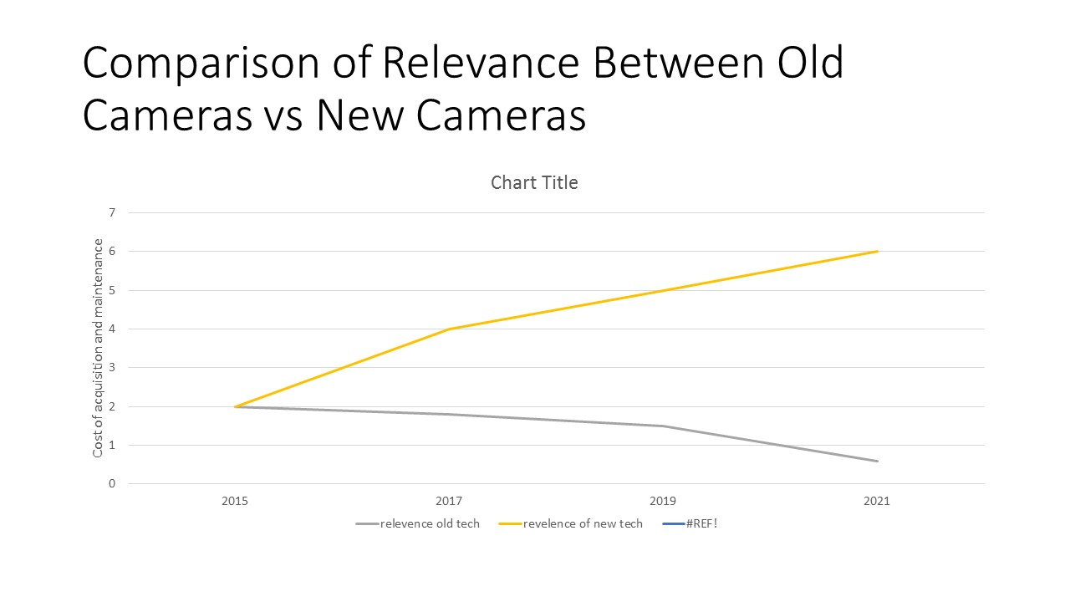
Comparison chart between old and new technology projected over the next 8 years; the higher the relevance the lower the risk.

Scenarios
Scenario One
The older camera personnel are kept. They will be familiar with the technology and business will continue as usual. If we keep the older cameras, the technology is approaching the end of its lifecycle. Replacement parts will be costly and maybe not available after a certain point. There would also be no need to retrain or add training for any employees. A disadvantage will be the older cameras will not offer a greater resolution than similar newer cameras. The resolution and quality will be downgraded compared to the competition. This will limited the company being able to offer the better quality to our customers. Stakeholder’s profit margin would be limited.

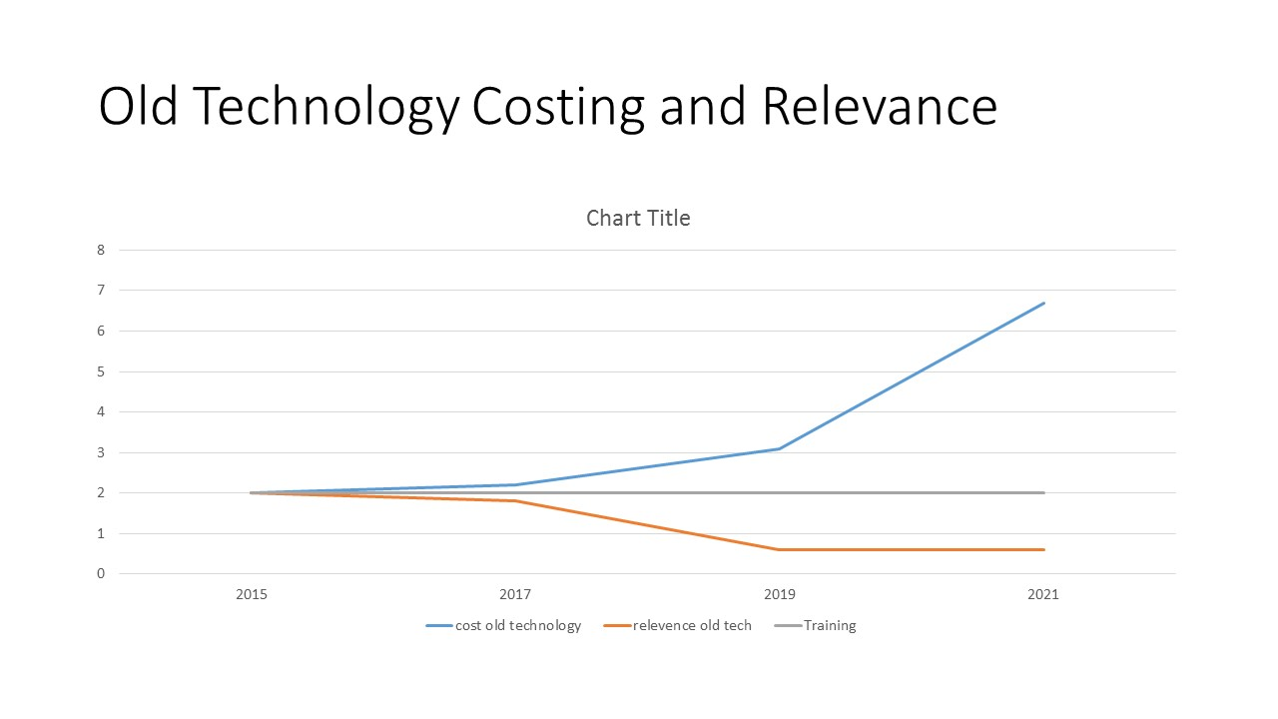
Old technology cost of maintenance and up keep and the training needed as well as the relevance to company bottom line. Notice relevance is below minimum standards

Scenario Two
New technology upgrades implemented within the stock and production of cameras. This process will have acquisition cost in the near term and may need some technology upgrades of the company systems and limited training. The biggest weakness may be an issue of the end user will disliking the changes and will have to get used to the new technology. A major strength and opportunity would be sharper picture and higher resolutions. The biggest threat is not taking advantage of the higher quality product and thus not being able to maintain a standard keeping us a challenge to our competitors.

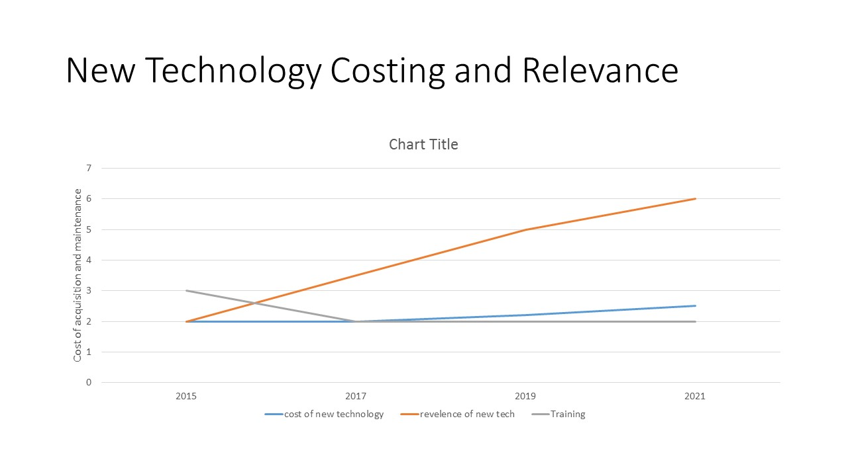
New technology cost of maintenance and up keep and the training needed as well as the relevance to company bottom line. Notice costing is steady and relevance is above standards.

References

Berry, T. (2015). How to perform a SWOT analysis. Retrieved from MPlan.com: http://www.mplans.com/articles/how-to-perform-a-swot-analysis/

Using SWOT Analysis to Develop a Marketing Strategy. (2015). Retrieved from Business Dictionary: http://www.businessdictionary.com/article/632/using-swot-analysis-to-develop-a-marketing-strategy/

